**Mobile Application Development Assignment**

**Name:- Rushikesh Dilip Narkhede**

**Class :- SYMCA (Sem III)**

**Division:- A**

**Roll No:- 49**

1. **Develop an application using views and widgets such as TextView, EditText, Button, Date and time Picker, etc (eg. Greet to the friend according to the current time. As in the morning 9:00 am show display message Good Morning Shyam).**

**Code:-**

**Activity_main.xml**

<?xml version="1.0" encoding="utf-8"?>  
<AbsoluteLayout xmlns:android="http://schemas.android.com/apk/res/android"  
 xmlns:app="http://schemas.android.com/apk/res-auto"  
 xmlns:tools="http://schemas.android.com/tools"  
 android:layout_width="match_parent"  
 android:layout_height="match_parent"  
 android:background="#FFFCFC"  
 tools:context=".MainActivity">  
  
  
 <TextView  
 android:id="@+id/name_tv"  
 android:layout_width="wrap_content"  
 android:layout_height="wrap_content"  
 android:layout_marginStart="25dp"  
 android:layout_marginLeft="25dp"  
 android:layout_marginTop="111dp"  
 android:layout_marginEnd="37dp"  
 android:layout_marginRight="37dp"  
 android:layout_marginBottom="113dp"  
 android:layout_x="28dp"  
 android:layout_y="47dp"  
 android:text="Name :- "  
 android:textColor="@color/black"  
 android:textSize="18dp"  
 app:layout_constraintBottom_toTopOf="@+id/textView"  
 app:layout_constraintEnd_toStartOf="@+id/name"  
 app:layout_constraintStart_toStartOf="parent"  
 app:layout_constraintTop_toTopOf="parent" />  
  
 <EditText  
 android:id="@+id/name"  
 android:layout_width="184dp"  
 android:layout_height="41dp"  
 android:layout_marginTop="108dp"  
 android:layout_marginEnd="28dp"  
 android:layout_marginRight="28dp"  
 android:layout_marginBottom="98dp"  
 android:layout_x="136dp"  
 android:layout_y="38dp"  
 android:hint="Enter name"  
 android:textSize="18sp"  
 app:layout_constraintBottom_toTopOf="@+id/radioGroup"  
 app:layout_constraintEnd_toEndOf="parent"  
 app:layout_constraintStart_toEndOf="@+id/name_tv"  
 app:layout_constraintTop_toTopOf="parent" />  
  
 <TextView  
 android:id="@+id/textView"  
 android:layout_width="wrap_content"  
 android:layout_height="wrap_content"  
 android:layout_marginStart="25dp"  
 android:layout_marginLeft="25dp"  
 android:layout_marginEnd="28dp"  
 android:layout_marginRight="28dp"  
 android:layout_marginBottom="360dp"  
 android:layout_x="26dp"  
 android:layout_y="89dp"  
 android:text="Gendar :-"  
 android:textColor="@color/black"  
 android:textSize="18dp"  
 app:layout_constraintBottom_toBottomOf="parent"  
 app:layout_constraintEnd_toStartOf="@+id/radioGroup"  
 app:layout_constraintStart_toStartOf="parent"  
 app:layout_constraintTop_toBottomOf="@+id/name_tv" />  
  
 <RadioGroup  
 android:id="@+id/radioGroup"  
 android:layout_width="226dp"  
 android:layout_height="wrap_content"  
 android:layout_marginEnd="7dp"  
 android:layout_marginRight="7dp"  
 android:layout_marginBottom="195dp"  
 android:layout_x="134dp"  
 android:layout_y="86dp"  
 app:layout_constraintBottom_toTopOf="@+id/button"  
 app:layout_constraintEnd_toEndOf="parent"  
 app:layout_constraintStart_toEndOf="@+id/textView"  
 app:layout_constraintTop_toBottomOf="@+id/name">  
  
 <RadioButton  
 android:id="@+id/female"  
 android:layout_width="wrap_content"  
 android:layout_height="wrap_content"  
 android:layout_x="144dp"  
 android:layout_y="139dp"  
 android:text="Female"  
  
 tools:layout_editor_absoluteX="72dp"  
 tools:layout_editor_absoluteY="274dp" />  
  
 <RadioButton  
 android:id="@+id/male"  
 android:layout_width="wrap_content"  
 android:layout_height="wrap_content"  
 android:layout_x="144dp"  
 android:layout_y="139dp"  
 android:text="Male"  
 tools:layout_editor_absoluteX="72dp"  
 tools:layout_editor_absoluteY="274dp" />  
  
  
 </RadioGroup>  
  
 <TextView  
 android:layout_width="wrap_content"  
 android:layout_height="wrap_content"  
 android:layout_x="32dp"  
 android:layout_y="209dp"  
 android:text="City :-"  
 android:textColor="@color/black"  
 android:textSize="18dp" />  
  
 <Spinner  
 android:id="@+id/city"  
 android:layout_width="150dp"  
 android:layout_height="wrap_content"  
 android:layout_x="138dp"  
 android:layout_y="212dp"  
 android:hint="@string/select_city"  
 android:textSize="18dp" />  
  
 <Button  
 android:id="@+id/button"  
 android:layout_width="wrap_content"  
 android:layout_height="wrap_content"  
 android:layout_marginStart="115dp"  
 android:layout_marginLeft="115dp"  
 android:layout_marginBottom="67dp"  
 android:layout_x="116dp"  
 android:layout_y="386dp"  
 android:onClick="register"  
 android:text="submit"  
 app:layout_constraintBottom_toBottomOf="parent"  
 app:layout_constraintStart_toStartOf="parent"  
 app:layout_constraintTop_toBottomOf="@+id/radioGroup" />  
  
 <DigitalClock  
 android:id="@+id/clock"  
 android:layout_width="100dp"  
 android:layout_height="40dp" />  
  
  
</AbsoluteLayout>

**MainActivity.java**

package com.example.q1_basicapplication;  
  
import androidx.appcompat.app.AppCompatActivity;  
import android.os.Bundle;  
import android.view.View;  
import android.widget.AdapterView;  
import android.widget.ArrayAdapter;  
import android.widget.Button;  
import android.widget.DigitalClock;  
import android.widget.EditText;  
import android.widget.RadioButton;  
import android.widget.RadioGroup;  
import android.widget.Spinner;  
import android.widget.TextView;  
import android.widget.Toast;  
import java.util.Date;  
import java.time.Clock;  
import java.util.Calendar;  
  
public class MainActivity extends AppCompatActivity implements AdapterView.OnItemSelectedListener{  
 Button submit_bt;  
 TextView name_tv;  
 EditText name;  
 RadioButton male,female;  
 DigitalClock clock;  
 Spinner city;  
 StringBuffer add;  
  
 String[] city_name={"Pune","Mumbai","Buldhana","Jalgaon","Nagpur"};  
  
  
  
  
 @Override  
 protected void onCreate(Bundle savedInstanceState) {  
 super.onCreate(savedInstanceState);  
 setContentView(R.layout.*activity_main*);  
  
 city = (Spinner) findViewById(R.id.*city*);  
 city.setOnItemSelectedListener(this);  
  
 ArrayAdapter aa = new ArrayAdapter(this,android.R.layout.*simple_spinner_item*,city_name);  
 aa.setDropDownViewResource(android.R.layout.*simple_spinner_dropdown_item*);  
 //Setting the ArrayAdapter data on the Spinner  
 city.setAdapter(aa);  
  
 clock= (DigitalClock) findViewById(R.id.*clock*);  
  
  
 }  
  
  
 @Override  
 public void onItemSelected(AdapterView<?> arg0, View arg1, int position,long id) {  
 String select;  
 select=city_name[position];  
 StringBuffer addcity = new StringBuffer();  
 addcity.append("City :-");  
 addcity.append(select);  
 add=addcity;  
 }  
  
 @Override  
 public void onNothingSelected(AdapterView<?> adapterView) {  
 //nothing  
 }  
  
 public void register(View view)  
 {  
 name_tv=(TextView)findViewById(R.id.*name_tv*);//find id  
 name=(EditText)findViewById(R.id.*name*);  
 male=(RadioButton)findViewById(R.id.*male*);  
 female=(RadioButton)findViewById(R.id.*female*);  
  
 String getName=name.getText().toString();//to get value from editText  
  
 StringBuffer info = new StringBuffer();  
  
 Calendar c = Calendar.*getInstance*();  
 int timeOfDay = c.get(Calendar.*HOUR_OF_DAY*);  
  
 if(timeOfDay >= 0 && timeOfDay < 12){  
 info.append("Good Morning ");  
 }else if(timeOfDay >= 12 && timeOfDay < 16){  
 info.append("Good Afternoon ");  
 }else if(timeOfDay >= 16 && timeOfDay < 21){  
 info.append("Good Evening ");  
 }else if(timeOfDay >= 21 && timeOfDay < 24){  
 info.append("Good Night ");  
 }  
 info.append(getName);  
  
 info.append("\nYour Information is :-\n");  
 info.append("Name :- ");  
  
 info.append(getName);  
  
 if(male.isChecked()==true){  
 info.append("\nGendar :- male \n");  
 }  
 if(female.isChecked()==true){  
 info.append("\nGendar :- female \n");  
 }  
  
 StringBuffer total_msg=info.append(add);  
  
  
  
 Toast.*makeText*(MainActivity.this,total_msg.toString(),Toast.*LENGTH_SHORT*).show();  
  
  
  
  
 }  
  
}

**Output:**

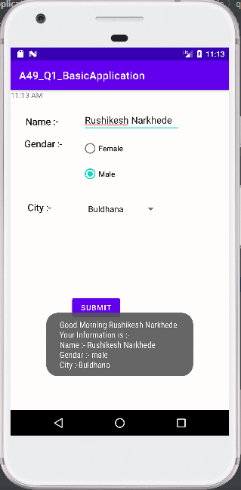

1. Develop an application for designing a functional calculator with basic operation.

**Code:**

**Activity_main.xml**

<?xml version="1.0" encoding="utf-8"?>  
<androidx.constraintlayout.widget.ConstraintLayout xmlns:android="http://schemas.android.com/apk/res/android"  
 xmlns:app="http://schemas.android.com/apk/res-auto"  
 xmlns:tools="http://schemas.android.com/tools"  
 android:layout_width="match_parent"  
 android:layout_height="match_parent"  
 tools:context=".MainActivity">  
  
 <TextView  
 android:layout_width="194dp"  
 android:layout_height="43dp"  
 android:layout_marginStart="114dp"  
 android:layout_marginLeft="114dp"  
 android:layout_marginTop="58dp"  
 android:layout_marginEnd="103dp"  
 android:layout_marginRight="103dp"  
 android:layout_marginBottom="502dp"  
 android:scrollbarSize="30dp"  
 android:text=" Calculator"  
 android:textAppearance="@style/TextAppearance.AppCompat.Body1"  
 android:textSize="30dp"  
 app:layout_constraintBottom_toBottomOf="parent"  
 app:layout_constraintEnd_toEndOf="parent"  
 app:layout_constraintStart_toStartOf="parent"  
 app:layout_constraintTop_toTopOf="parent" />  
  
 <!-- Edit Text View to input the values -->  
 <EditText  
 android:id="@+id/num1"  
 android:layout_width="364dp"  
 android:layout_height="28dp"  
 android:layout_marginStart="72dp"  
 android:layout_marginTop="70dp"  
 android:layout_marginEnd="71dp"  
 android:layout_marginBottom="416dp"  
 android:background="@android:color/white"  
 android:ems="10"  
 android:hint="Number1"  
 android:inputType="number"  
 app:layout_constraintBottom_toBottomOf="parent"  
 app:layout_constraintEnd_toEndOf="parent"  
 app:layout_constraintStart_toStartOf="parent"  
 app:layout_constraintTop_toTopOf="parent" />  
 <EditText  
 android:id="@+id/num2"  
 android:layout_width="363dp"  
 android:layout_height="30dp"  
 android:layout_marginStart="72dp"  
 android:layout_marginTop="112dp"  
 android:layout_marginEnd="71dp"  
 android:layout_marginBottom="374dp"  
 android:background="@android:color/white"  
 android:ems="10"  
 android:hint="number2"  
 android:inputType="number"  
 app:layout_constraintBottom_toBottomOf="parent"  
 app:layout_constraintEnd_toEndOf="parent"  
 app:layout_constraintStart_toStartOf="parent"  
 app:layout_constraintTop_toTopOf="parent" />  
  
 <!-- Text View to display result -->  
 <TextView  
 android:id="@+id/result"  
 android:layout_width="356dp"  
 android:layout_height="71dp"  
 android:layout_marginStart="41dp"  
 android:layout_marginTop="151dp"  
 android:layout_marginEnd="48dp"  
 android:layout_marginBottom="287dp"  
 android:background="@android:color/white"  
 android:text="result"  
 android:textColorLink="#673AB7"  
 android:textSize="25sp"  
 app:layout_constraintBottom_toBottomOf="parent"  
 app:layout_constraintEnd_toEndOf="parent"  
 app:layout_constraintStart_toStartOf="parent"  
 app:layout_constraintTop_toTopOf="parent" />  
  
 <!-- A button to perform 'sum' operation -->  
 <Button  
 android:id="@+id/sum"  
 android:layout_width="wrap_content"  
 android:layout_height="wrap_content"  
 android:layout_marginStart="16dp"  
 android:layout_marginTop="292dp"  
 android:layout_marginEnd="307dp"  
 android:layout_marginBottom="263dp"  
 android:backgroundTint="@android:color/tertiary_text_light"  
 android:onClick="doSum"  
 android:text="+"  
 app:layout_constraintBottom_toBottomOf="parent"  
 app:layout_constraintEnd_toEndOf="parent"  
 app:layout_constraintStart_toStartOf="parent"  
 app:layout_constraintTop_toTopOf="parent" />  
  
 <!-- A button to perform subtraction operation. -->  
 <Button  
 android:id="@+id/sub"  
 android:layout_width="wrap_content"  
 android:layout_height="wrap_content"  
 android:layout_marginStart="210dp"  
 android:layout_marginTop="292dp"  
 android:layout_marginEnd="113dp"  
 android:layout_marginBottom="263dp"  
 android:backgroundTint="@android:color/tertiary_text_light"  
 android:onClick="doSub"  
 android:text="-"  
 app:layout_constraintBottom_toBottomOf="parent"  
 app:layout_constraintEnd_toEndOf="parent"  
 app:layout_constraintStart_toStartOf="parent"  
 app:layout_constraintTop_toTopOf="parent" />  
  
 <!-- A button to perform division. -->  
 <Button  
 android:id="@+id/div"  
 android:layout_width="wrap_content"  
 android:layout_height="wrap_content"  
 android:layout_marginStart="307dp"  
 android:layout_marginTop="292dp"  
 android:layout_marginEnd="16dp"  
 android:layout_marginBottom="263dp"  
 android:backgroundTint="@android:color/tertiary_text_light"  
 android:onClick="doDiv"  
 android:text="/"  
 app:layout_constraintBottom_toBottomOf="parent"  
 app:layout_constraintEnd_toEndOf="parent"  
 app:layout_constraintHorizontal_bias="0.0"  
 app:layout_constraintStart_toStartOf="parent"  
 app:layout_constraintTop_toTopOf="parent" />  
  
 <!-- A button to perform multiplication. -->  
 <Button  
 android:id="@+id/mul"  
 android:layout_width="wrap_content"  
 android:layout_height="wrap_content"  
 android:layout_marginStart="16dp"  
 android:layout_marginTop="356dp"  
 android:layout_marginEnd="307dp"  
 android:layout_marginBottom="199dp"  
 android:backgroundTint="@android:color/tertiary_text_light"  
 android:onClick="doMul"  
 android:text="x"  
 app:layout_constraintBottom_toBottomOf="parent"  
 app:layout_constraintEnd_toEndOf="parent"  
 app:layout_constraintStart_toStartOf="parent"  
 app:layout_constraintTop_toTopOf="parent" />  
  
 <!-- A button to perform a modulus function. -->  
 <Button  
 android:id="@+id/button"  
 android:layout_width="92dp"  
 android:layout_height="48dp"  
 android:layout_marginStart="113dp"  
 android:layout_marginTop="356dp"  
 android:layout_marginEnd="206dp"  
 android:layout_marginBottom="199dp"  
 android:backgroundTint="@android:color/tertiary_text_light"  
 android:onClick="doMod"  
 android:text="%(mod)"  
 app:layout_constraintBottom_toBottomOf="parent"  
 app:layout_constraintEnd_toEndOf="parent"  
 app:layout_constraintStart_toStartOf="parent"  
 app:layout_constraintTop_toTopOf="parent" />  
  
 <!-- A button to perform a power function. -->  
 <Button  
 android:id="@+id/pow"  
 android:layout_width="wrap_content"  
 android:layout_height="wrap_content"  
 android:layout_marginStart="113dp"  
 android:layout_marginTop="292dp"  
 android:layout_marginEnd="210dp"  
 android:layout_marginBottom="263dp"  
 android:backgroundTint="@android:color/tertiary_text_light"  
 android:onClick="doPow"  
 android:text="n1^n2"  
 app:layout_constraintBottom_toBottomOf="parent"  
 app:layout_constraintEnd_toEndOf="parent"  
 app:layout_constraintStart_toStartOf="parent"  
 app:layout_constraintTop_toTopOf="parent" />  
</androidx.constraintlayout.widget.ConstraintLayout>

**MainActivity.java**

package com.example.q2_calculator;  
  
import androidx.appcompat.app.AppCompatActivity;  
import android.os.Bundle;  
import android.view.View;  
import android.widget.EditText;  
import android.widget.TextView;  
  
  
  
public class MainActivity extends AppCompatActivity {  
  
 EditText e1, e2;  
 TextView t1;  
 int num1, num2;  
  
 @Override  
 protected void onCreate(Bundle savedInstanceState) {  
 super.onCreate(savedInstanceState);  
 setContentView(R.layout.*activity_main*);  
 }  
  
  
 public boolean getNumbers() {  
  
  
 e1 = (EditText) findViewById(R.id.*num1*);  
  
  
 e2 = (EditText) findViewById(R.id.*num2*);  
  
 t1 = (TextView) findViewById(R.id.*result*);  
  
  
 String s1 = e1.getText().toString();  
  
  
 String s2 = e2.getText().toString();  
  
  
 if ((s1.equals(null) && s2.equals(null))  
 || (s1.equals("") && s2.equals(""))) {  
  
 String result = "Please enter a value";  
 t1.setText(result);  
  
 return false;  
 } else {  
  
 num1 = Integer.*parseInt*(s1);  
  
  
 num2 = Integer.*parseInt*(s2);  
 }  
  
 return true;  
 }  
  
  
 public void doSum(View v) {  
  
  
 if (getNumbers()) {  
 int sum = num1 + num2;  
 t1.setText(Integer.*toString*(sum));  
 }  
 }  
  
  
 public void doPow(View v) {  
  
  
 if (getNumbers()) {  
 double sum = Math.*pow*(num1, num2);  
 t1.setText(Double.*toString*(sum));  
 }  
 }  
  
  
 public void doSub(View v) {  
  
  
 if (getNumbers()) {  
 int sum = num1 - num2;  
 t1.setText(Integer.*toString*(sum));  
 }  
 }  
  
  
 public void doMul(View v) {  
  
  
 if (getNumbers()) {  
 int sum = num1 * num2;  
 t1.setText(Integer.*toString*(sum));  
 }  
 }  
  
 public void doDiv(View v) {  
  
 if (getNumbers()) {  
  
  
 double sum = num1 / (num2 * 1.0);  
 t1.setText(Double.*toString*(sum));  
 }  
 }  
  
  
 public void doMod(View v) {  
  
  
 if (getNumbers()) {  
 double sum = num1 % num2;  
 t1.setText(Double.*toString*(sum));  
 }  
 }  
}

**Output:**

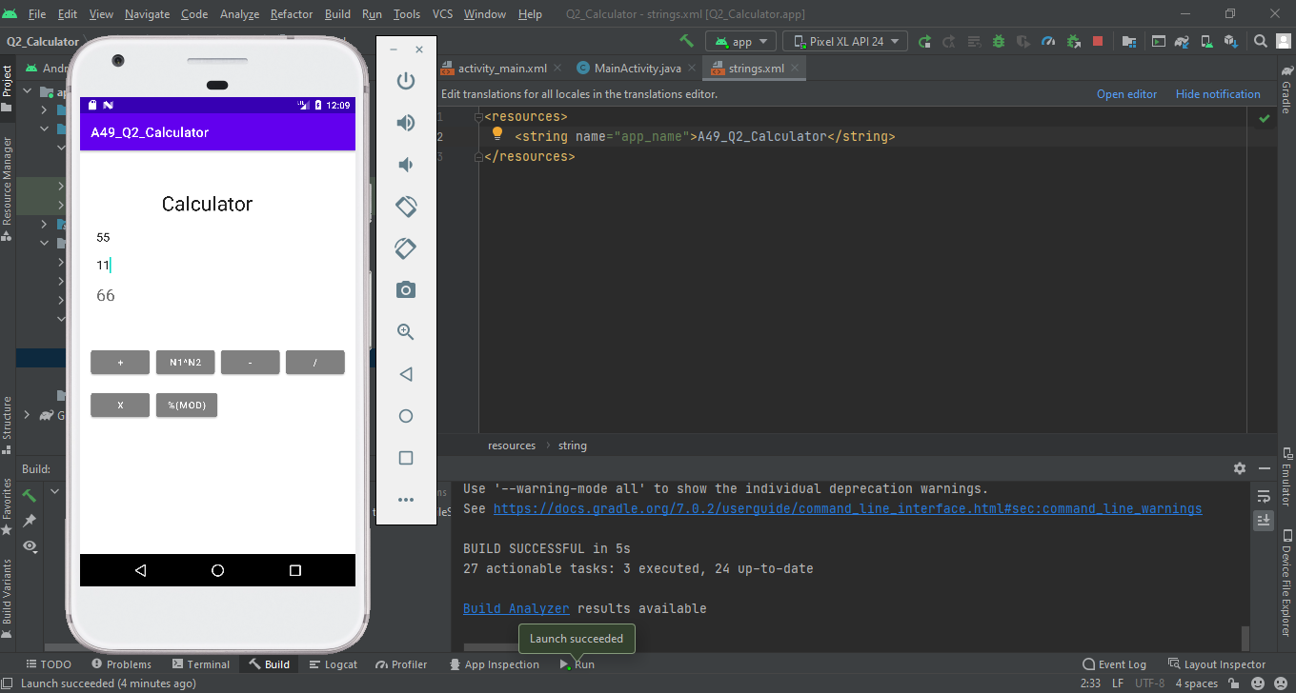

1. Develop an application for the login and registration form of a student using explicit intent. Add following widgets TextView, EditText, Button check box, radio button for accepting details of a Student such as name, address, class, division, state, gender, MCA score. Display student details n next activity.

**Code:**

**Activity_main.xml**

<?xml version="1.0" encoding="utf-8"?>  
<AbsoluteLayout xmlns:android="http://schemas.android.com/apk/res/android"  
 xmlns:app="http://schemas.android.com/apk/res-auto"  
 xmlns:tools="http://schemas.android.com/tools"  
 android:layout_width="match_parent"  
 android:layout_height="match_parent"  
 tools:context=".MainActivity">  
  
 <TextView  
 android:id="@+id/name_tv"  
 android:layout_width="wrap_content"  
 android:layout_height="wrap_content"  
 android:layout_marginStart="25dp"  
 android:layout_marginLeft="25dp"  
 android:layout_marginTop="111dp"  
 android:layout_marginEnd="37dp"  
 android:layout_marginRight="37dp"  
 android:layout_marginBottom="113dp"  
 android:layout_x="26dp"  
 android:layout_y="19dp"  
 android:text="Name :- "  
 android:textColor="@color/black"  
 android:textSize="18dp"  
 app:layout_constraintBottom_toTopOf="@+id/textView"  
 app:layout_constraintEnd_toStartOf="@+id/name"  
 app:layout_constraintStart_toStartOf="parent"  
 app:layout_constraintTop_toTopOf="parent" />  
  
 <EditText  
 android:id="@+id/name"  
 android:layout_width="223dp"  
 android:layout_height="wrap_content"  
 android:layout_marginTop="108dp"  
 android:layout_marginEnd="28dp"  
 android:layout_marginRight="28dp"  
 android:layout_marginBottom="98dp"  
 android:layout_x="136dp"  
 android:layout_y="13dp"  
 android:hint="Enter name"  
 android:textSize="15dp"  
 app:layout_constraintBottom_toTopOf="@+id/radioGroup"  
 app:layout_constraintEnd_toEndOf="parent"  
 app:layout_constraintStart_toEndOf="@+id/name_tv"  
 app:layout_constraintTop_toTopOf="parent" />  
  
 <TextView  
 android:id="@+id/textView"  
 android:layout_width="wrap_content"  
 android:layout_height="wrap_content"  
 android:layout_marginStart="25dp"  
 android:layout_marginLeft="25dp"  
 android:layout_marginEnd="28dp"  
 android:layout_marginRight="28dp"  
 android:layout_marginBottom="360dp"  
 android:layout_x="26dp"  
 android:layout_y="71dp"  
 android:text="Gendar :-"  
 android:textColor="@color/black"  
 android:textSize="18dp"  
 app:layout_constraintBottom_toBottomOf="parent"  
 app:layout_constraintEnd_toStartOf="@+id/radioGroup"  
 app:layout_constraintStart_toStartOf="parent"  
 app:layout_constraintTop_toBottomOf="@+id/name_tv" />  
 <RadioGroup  
 android:id="@+id/radioGroup"  
 android:layout_width="220dp"  
 android:layout_height="wrap_content"  
 android:layout_marginEnd="7dp"  
 android:layout_marginRight="7dp"  
 android:layout_marginBottom="195dp"  
 android:layout_x="138dp"  
 android:layout_y="58dp"  
 app:layout_constraintBottom_toTopOf="@+id/button"  
 app:layout_constraintEnd_toEndOf="parent"  
 app:layout_constraintStart_toEndOf="@+id/textView"  
 app:layout_constraintTop_toBottomOf="@+id/name">  
  
 <RadioButton  
 android:id="@+id/female"  
 android:layout_width="wrap_content"  
 android:layout_height="wrap_content"  
 android:layout_x="144dp"  
 android:layout_y="139dp"  
 android:text="Female"  
  
 tools:layout_editor_absoluteX="72dp"  
 tools:layout_editor_absoluteY="274dp" />  
  
 <RadioButton  
 android:id="@+id/male"  
 android:layout_width="wrap_content"  
 android:layout_height="wrap_content"  
 android:layout_x="144dp"  
 android:layout_y="139dp"  
 android:text="Male"  
 tools:layout_editor_absoluteX="72dp"  
 tools:layout_editor_absoluteY="274dp" />  
  
  
 </RadioGroup>  
  
 <TextView  
 android:id="@+id/textView1"  
 android:layout_width="wrap_content"  
 android:layout_height="wrap_content"  
 android:layout_marginStart="25dp"  
 android:layout_marginLeft="25dp"  
 android:layout_marginEnd="28dp"  
 android:layout_marginRight="28dp"  
 android:layout_marginBottom="360dp"  
 android:layout_x="32dp"  
 android:layout_y="175dp"  
 android:text="Class :-"  
 android:textColor="@color/black"  
 android:textSize="18dp" />  
  
 <RadioGroup  
 android:id="@+id/radioGroup1"  
 android:layout_width="219dp"  
 android:layout_height="wrap_content"  
 android:layout_marginEnd="7dp"  
 android:layout_marginRight="7dp"  
 android:layout_marginBottom="195dp"  
 android:layout_x="143dp"  
 android:layout_y="173dp"  
 app:layout_constraintBottom_toTopOf="@+id/button"  
 app:layout_constraintEnd_toEndOf="parent"  
 app:layout_constraintStart_toEndOf="@+id/textView"  
 app:layout_constraintTop_toBottomOf="@+id/name">  
  
 <RadioButton  
 android:id="@+id/FYMCA"  
 android:layout_width="wrap_content"  
 android:layout_height="wrap_content"  
 android:layout_x="144dp"  
 android:layout_y="139dp"  
 android:text="FYMCA"  
  
 tools:layout_editor_absoluteX="72dp"  
 tools:layout_editor_absoluteY="274dp" />  
  
 <RadioButton  
 android:id="@+id/SYMCA"  
 android:layout_width="wrap_content"  
 android:layout_height="wrap_content"  
 android:layout_x="144dp"  
 android:layout_y="139dp"  
 android:text="SYMCA"  
 tools:layout_editor_absoluteX="72dp"  
 tools:layout_editor_absoluteY="274dp" />  
  
 <RadioButton  
 android:id="@+id/TYMCA"  
 android:layout_width="wrap_content"  
 android:layout_height="wrap_content"  
 android:layout_x="144dp"  
 android:layout_y="139dp"  
 android:text="TYMCA"  
 tools:layout_editor_absoluteX="72dp"  
 tools:layout_editor_absoluteY="274dp" />  
  
 </RadioGroup>  
  
 <TextView  
 android:layout_width="wrap_content"  
 android:layout_height="wrap_content"  
 android:layout_x="29dp"  
 android:layout_y="329dp"  
 android:text="Address :-"  
 android:textColor="@color/black"  
 android:textSize="18dp" />  
  
 <EditText  
 android:id="@+id/address"  
 android:layout_width="223dp"  
 android:layout_height="94dp"  
 android:layout_x="141dp"  
 android:layout_y="321dp"  
 android:padding="30dp"  
 android:textSize="18dp"  
 />  
  
 <TextView  
 android:layout_width="wrap_content"  
 android:layout_height="wrap_content"  
 android:layout_x="31dp"  
 android:layout_y="427dp"  
 android:text="State :-"  
 android:textColor="@color/black"  
 android:textSize="18dp" />  
  
 <Spinner  
 android:id="@+id/state"  
 android:layout_width="219dp"  
 android:layout_height="wrap_content"  
 android:layout_x="144dp"  
 android:layout_y="429dp"  
 android:hint="@string/select_city"  
 android:textSize="18dp" />  
  
 <Button  
 android:id="@+id/button"  
 android:layout_width="wrap_content"  
 android:layout_height="wrap_content"  
 android:layout_marginStart="115dp"  
 android:layout_marginLeft="115dp"  
 android:layout_marginBottom="67dp"  
 android:layout_x="127dp"  
 android:layout_y="517dp"  
 android:onClick="register"  
 android:text="submit"  
 app:layout_constraintBottom_toBottomOf="parent"  
 app:layout_constraintStart_toStartOf="parent"  
 app:layout_constraintTop_toBottomOf="@+id/radioGroup" />  
  
  
</AbsoluteLayout>

**Activity_main2.xml**

<?xml version="1.0" encoding="utf-8"?>  
<AbsoluteLayout xmlns:android="http://schemas.android.com/apk/res/android"  
 xmlns:app="http://schemas.android.com/apk/res-auto"  
 xmlns:tools="http://schemas.android.com/tools"  
 android:layout_width="match_parent"  
 android:layout_height="match_parent"  
 tools:context=".MainActivity2">  
  
 <TextView  
 android:id="@+id/received_value"  
 android:layout_width="373dp"  
 android:layout_height="305dp"  
 android:layout_x="20dp"  
 android:layout_y="26dp"  
 android:textColor="@color/black"  
 android:textSize="20dp"  
 android:padding="20dp"  
 android:textStyle="bold" />  
  
 <Button  
 android:id="@+id/Button01"  
 android:layout_width="wrap_content"  
 android:layout_height="wrap_content"  
 android:layout_x="24dp"  
 android:layout_y="370dp"  
  
 android:text="back" />  
  
  
</AbsoluteLayout>

**MainActivity.java**

package com.example.q3_registerform;  
  
import androidx.appcompat.app.AppCompatActivity;  
  
import android.content.Intent;  
import android.os.Bundle;  
import android.view.View;  
import android.widget.AdapterView;  
import android.widget.ArrayAdapter;  
import android.widget.Button;  
import android.widget.DigitalClock;  
import android.widget.EditText;  
import android.widget.RadioButton;  
import android.widget.RadioGroup;  
import android.widget.Spinner;  
import android.widget.TextView;  
import android.widget.Toast;  
  
import java.io.Serializable;  
import java.util.Calendar;  
  
public class MainActivity extends AppCompatActivity implements AdapterView.OnItemSelectedListener{  
 Button submit_bt;  
 EditText name,address;  
 RadioButton male,female;  
 RadioGroup rg;  
 DigitalClock clock;  
 Spinner state;  
 StringBuffer add;  
  
 String[] state_name={"Andhra Pradesh","Assam","Bihar","Goa","Gujarat","Karnataka","Kerla","Maharashtra","Odisha","Punjab"};  
  
 @Override  
 protected void onCreate(Bundle savedInstanceState)  
 {  
 super.onCreate(savedInstanceState);  
 setContentView(R.layout.*activity_main*);  
  
 state= (Spinner) findViewById(R.id.*state*);  
 state.setOnItemSelectedListener((AdapterView.OnItemSelectedListener) this);  
  
 ArrayAdapter aa = new ArrayAdapter(this,android.R.layout.*simple_spinner_item*,state_name);  
 aa.setDropDownViewResource(android.R.layout.*simple_spinner_dropdown_item*);  
 //Setting the ArrayAdapter data on the Spinner  
 state.setAdapter(aa);  
  
  
 }//protected void onCreate(Bundle savedInstanceState)  
 @Override  
 public void onItemSelected(AdapterView<?> adapterView, View view, int i, long l) {  
 String select;  
 select=state_name[i];  
 StringBuffer addcity = new StringBuffer();  
 addcity.append("\nState :-");  
 addcity.append(select);  
 add=addcity;  
 }//public void onItemSelected(AdapterView<?> adapterView, View view, int i, long l)  
  
 @Override  
 public void onNothingSelected(AdapterView<?> adapterView) {  
  
 }  
  
  
  
  
 public void register(View view)  
 {  
  
 name=(EditText)findViewById(R.id.*name*);  
 address=(EditText)findViewById(R.id.*address*);  
 male=(RadioButton)findViewById(R.id.*male*);  
 female=(RadioButton)findViewById(R.id.*female*);  
  
 String getName=name.getText().toString();//to get value from editText  
 String getAddress=name.getText().toString();//to get value from editText  
  
 RadioGroup rg = (RadioGroup) findViewById(R.id.*radioGroup1*);  
 final String value = ((RadioButton)findViewById(rg.getCheckedRadioButtonId()))  
 .getText().toString();  
  
  
 StringBuffer info = new StringBuffer();  
 info.append("\nYour Information is :-\n");  
 info.append("Name :- ");  
  
 info.append(getName);  
  
 if(male.isChecked()==true){  
 info.append("\nGendar :- male");  
 }  
 if(female.isChecked()==true){  
 info.append("\nGendar :- female");  
 }  
 info.append("\nClass :- ");  
 info.append(value);  
 info.append("\nAddress :- ");  
 info.append(getName);  
 StringBuffer total_msg=info.append(add);  
 //Toast.makeText(MainActivity.this,total_msg.toString(),Toast.LENGTH_SHORT).show();  
  
 StringBuffer s=total_msg;  
 Intent i = new Intent(getApplicationContext(), MainActivity2.class);  
 i.putExtra("keyName", (Serializable) s);  
 startActivity(i);  
 }//public void register(View view)  
  
  
}

**MainActivity2.java**

package com.example.q3_registerform;  
  
import androidx.appcompat.app.AppCompatActivity;  
  
import android.content.Intent;  
import android.os.Bundle;  
import android.view.View;  
import android.widget.Button;  
import android.widget.TextView;  
  
public class MainActivity2 extends AppCompatActivity {  
  
 @Override  
 protected void onCreate(Bundle savedInstanceState) {  
 super.onCreate(savedInstanceState);  
 setContentView(R.layout.*activity_main2*);  
 Button button1 = (Button)findViewById(R.id.*Button01*);  
  
 TextView receiver_msg = (TextView) findViewById(R.id.*received_value*);  
 Intent intent = getIntent();  
 Bundle extras = intent.getExtras();  
 String str = extras.getString("keyName");  
  
 receiver_msg.setText(str);  
  
  
 button1.setOnClickListener(new View.OnClickListener() {  
 @Override  
 public void onClick(View view) {  
 Intent i = new Intent(getApplicationContext(), MainActivity.class);  
 startActivity(i);  
  
 }  
 });  
 }  
}

**Output:**

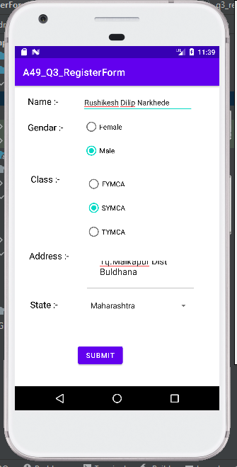

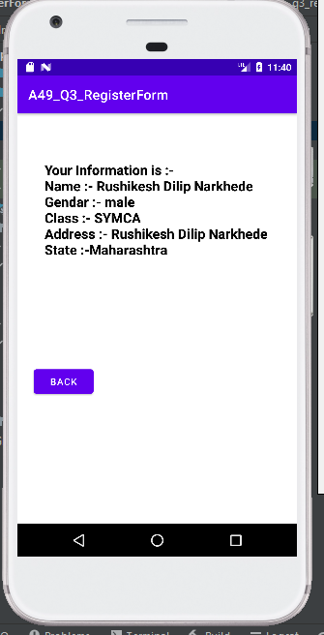

1. Develop an android application for accepting student’s hobbies and displaying information related to it. [Use Spinner for displaying hobbies].

**Code:**

**Activity_main.xml**

<?xml version="1.0" encoding="utf-8"?>  
<AbsoluteLayout xmlns:android="http://schemas.android.com/apk/res/android"  
 xmlns:app="http://schemas.android.com/apk/res-auto"  
 xmlns:tools="http://schemas.android.com/tools"  
 android:layout_width="match_parent"  
 android:layout_height="match_parent"  
 android:background="@color/white"  
 tools:context=".MainActivity">  
  
 <Spinner  
 android:id="@+id/spinner"  
 android:layout_width="197dp"  
 android:layout_height="35dp"  
 android:layout_x="202dp"  
 android:layout_y="65dp"  
 android:minHeight="48dp"  
 android:textColor="@color/black"  
 android:textSize="20dp"  
 android:textStyle="bold"  
 app:layout_constraintBottom_toBottomOf="parent"  
 app:layout_constraintEnd_toEndOf="parent"  
 app:layout_constraintHorizontal_bias="1.0"  
 app:layout_constraintStart_toStartOf="parent"  
 app:layout_constraintTop_toTopOf="parent"  
 app:layout_constraintVertical_bias="0.183"  
 tools:ignore="SpeakableTextPresentCheck,TouchTargetSizeCheck" />  
  
 <TextView  
 android:id="@+id/txt"  
 android:layout_width="295dp"  
 android:layout_height="358dp"  
 android:layout_x="41dp"  
 android:layout_y="186dp"  
 android:background="@drawable/boarder"  
 android:padding="20dp"  
 android:textAlignment="gravity"  
 android:textColor="@color/black"  
 android:textSize="15dp"  
 android:textStyle="bold"  
 app:layout_constraintBottom_toBottomOf="parent"  
 app:layout_constraintEnd_toEndOf="parent"  
 app:layout_constraintHorizontal_bias="0.473"  
 app:layout_constraintStart_toStartOf="parent"  
 app:layout_constraintTop_toTopOf="parent"  
 app:layout_constraintVertical_bias="0.827" />  
  
 <TextView  
 android:id="@+id/textView3"  
 android:layout_width="wrap_content"  
 android:layout_height="wrap_content"  
 android:layout_x="0dp"  
 android:layout_y="70dp"  
 android:text="Choose Your Hobby : "  
 android:textColor="@color/black"  
 android:textSize="20sp"  
 android:textStyle="bold"  
 app:layout_constraintBottom_toBottomOf="parent"  
 app:layout_constraintEnd_toEndOf="parent"  
 app:layout_constraintHorizontal_bias="0.164"  
 app:layout_constraintStart_toStartOf="parent"  
 app:layout_constraintTop_toTopOf="parent"  
 app:layout_constraintVertical_bias="0.122" />  
</AbsoluteLayout>

**MainActivity.java**

package com.example.q4_hobbies;  
  
import androidx.appcompat.app.AppCompatActivity;  
  
import android.os.Bundle;  
import android.view.View;  
import android.widget.AdapterView;  
import android.widget.ArrayAdapter;  
  
import android.widget.Spinner;  
import android.widget.TextView;  
import android.widget.Toast;  
  
public class MainActivity extends AppCompatActivity {  
 String []hobby={"---Select---","Writing","Photography","Cooking","Dance","Gardening","Drawing"};  
 TextView txt;  
 String st1,st2,st3,st4,st5,st6;  
  
 @Override  
 protected void onCreate(Bundle savedInstanceState) {  
 super.onCreate(savedInstanceState);  
 setContentView(R.layout.*activity_main*);  
  
 Spinner spin=findViewById(R.id.*spinner*);  
 ArrayAdapter aa=new ArrayAdapter(this,android.R.layout.*simple_spinner_dropdown_item*,hobby);  
 spin.setAdapter(aa);  
 txt=findViewById(R.id.*txt*);  
 spin.setOnItemSelectedListener(new AdapterView.OnItemSelectedListener() {  
 @Override  
 public void onItemSelected(AdapterView<?> adapterView, View view, int position, long l) {  
 st1="Writing is a medium of human communication that involves the representation of a language with written symbols. Writing systems are not themselves human languages (with the debatable exception of computer languages); they are means of rendering a language into a form that can be reconstructed by other humans separated by time and/or space.";  
 st2="Photography is the art, application, and practice of creating durable images by recording light, either electronically by means of an image sensor, or chemically by means of a light-sensitive material such as photographic film. It is employed in many fields of science, manufacturing (e.g., photolithography), and business, as well as its more direct uses for art, film and video production, recreational purposes, hobby, and mass communication.";  
 st3="Cooking, cookery, or culinary arts is the art, science, and craft of using heat to prepare food for consumption. Cooking techniques and ingredients vary widely, from grilling food over an open fire to using electric stoves, to baking in various types of ovens, reflecting local conditions. Types of cooking also depend on the skill levels and training of the cooks. Cooking is done both by people in their own dwellings and by professional cooks and chefs in restaurants and other food establishments.";  
 st4="Dance is a performing art form consisting of sequences of movement, either improvised or purposefully selected. This movement has aesthetic and often symbolic value. Dance can be categorized and described by its choreography, by its repertoire of movements, or by its historical period or place of origin.";  
 st5="Gardening is the practice of growing and cultivating plants as part of horticulture. In gardens, ornamental plants are often grown for their flowers, foliage, or overall appearance; useful plants, such as root vegetables, leaf vegetables, fruits, and herbs, are grown for consumption, for use as dyes, or for medicinal or cosmetic use.";  
 st6="Drawing is a form of visual art in which an artist uses instruments to mark paper or other two-dimensional surface. Drawing instruments include graphite pencils, pen and ink, various kinds of paints, inked brushes, colored pencils, crayons, charcoal, chalk, pastels, erasers, markers, styluses, and metals (such as silverpoint). Digital drawing is the act of drawing on graphics software in a computer. Common methods of digital drawing include a stylus or finger on a touchscreen device, stylus- or finger-to-touchpad, or in some cases, a mouse. There are many digital art programs and devices.";  
 String selectedItem = spin.getItemAtPosition(position).toString();  
 if (selectedItem.equals("---Select---")) {  
 txt.setText("");  
 }  
 if (selectedItem.equals("Writing")) {  
 txt.setText(st1);  
 }  
 if (selectedItem.equals("Photography")) {  
 txt.setText(st2);  
 }  
 if (selectedItem.equals("Cooking")) {  
 txt.setText(st3);  
 }  
 if (selectedItem.equals("Dance")) {  
 txt.setText(st4);  
 }  
 if (selectedItem.equals("Gardening")) {  
 txt.setText(st5);  
 }  
 if (selectedItem.equals("Drawing")) {  
 txt.setText(st6);  
 }  
  
 }  
 @Override  
 public void onNothingSelected(AdapterView<?> adapterView) {  
  
 }  
 });  
  
 }  
}

**Output:**

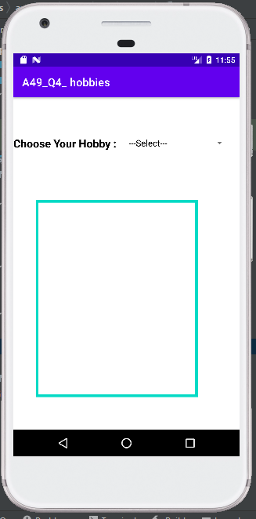

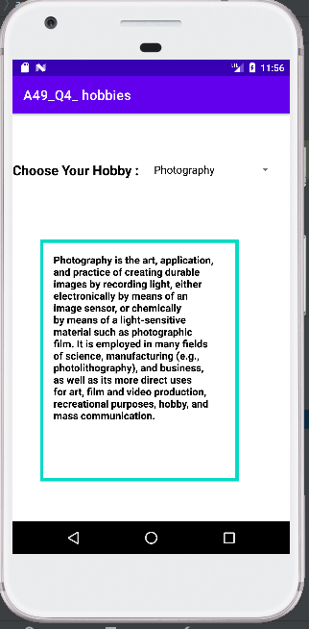

1. Develop an application for displaying images of movies and on click of image user should be able to give rating on that movie.

**Code:**

**Activity_main.xml**

<?xml version="1.0" encoding="utf-8"?>  
<AbsoluteLayout xmlns:android="http://schemas.android.com/apk/res/android"  
 xmlns:app="http://schemas.android.com/apk/res-auto"  
 xmlns:tools="http://schemas.android.com/tools"  
 android:layout_width="match_parent"  
 android:layout_height="match_parent"  
 tools:context=".MainActivity">  
  
  
  
 <ImageView  
 android:id="@+id/bolt"  
 android:layout_width="118dp"  
 android:layout_height="148dp"  
 android:layout_x="55dp"  
 android:layout_y="53dp"  
 android:tooltipText="Bolt"  
 app:srcCompat="@drawable/bolt" />  
  
 <ImageView  
 android:id="@+id/frozen"  
 android:layout_width="118dp"  
 android:layout_height="148dp"  
 android:layout_x="219dp"  
 android:layout_y="50dp"  
 app:srcCompat="@drawable/frozen" />  
  
 <ImageView  
 android:id="@+id/iceage"  
 android:layout_width="118dp"  
 android:layout_height="148dp"  
 android:layout_x="52dp"  
 android:layout_y="234dp"  
 app:srcCompat="@drawable/iceage" />  
  
 <ImageView  
 android:id="@+id/jumanji"  
 android:layout_width="118dp"  
 android:layout_height="148dp"  
 android:layout_x="219dp"  
 android:layout_y="235dp"  
 app:srcCompat="@drawable/jumanji" />  
  
 <TextView  
 android:id="@+id/textView"  
 android:layout_width="287dp"  
 android:layout_height="90dp"  
 android:layout_x="62dp"  
 android:layout_y="445dp"  
 android:textColor="@color/black"  
 android:textStyle="bold"  
 android:textSize="20dp" />  
</AbsoluteLayout>

**MainActivity.java**

package com.example.q5_ratingmovie;  
  
import androidx.appcompat.app.AlertDialog;  
import androidx.appcompat.app.AppCompatActivity;  
  
import android.content.DialogInterface;  
import android.os.Bundle;  
import android.view.View;  
import android.widget.ImageView;  
import android.widget.RatingBar;  
import android.widget.TextView;  
  
public class MainActivity extends AppCompatActivity implements View.OnClickListener{  
  
  
 ImageView bolt,frozen,iceage,jumanji;  
 TextView textView;  
 public String Add;  
 @Override  
 protected void onCreate(Bundle savedInstanceState) {  
 super.onCreate(savedInstanceState);  
 setContentView(R.layout.*activity_main*);  
  
 bolt=(ImageView)findViewById(R.id.*bolt*);  
 frozen=(ImageView)findViewById(R.id.*frozen*);  
 iceage=(ImageView)findViewById(R.id.*iceage*);  
 jumanji=(ImageView)findViewById(R.id.*jumanji*);  
  
 bolt.setOnClickListener(this);  
 frozen.setOnClickListener(this);  
 iceage.setOnClickListener(this);  
 jumanji.setOnClickListener(this);  
  
 textView = (TextView)findViewById(R.id.*textView*);  
 }  
  
 @Override  
 public void onClick(View v)  
 {  
 textView.setText("");  
 int id = v.getId();  
 /*switch (id)  
 {  
 case R.id.bolt:  
 Add="Your rating for Bolt is ";  
 case R.id.frozen:  
 Add="Your rating for frozen is ";  
 }*/  
 if(id==R.id.*bolt*){  
 Add="Your rating for Bolt is ";  
 }  
 if(id==R.id.*frozen*){  
 Add="Your rating for Frozen is ";  
 }if(id==R.id.*iceage*){  
 Add="Your rating for Ice Age is ";  
 }  
 if(id==R.id.*jumanji*){  
 Add="Your rating for Jumanji is ";  
 }  
  
  
 ShowDialog();  
  
 }//public void onClick(View view)  
  
 public void ShowDialog()  
 {  
 final AlertDialog.Builder popDialog = new AlertDialog.Builder(this);  
 RatingBar rating = new RatingBar(this);  
 popDialog.setIcon(android.R.drawable.*btn_star_big_on*);  
 popDialog.setTitle("Rate!! ");  
 popDialog.setView(rating);  
  
 // Button OK  
 popDialog.setPositiveButton(android.R.string.*ok*,  
 new DialogInterface.OnClickListener() {  
 public void onClick(DialogInterface dialog, int which) {  
 String ratingp=(String.*valueOf*(rating.getProgress()));  
 Add=Add+(ratingp);  
 textView.setText(Add);  
 dialog.dismiss();  
 }  
 })  
 .setNegativeButton("Cancel",  
 new DialogInterface.OnClickListener() {  
 public void onClick(DialogInterface dialog, int id) {  
 textView.setText("");  
 dialog.cancel();  
 }  
 });  
 popDialog.create();  
 popDialog.show();  
 }//public void ShowDialog()  
  
}

**Output:**

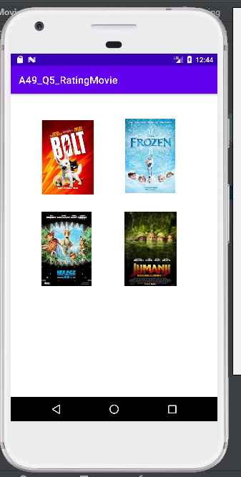

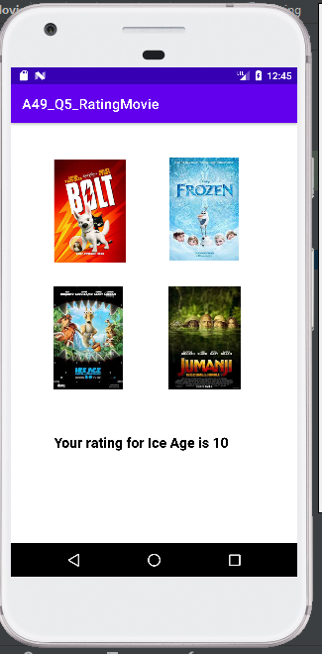

1. Write an android code to make phone call using Intent.

Code:

**MainActivity.java**

package com.example.makecall;  
  
import android.net.Uri;  
import android.os.Bundle;  
import android.app.Activity;  
import android.content.Intent;  
import android.view.Menu;  
import android.view.View;  
import android.view.View.OnClickListener;  
import android.widget.Button;  
import android.widget.EditText;  
  
public class MainActivity extends Activity {  
 EditText edittext1;  
 Button button1;  
 @Override  
 protected void onCreate(Bundle savedInstanceState) {  
 super.onCreate(savedInstanceState);  
 setContentView(R.layout.*activity_main*);  
  
 //Getting the edittext and button instance  
 edittext1=(EditText)findViewById(R.id.*editText1*);  
 button1=(Button)findViewById(R.id.*button1*);  
  
 //Performing action on button click  
 button1.setOnClickListener(new OnClickListener(){  
  
 @Override  
 public void onClick(View arg0) {  
// String number=edittext1.getText().toString();  
 Intent callIntent = new Intent(Intent.*ACTION_DIAL*);  
 callIntent.setData(Uri.*parse*("tel:"+edittext1.getText().toString()));  
 startActivity(callIntent);  
 }  
  
 });  
 }  
  
 @Override  
 public boolean onCreateOptionsMenu(Menu menu) {  
 // Inflate the menu; this adds items to the action bar if it is present.  
 getMenuInflater().inflate(R.menu.*activity_main*, menu);  
 return true;  
 }  
  
}

**AndroidMainfest.xml**

<?xml version="1.0" encoding="utf-8"?>  
<manifest xmlns:android="http://schemas.android.com/apk/res/android"  
 package="com.example.makecall" >  
 <uses-permission android:name="android.permission.MANAGE_OWN_CALLS"/>  
 <uses-permission android:name="android.permission.CALL_PHONE" />  
 <application  
 android:allowBackup="true"  
 android:icon="@mipmap/ic_launcher"  
 android:label="@string/app_name"  
 android:roundIcon="@mipmap/ic_launcher_round"  
 android:supportsRtl="true"  
 android:theme="@style/Theme.Makecall" >  
 <activity  
 android:name=".MainActivity"  
 android:exported="true" >  
 <intent-filter>  
 <action android:name="android.intent.action.MAIN" />  
  
 <category android:name="android.intent.category.LAUNCHER" />  
 </intent-filter>  
 </activity>  
 </application>  
  
</manifest>

**activity_main.xml**

<?xml version="1.0" encoding="utf-8"?>  
<androidx.constraintlayout.widget.ConstraintLayout  
 xmlns:android="http://schemas.android.com/apk/res/android"  
 xmlns:tools="http://schemas.android.com/tools"  
 xmlns:app="http://schemas.android.com/apk/res-auto"  
 android:layout_width="match_parent"  
 android:layout_height="match_parent"  
 tools:context=".MainActivity">  
  
 <EditText  
 android:id="@+id/editText1"  
 android:layout_width="wrap_content"  
 android:layout_height="wrap_content"  
 android:layout_marginTop="40dp"  
 android:ems="10"  
 android:hint="Enter phone number"  
 android:inputType="textPersonName"  
 android:text=""  
 android:textColor="#0B9711"  
 android:textSize="34sp"  
 app:layout_constraintEnd_toEndOf="parent"  
 app:layout_constraintHorizontal_bias="0.497"  
 app:layout_constraintStart_toStartOf="parent"  
 app:layout_constraintTop_toBottomOf="@+id/textView" />  
  
 <Button  
 android:id="@+id/button1"  
 android:layout_width="wrap_content"  
 android:layout_height="wrap_content"  
 android:layout_marginTop="100dp"  
 android:text="call"  
 android:textColor="#0E9A14"  
 android:textColorHighlight="#19971E"  
 android:textSize="24sp"  
 app:layout_constraintBottom_toBottomOf="parent"  
 app:layout_constraintEnd_toEndOf="parent"  
 app:layout_constraintHorizontal_bias="0.498"  
 app:layout_constraintStart_toStartOf="parent"  
 app:layout_constraintTop_toBottomOf="@+id/editText1"  
 app:layout_constraintVertical_bias="0.0" />  
  
 <TextView  
 android:id="@+id/textView"  
 android:layout_width="wrap_content"  
 android:layout_height="wrap_content"  
 android:layout_marginTop="112dp"  
 android:text="Dial Call"  
 android:textColor="#14C11B"  
 android:textSize="34sp"  
 android:textStyle="bold"  
 app:layout_constraintEnd_toEndOf="parent"  
 app:layout_constraintHorizontal_bias="0.498"  
 app:layout_constraintStart_toStartOf="parent"  
 app:layout_constraintTop_toTopOf="parent" />  
</androidx.constraintlayout.widget.ConstraintLayout>

OUTPUT:

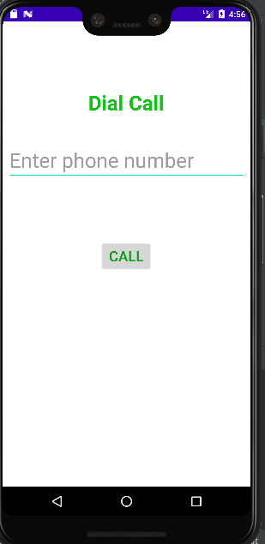

1. Write an android code to turn ON/OFF Bluetooth.

Code:

**MainActivity.java**

package com.rushikeshnarkhede.bluetooth;  
  
import androidx.appcompat.app.AppCompatActivity;  
  
import android.os.Bundle;  
  
import android.bluetooth.BluetoothAdapter;  
import android.content.Intent;  
import android.view.View;  
import android.widget.Button;  
import android.widget.Toast;  
  
public class MainActivity extends AppCompatActivity {  
 @Override  
 protected void onCreate(Bundle savedInstanceState) {  
 super.onCreate(savedInstanceState);  
 setContentView(R.layout.*activity_main*);  
 Button btntOn = (Button)findViewById(R.id.*btnOn*);  
 Button btntOff = (Button)findViewById(R.id.*btnOFF*);  
 final BluetoothAdapter bAdapter = BluetoothAdapter.*getDefaultAdapter*();  
 btntOn.setOnClickListener(new View.OnClickListener() {  
 @Override  
 public void onClick(View v) {  
 if(bAdapter == null)  
 {  
 Toast.*makeText*(getApplicationContext(),"Bluetooth Not Supported",Toast.*LENGTH_SHORT*).show();  
 }  
 else{  
 if(!bAdapter.isEnabled()){  
 startActivityForResult(new Intent(BluetoothAdapter.*ACTION_REQUEST_ENABLE*),1);  
 Toast.*makeText*(getApplicationContext(),"Bluetooth Turned ON",Toast.*LENGTH_SHORT*).show();  
 }  
 }  
 }  
 });  
 btntOff.setOnClickListener(new View.OnClickListener() {  
 @Override  
 public void onClick(View v) {  
 bAdapter.disable();  
 Toast.*makeText*(getApplicationContext(),"Bluetooth Turned OFF", Toast.*LENGTH_SHORT*).show();  
 }  
 });  
 }  
}

**AndroidMainfest.xml**

<?xml version="1.0" encoding="utf-8"?>  
<manifest xmlns:android="http://schemas.android.com/apk/res/android"  
 package="com.rushikeshnarkhede.bluetooth">  
  
 <uses-permission android:name="android.permission.BLUETOOTH"/>  
 <uses-permission android:name="android.permission.BLUETOOTH_ADMIN"/>  
 <uses-permission android:name="android.permission.ACCESS_COARSE_LOCATION"/>  
 <uses-permission android:name="android.permission.BLUETOOTH_CONNECT" />  
  
 <application  
 android:allowBackup="true"  
 android:icon="@mipmap/ic_launcher"  
 android:label="@string/app_name"  
 android:roundIcon="@mipmap/ic_launcher_round"  
 android:supportsRtl="true"  
 android:theme="@style/Theme.Bluetooth">  
 <activity  
 android:name=".MainActivity"  
 android:exported="true">  
 <intent-filter>  
 <action android:name="android.intent.action.MAIN" />  
  
 <category android:name="android.intent.category.LAUNCHER" />  
 </intent-filter>  
 </activity>  
 </application>  
  
</manifest>

**activity_main.xml**

<?xml version="1.0" encoding="utf-8"?>  
<androidx.constraintlayout.widget.ConstraintLayout xmlns:android="http://schemas.android.com/apk/res/android"  
 xmlns:app="http://schemas.android.com/apk/res-auto"  
 xmlns:tools="http://schemas.android.com/tools"  
 android:layout_width="match_parent"  
 android:layout_height="match_parent"  
 tools:context=".MainActivity">  
  
 <Button  
 android:id="@+id/btnOn"  
 android:layout_width="wrap_content"  
 android:layout_height="wrap_content"  
 android:text="Turn On"  
 app:layout_constraintBottom_toBottomOf="parent"  
 app:layout_constraintEnd_toEndOf="parent"  
 app:layout_constraintHorizontal_bias="0.519"  
 app:layout_constraintStart_toStartOf="parent"  
 app:layout_constraintTop_toTopOf="parent"  
 app:layout_constraintVertical_bias="0.221" />  
  
 <Button  
 android:id="@+id/btnOFF"  
 android:layout_width="wrap_content"  
 android:layout_height="wrap_content"  
 android:layout_alignBottom="@+id/btnOn"  
 android:layout_toRightOf="@+id/btnOn"  
 android:text="Turn OFF"  
 app:layout_constraintBottom_toBottomOf="parent"  
 app:layout_constraintEnd_toEndOf="parent"  
 app:layout_constraintHorizontal_bias="0.532"  
 app:layout_constraintStart_toStartOf="parent"  
 app:layout_constraintTop_toTopOf="parent"  
 app:layout_constraintVertical_bias="0.349" />  
  
</androidx.constraintlayout.widget.ConstraintLayout>

OUTPUT:

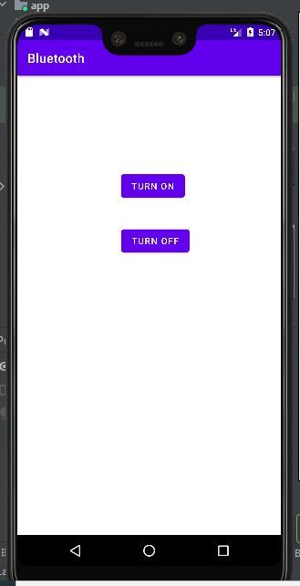

1. Write an android code to turn ON /OFF the Wi-Fi.

Code:

**MainActivity.java**

package com.rushikeshnarkhede.wifi;  
  
import androidx.appcompat.app.AppCompatActivity;  
  
import android.os.Bundle;  
  
import android.content.Context;  
import android.net.wifi.WifiManager;  
import android.widget.CompoundButton;  
import android.widget.TextView;  
import android.widget.ToggleButton;  
  
public class MainActivity extends AppCompatActivity {  
  
 ToggleButton toggleButton;  
 TextView textView;  
  
 @Override  
 protected void onCreate(Bundle savedInstanceState) {  
 super.onCreate(savedInstanceState);  
 setContentView(R.layout.*activity_main*);  
  
 // Getting toggle button and textView from activity_main  
 toggleButton = (ToggleButton) findViewById(R.id.*toggleButton*);  
 textView = (TextView) findViewById(R.id.*textView*);  
  
 // Put listener on toggle button  
 toggleButton.setOnCheckedChangeListener(new CompoundButton.OnCheckedChangeListener() {  
 @Override  
 public void onCheckedChanged(CompoundButton compoundButton, boolean checked) {  
 if (checked) {  
 textView.setText("WiFi is ON");  
 WifiManager wifi = (WifiManager) getApplicationContext().getSystemService(Context.*WIFI_SERVICE*);  
 wifi.setWifiEnabled(true);  
 } else {  
 textView.setText("WiFi is OFF");  
 WifiManager wifi = (WifiManager) getApplicationContext().getSystemService(Context.*WIFI_SERVICE*);  
 wifi.setWifiEnabled(false);  
 }  
 }  
 });  
 // For initial setting  
 if (toggleButton.isChecked()) {  
 textView.setText("WiFi is ON");  
 WifiManager wifi = (WifiManager) getApplicationContext().getSystemService(Context.*WIFI_SERVICE*);  
 wifi.setWifiEnabled(true);  
 } else {  
 textView.setText("WiFi is OFF");  
 WifiManager wifi = (WifiManager) getApplicationContext().getSystemService(Context.*WIFI_SERVICE*);  
 wifi.setWifiEnabled(false);  
 }  
 }  
}

**AndroidMainfest.xml**

<?xml version="1.0" encoding="utf-8"?>  
<manifest xmlns:android="http://schemas.android.com/apk/res/android"  
 package="com.rushikeshnarkhede.wifi">  
  
 <uses-permission android:name="android.permission.ACCESS_WIFI_STATE"/>  
 <uses-permission android:name="android.permission.CHANGE_WIFI_STATE"/>  
  
 <application  
 android:allowBackup="true"  
 android:icon="@mipmap/ic_launcher"  
 android:label="@string/app_name"  
 android:roundIcon="@mipmap/ic_launcher_round"  
 android:supportsRtl="true"  
 android:theme="@style/Theme.WiFi">  
 <activity  
 android:name=".MainActivity"  
 android:exported="true">  
 <intent-filter>  
 <action android:name="android.intent.action.MAIN" />  
  
 <category android:name="android.intent.category.LAUNCHER" />  
 </intent-filter>  
 </activity>  
 </application>  
  
</manifest>

**activity_main.xml**

<?xml version="1.0" encoding="utf-8"?>  
<LinearLayout xmlns:android="http://schemas.android.com/apk/res/android"  
 android:layout_width="match_parent"  
 android:layout_height="match_parent"  
 android:layout_margin="16dp"  
 android:gravity="center"  
 android:orientation="vertical">  
  
 <ToggleButton  
 android:id="@+id/toggleButton"  
 android:layout_width="wrap_content"  
 android:layout_height="wrap_content"  
 android:checked="false"  
 />  
  
 <TextView  
 android:id="@+id/textView"  
 android:layout_width="wrap_content"  
 android:layout_height="wrap_content"  
 android:layout_marginTop="16dp"  
 />  
  
</LinearLayout>

OUTPUT:

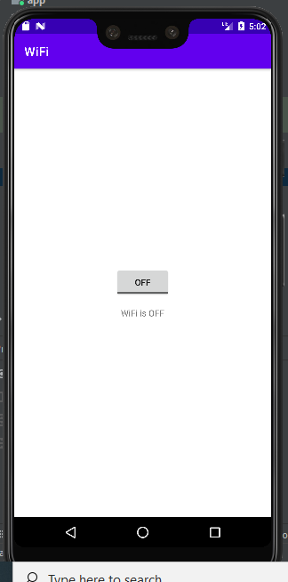

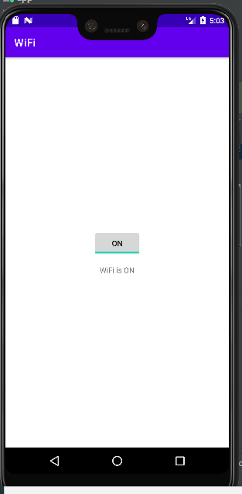

1. Design android application for login activity. Write android code to check login credentials with username = "mca" and password = "android". Display appropriate toast message to the user.

Code:

**MainActivity.java**

package com.rushikeshnarkhede.login;  
  
import androidx.appcompat.app.AppCompatActivity;  
  
import android.os.Bundle;  
import android.text.TextUtils;  
import android.view.View;  
import android.widget.Button;  
import android.widget.EditText;  
import android.widget.Toast;  
  
public class MainActivity extends AppCompatActivity {  
 EditText username,password;  
 Button button;  
 String correct_username="mca";  
 String correct_password="android";  
  
  
 @Override  
 protected void onCreate(Bundle savedInstanceState) {  
 super.onCreate(savedInstanceState);  
 setContentView(R.layout.*activity_main*);  
  
 username=findViewById(R.id.*username*);  
 password=findViewById(R.id.*password*);  
 button=findViewById(R.id.*button*);  
  
 button.setOnClickListener(new View.OnClickListener() {  
 @Override  
 public void onClick(View view) {  
  
 if(TextUtils.*isEmpty*(username.getText().toString()) || TextUtils.*isEmpty*(password.getText().toString())){  
 Toast.*makeText*(MainActivity.this, "Empty data provided",Toast.*LENGTH_LONG*).show();  
 }else if(username.getText().toString().equals(correct_username)){  
 if(password.getText().toString().equals(correct_password)){  
 Toast.*makeText*(MainActivity.this, "Success Login",Toast.*LENGTH_LONG*).show();  
 }else{  
 Toast.*makeText*(MainActivity.this, "Invalid Login",Toast.*LENGTH_LONG*).show();  
  
 }  
  
 }else{  
 Toast.*makeText*(MainActivity.this, "Invalid Username/Password",Toast.*LENGTH_LONG*).show();  
  
 }  
  
 }  
 });  
 }  
}

**AndroidMainfest.xml**

<?xml version="1.0" encoding="utf-8"?>  
<manifest xmlns:android="http://schemas.android.com/apk/res/android"  
 package="com.rushikeshnarkhede.login">  
  
 <application  
 android:allowBackup="true"  
 android:icon="@mipmap/ic_launcher"  
 android:label="@string/app_name"  
 android:roundIcon="@mipmap/ic_launcher_round"  
 android:supportsRtl="true"  
 android:theme="@style/Theme.Login">  
 <activity  
 android:name=".MainActivity"  
 android:exported="true">  
 <intent-filter>  
 <action android:name="android.intent.action.MAIN" />  
  
 <category android:name="android.intent.category.LAUNCHER" />  
 </intent-filter>  
 </activity>  
 </application>  
  
</manifest>

**activity_main.xml**

<?xml version="1.0" encoding="utf-8"?>  
<androidx.constraintlayout.widget.ConstraintLayout xmlns:android="http://schemas.android.com/apk/res/android"  
 xmlns:app="http://schemas.android.com/apk/res-auto"  
 xmlns:tools="http://schemas.android.com/tools"  
 android:layout_width="match_parent"  
 android:layout_height="match_parent"  
 android:background="@drawable/img8"  
 tools:context=".MainActivity">  
  
 <EditText  
 android:id="@+id/username"  
 android:layout_width="272dp"  
 android:layout_height="58dp"  
 android:ems="10"  
 android:hint="Username"  
 android:inputType="textPersonName"  
 app:layout_constraintBottom_toBottomOf="parent"  
 app:layout_constraintEnd_toEndOf="parent"  
 app:layout_constraintHorizontal_bias="0.496"  
 app:layout_constraintStart_toStartOf="parent"  
 app:layout_constraintTop_toTopOf="parent"  
 app:layout_constraintVertical_bias="0.148" />  
  
 <EditText  
 android:id="@+id/password"  
 android:layout_width="279dp"  
 android:layout_height="67dp"  
 android:ems="10"  
 android:hint="Password"  
 android:inputType="textPersonName"  
 app:layout_constraintBottom_toBottomOf="parent"  
 app:layout_constraintEnd_toEndOf="parent"  
 app:layout_constraintHorizontal_bias="0.522"  
 app:layout_constraintStart_toStartOf="parent"  
 app:layout_constraintTop_toTopOf="parent"  
 app:layout_constraintVertical_bias="0.266" />  
  
 <Button  
 android:id="@+id/button"  
 android:layout_width="134dp"  
 android:layout_height="63dp"  
 android:text="LOGIN"  
 app:layout_constraintBottom_toBottomOf="parent"  
 app:layout_constraintEnd_toEndOf="parent"  
 app:layout_constraintHorizontal_bias="0.498"  
 app:layout_constraintStart_toStartOf="parent"  
 app:layout_constraintTop_toBottomOf="@+id/password"  
 app:layout_constraintVertical_bias="0.346" />  
</androidx.constraintlayout.widget.ConstraintLayout>

OUTPUT:

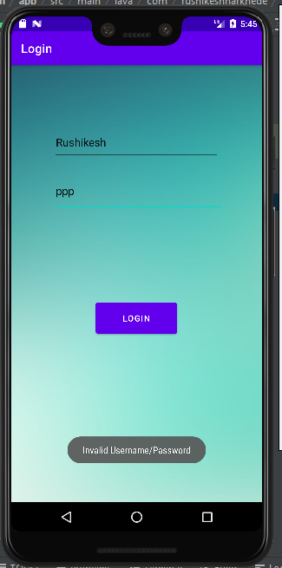

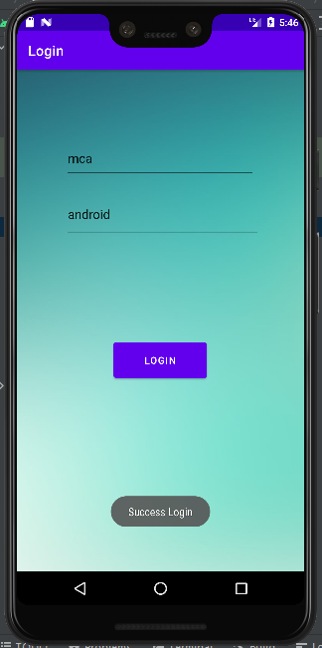

1. Create a fragment that has its own UI and enable your activities to communicate with fragments.

Code:

**MainActivity.java**

package com.rushikeshnarkhede.fragments;  
  
import androidx.appcompat.app.AppCompatActivity;  
  
import android.os.Bundle;  
  
public class MainActivity extends AppCompatActivity implements FragmentA.FragmentAListener, FragmentB.FragmentBListener {  
 private FragmentA fragmentA = new FragmentA();  
 private FragmentB fragmentB;  
  
 @Override  
 protected void onCreate(Bundle savedInstanceState) {  
 super.onCreate(savedInstanceState);  
 setContentView(R.layout.*activity_main*);  
  
 fragmentB = new FragmentB();  
  
 getSupportFragmentManager().beginTransaction()  
 .replace(R.id.*container_a*, fragmentA)  
 .replace(R.id.*container_b*, fragmentB)  
 .commit();  
 }  
  
 @Override  
 public void onInputASent(CharSequence input) {  
 fragmentB.updateEditText(input);  
 }  
  
 @Override  
 public void onInputBSent(CharSequence input) {  
 fragmentA.updateEditText(input);  
 }  
}

**AndroidMainfest.xml**

<?xml version="1.0" encoding="utf-8"?>  
<manifest xmlns:android="http://schemas.android.com/apk/res/android"  
 package="com.rushikeshnarkhede.fragments">  
  
 <application  
 android:allowBackup="true"  
 android:icon="@mipmap/ic_launcher"  
 android:label="@string/app_name"  
 android:roundIcon="@mipmap/ic_launcher_round"  
 android:supportsRtl="true"  
 android:theme="@style/Theme.Fragments">  
 <activity  
 android:name=".MainActivity"  
 android:exported="true">  
 <intent-filter>  
 <action android:name="android.intent.action.MAIN" />  
  
 <category android:name="android.intent.category.LAUNCHER" />  
 </intent-filter>  
 </activity>  
 </application>  
  
</manifest>

**activity_main.xml**

<?xml version="1.0" encoding="utf-8"?>  
<LinearLayout xmlns:android="http://schemas.android.com/apk/res/android"  
 xmlns:app="http://schemas.android.com/apk/res-auto"  
 xmlns:tools="http://schemas.android.com/tools"  
 android:layout_width="match_parent"  
 android:layout_height="match_parent"  
 android:orientation="vertical"  
 tools:context=".MainActivity">  
  
 <FrameLayout  
 android:id="@+id/container_a"  
 android:layout_width="match_parent"  
 android:layout_height="wrap_content" />  
  
 <FrameLayout  
 android:id="@+id/container_b"  
 android:layout_width="match_parent"  
 android:layout_height="wrap_content" />  
  
</LinearLayout>

OUTPUT:

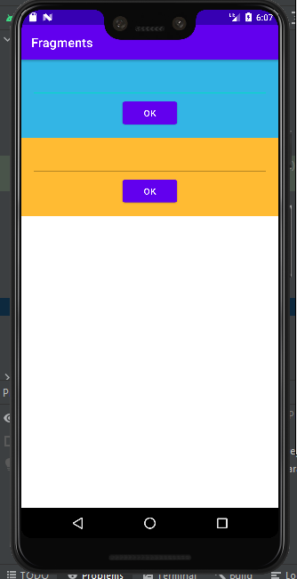

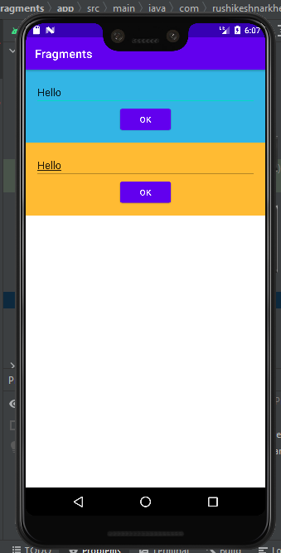

1. Demonstrate Array Adapter using List View to display list of fruits.

Code:

**MainActivity.java**

package com.rushikeshnarkhede.listviewimage;  
  
import androidx.appcompat.app.AppCompatActivity;  
  
import android.os.Bundle;  
  
import android.app.Activity;  
import android.view.LayoutInflater;  
import android.view.View;  
import android.view.ViewGroup;  
import android.widget.ArrayAdapter;  
import android.widget.ImageView;  
import android.widget.ListView;  
import android.widget.TextView;  
  
public class MainActivity extends AppCompatActivity {  
 ListView lv;  
 private android.widget.Toast Toast;  
  
 @Override  
 protected void onCreate(Bundle savedInstanceState) {  
 super.onCreate(savedInstanceState);  
 setContentView(R.layout.*activity_main*);  
 lv=findViewById(R.id.*lv*);  
  
 String []name={"Apple","Banana","Grapes","Strawberry","Pomegranate"};  
 Integer[]img={R.drawable.*ap*,R.drawable.*bn*,R.drawable.*gp1*,R.drawable.*st*,R.drawable.*po*};  
  
 MyListAdapter adapter=new MyListAdapter(this, name,img);  
 lv.setAdapter(adapter);  
  
 }  
 public void displayToast(View lv){  
 Toast.*makeText*(MainActivity.this,"Welcome to the App",Toast.*LENGTH_SHORT*).show();  
 }  
  
 public class MyListAdapter extends ArrayAdapter<String> {  
  
 private final Activity context;  
 private final String[] name;  
 private final Integer[] img;  
  
 public MyListAdapter(Activity context, String[] name,Integer[] img) {  
 super(context, R.layout.*customlist*, name);  
 // *TODO Auto-generated constructor stub* this.context=context;  
 this.img = img;  
 this.name=name;  
 }  
  
 public View getView(int position, View view, ViewGroup parent) {  
 LayoutInflater inflater=context.getLayoutInflater();  
 View rowView=inflater.inflate(R.layout.*customlist*, null,true);  
  
 TextView titleText = (TextView) rowView.findViewById(R.id.*title*);  
 ImageView imageView = (ImageView) rowView.findViewById(R.id.*icon*);  
  
 titleText.setText(name[position]);  
 imageView.setImageResource(img[position]);  
  
 return rowView;  
  
 };  
 }  
  
}

**AndroidMainfest.xml**

<?xml version="1.0" encoding="utf-8"?>  
<manifest xmlns:android="http://schemas.android.com/apk/res/android"  
 package="com.rushikeshnarkhede.listviewimage">  
  
 <application  
 android:allowBackup="true"  
 android:icon="@mipmap/ic_launcher"  
 android:label="@string/app_name"  
 android:roundIcon="@mipmap/ic_launcher_round"  
 android:supportsRtl="true"  
 android:theme="@style/Theme.ListViewImage">  
 <activity  
 android:name=".MainActivity"  
 android:exported="true">  
 <intent-filter>  
 <action android:name="android.intent.action.MAIN" />  
  
 <category android:name="android.intent.category.LAUNCHER" />  
 </intent-filter>  
 </activity>  
 </application>  
  
</manifest>

**activity_main.xml**

<?xml version="1.0" encoding="utf-8"?>  
<androidx.constraintlayout.widget.ConstraintLayout xmlns:android="http://schemas.android.com/apk/res/android"  
 xmlns:app="http://schemas.android.com/apk/res-auto"  
 xmlns:tools="http://schemas.android.com/tools"  
 android:layout_width="match_parent"  
 android:layout_height="match_parent"  
 tools:context=".MainActivity">  
  
 <ListView  
 android:id="@+id/lv"  
 android:layout_width="match_parent"  
 android:layout_height="match_parent">  
 android:onClick="onClick"  
 android:text="Click"  
 </ListView>  
</androidx.constraintlayout.widget.ConstraintLayout>

OUTPUT:

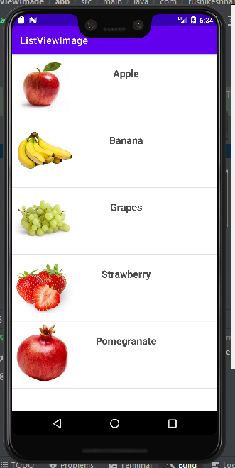

1. Write an application to demonstrate Alert Dialog Box in android.

Code:

**MainActivity.java**

package com.rushikeshnarkhede.alert;  
  
import androidx.appcompat.app.AppCompatActivity;  
import android.os.Bundle;  
import android.view.View;  
import android.widget.Button;  
import android.app.AlertDialog;  
import android.widget.Toast;  
import android.content.DialogInterface;  
  
  
public class MainActivity extends AppCompatActivity {  
 Button closeButton;  
 AlertDialog.Builder builder;  
 @Override  
 protected void onCreate(Bundle savedInstanceState) {  
 super.onCreate(savedInstanceState);  
 setContentView(R.layout.*activity_main*);  
  
 closeButton = (Button) findViewById(R.id.*button*);  
 builder = new AlertDialog.Builder(this);  
 closeButton.setOnClickListener(new View.OnClickListener() {  
 @Override  
 public void onClick(View v) {  
  
 //Uncomment the below code to Set the message and title from the strings.xml file  
 builder.setMessage(R.string.*dialog_message*) .setTitle(R.string.*dialog_title*);  
  
 //Setting message manually and performing action on button click  
 builder.setMessage("Do you want to close this application ?")  
 .setCancelable(false)  
 .setPositiveButton("Yes", new DialogInterface.OnClickListener() {  
 public void onClick(DialogInterface dialog, int id) {  
 finish();  
 Toast.*makeText*(getApplicationContext(),"you choose yes action for alertbox",  
 Toast.*LENGTH_SHORT*).show();  
 }  
 })  
 .setNegativeButton("No", new DialogInterface.OnClickListener() {  
 public void onClick(DialogInterface dialog, int id) {  
 // Action for 'NO' Button  
 dialog.cancel();  
 Toast.*makeText*(getApplicationContext(),"you choose no action for alertbox",  
 Toast.*LENGTH_SHORT*).show();  
 }  
 });  
 //Creating dialog box  
 AlertDialog alert = builder.create();  
 //Setting the title manually  
 alert.setTitle("AlertDialogExample");  
 alert.show();  
 }  
 });  
 }  
}

**AndroidMainfest.xml**

<?xml version="1.0" encoding="utf-8"?>  
<manifest xmlns:android="http://schemas.android.com/apk/res/android"  
 package="com.rushikeshnarkhede.alert">  
  
 <application  
 android:allowBackup="true"  
 android:icon="@mipmap/ic_launcher"  
 android:label="@string/app_name"  
 android:roundIcon="@mipmap/ic_launcher_round"  
 android:supportsRtl="true"  
 android:theme="@style/Theme.Alert">  
 <activity  
 android:name=".MainActivity"  
 android:exported="true">  
 <intent-filter>  
 <action android:name="android.intent.action.MAIN" />  
  
 <category android:name="android.intent.category.LAUNCHER" />  
 </intent-filter>  
 </activity>  
 </application>  
  
</manifest>

**activity_main.xml**

<?xml version="1.0" encoding="utf-8"?>  
<androidx.constraintlayout.widget.ConstraintLayout xmlns:android="http://schemas.android.com/apk/res/android"  
 xmlns:app="http://schemas.android.com/apk/res-auto"  
 xmlns:tools="http://schemas.android.com/tools"  
 android:layout_width="match_parent"  
 android:layout_height="match_parent"  
 tools:context=".MainActivity">  
  
 <Button  
 android:id="@+id/button"  
 android:layout_width="wrap_content"  
 android:layout_height="wrap_content"  
 android:text="CLICK HERE"  
 app:layout_constraintBottom_toBottomOf="parent"  
 app:layout_constraintLeft_toLeftOf="parent"  
 app:layout_constraintRight_toRightOf="parent"  
 app:layout_constraintTop_toTopOf="parent" />  
</androidx.constraintlayout.widget.ConstraintLayout>

OUTPUT:

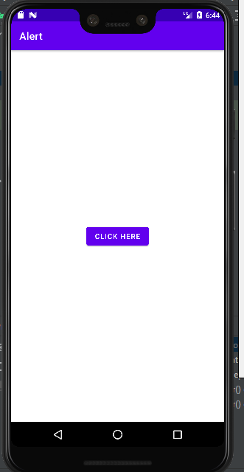

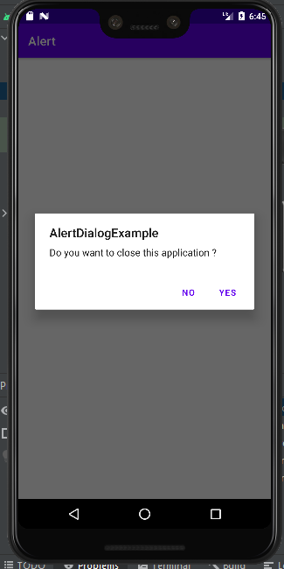

1. Write a program to demonstrate Options Menu in android for a restaurant and display appropriate message related to the dish user has opted from the menu on text field.

Code:

**MainActivity.java**

package com.rushikeshnarkhede.menuapp;  
  
import androidx.appcompat.app.AppCompatActivity;  
  
import android.os.Bundle;  
  
import android.view.Menu;  
import android.view.MenuInflater;  
import android.view.MenuItem;  
import android.widget.Toast;  
  
public class MainActivity extends AppCompatActivity {  
  
 @Override  
 protected void onCreate(Bundle savedInstanceState) {  
 super.onCreate(savedInstanceState);  
 setContentView(R.layout.*activity_main*);  
  
 }  
  
 @Override  
 public boolean onCreateOptionsMenu(Menu menu){  
  
 MenuInflater inflater=getMenuInflater();  
 inflater.inflate(R.menu.*menu*,menu);  
 return true;  
 }  
  
 @Override  
 public boolean onOptionsItemSelected(MenuItem item){  
 switch (item.getItemId()){  
 case R.id.*itemone*:  
 Toast.*makeText*(this, "Lachha paratha", Toast.*LENGTH_SHORT*).show();  
 return true;  
  
 case R.id.*itemTwo*:  
 Toast.*makeText*(this, "Paneer butter masala", Toast.*LENGTH_SHORT*).show();  
 return true;  
  
 case R.id.*itemThree*:  
 Toast.*makeText*(this, "Veg manchurian", Toast.*LENGTH_SHORT*).show();  
 return true;  
  
 default:  
 return super.onOptionsItemSelected(item);  
  
 }  
  
 }  
  
}

**AndroidMainfest.xml**

<?xml version="1.0" encoding="utf-8"?>  
<manifest xmlns:android="http://schemas.android.com/apk/res/android"  
 package="com.rushikeshnarkhede.menuapp">  
  
 <application  
 android:allowBackup="true"  
 android:icon="@mipmap/ic_launcher"  
 android:label="@string/app_name"  
 android:roundIcon="@mipmap/ic_launcher_round"  
 android:supportsRtl="true"  
 android:theme="@style/Theme.MenuApp">  
 <activity  
 android:name=".MainActivity"  
 android:exported="true">  
 <intent-filter>  
 <action android:name="android.intent.action.MAIN" />  
  
 <category android:name="android.intent.category.LAUNCHER" />  
 </intent-filter>  
 </activity>  
 </application>  
  
</manifest>

**activity_main.xml**

<?xml version="1.0" encoding="utf-8"?>  
<androidx.constraintlayout.widget.ConstraintLayout xmlns:android="http://schemas.android.com/apk/res/android"  
 xmlns:app="http://schemas.android.com/apk/res-auto"  
 xmlns:tools="http://schemas.android.com/tools"  
 android:layout_width="match_parent"  
 android:layout_height="match_parent"  
 android:background="@drawable/rs"  
 tools:context=".MainActivity" />

OUTPUT:

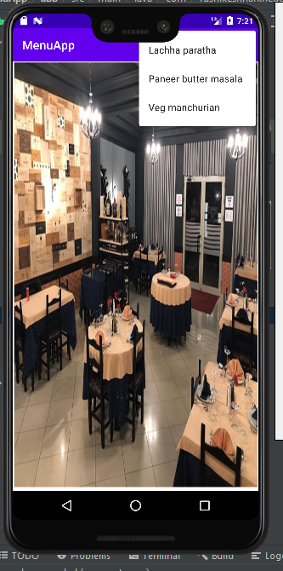

1. Write a program to demonstrate Context Menu in android for notepad.

Code:

**MainActivity.java**

<?xml version="1.0" encoding="utf-8"?>  
<manifest xmlns:android="http://schemas.android.com/apk/res/android"  
 package="com.rushikeshnarkhede.menunotepad">  
  
 <application  
 android:allowBackup="true"  
 android:icon="@mipmap/ic_launcher"  
 android:label="@string/app_name"  
 android:roundIcon="@mipmap/ic_launcher_round"  
 android:supportsRtl="true"  
 android:theme="@style/Theme.MenuNotepad">  
 <activity  
 android:name=".MainActivity"  
 android:exported="true">  
 <intent-filter>  
 <action android:name="android.intent.action.MAIN" />  
  
 <category android:name="android.intent.category.LAUNCHER" />  
 </intent-filter>  
 </activity>  
 </application>  
  
</manifest>

**AndroidMainfest.xml**

package com.rushikeshnarkhede.menunotepad;  
  
import androidx.appcompat.app.AppCompatActivity;  
  
import android.os.Bundle;  
  
import androidx.annotation.NonNull;  
  
import android.content.res.Resources;  
import android.view.ContextMenu;  
import android.view.MenuInflater;  
import android.view.MenuItem;  
import android.view.View;  
import android.widget.TextView;  
import android.widget.Toast;  
  
public class MainActivity extends AppCompatActivity {  
 TextView txt1,txt2,txt3,txt4,txt5;  
 @Override  
 protected void onCreate(Bundle savedInstanceState) {  
 super.onCreate(savedInstanceState);  
 setContentView(R.layout.*activity_main*);  
 txt1=findViewById(R.id.*file*);  
 txt2=findViewById(R.id.*edit*);  
 txt3=findViewById(R.id.*format*);  
 txt4=findViewById(R.id.*view*);  
 txt5=findViewById(R.id.*help*);  
 registerForContextMenu(txt1);  
 registerForContextMenu(txt2);  
 registerForContextMenu(txt3);  
 registerForContextMenu(txt4);  
 registerForContextMenu(txt5);  
 }  
  
 @Override  
 public void onCreateContextMenu(ContextMenu menu, View v, ContextMenu.ContextMenuInfo menuInfo) {  
 super.onCreateContextMenu(menu, v, menuInfo);  
 int id=v.getId();  
 if(id==R.id.*file*)  
 {  
 MenuInflater mi=getMenuInflater();  
 mi.inflate(R.menu.*file*,menu);  
 }  
  
 if(id==R.id.*edit*)  
 {  
 MenuInflater mi=getMenuInflater();  
 mi.inflate(R.menu.*edit*,menu);  
 }  
 if(id==R.id.*format*)  
 {  
 MenuInflater mi=getMenuInflater();  
 mi.inflate(R.menu.*format*,menu);  
 }  
 if(id==R.id.*view*)  
 {  
 MenuInflater mi=getMenuInflater();  
 mi.inflate(R.menu.*view*,menu);  
 }  
 if(id==R.id.*help*)  
 {  
 MenuInflater mi=getMenuInflater();  
 mi.inflate(R.menu.*help*,menu);  
 }  
  
 }  
  
 @Override  
 public boolean onContextItemSelected(@NonNull MenuItem item) {  
 super.onContextItemSelected(item);  
 int id=item.getItemId();  
 Resources r=getResources();  
 switch(id)  
 {  
 case R.id.*file1*:  
 Toast.*makeText*(this, "New", Toast.*LENGTH_SHORT*).show();  
 break;  
 case R.id.*file2*:  
 Toast.*makeText*(this, "New Window", Toast.*LENGTH_SHORT*).show();  
 break;  
 case R.id.*file3*:  
 Toast.*makeText*(this, "Open", Toast.*LENGTH_SHORT*).show();  
 break;  
 case R.id.*file4*:  
 Toast.*makeText*(this, "Save", Toast.*LENGTH_SHORT*).show();  
 break;  
 case R.id.*file5*:  
 Toast.*makeText*(this, "Save As", Toast.*LENGTH_SHORT*).show();  
 break;  
 case R.id.*edit1*:  
 Toast.*makeText*(this, "Undo", Toast.*LENGTH_SHORT*).show();  
 break;  
 case R.id.*edit2*:  
 Toast.*makeText*(this, "Cut", Toast.*LENGTH_SHORT*).show();  
 break;  
 case R.id.*edit3*:  
 Toast.*makeText*(this, "Copy", Toast.*LENGTH_SHORT*).show();  
 break;  
 case R.id.*edit4*:  
 Toast.*makeText*(this, "Paste", Toast.*LENGTH_SHORT*).show();  
 break;  
 case R.id.*edit5*:  
 Toast.*makeText*(this, "Delete", Toast.*LENGTH_SHORT*).show();  
 break;  
 case R.id.*format1*:  
 Toast.*makeText*(this, "Word Wrap", Toast.*LENGTH_SHORT*).show();  
 break;  
 case R.id.*format2*:  
 Toast.*makeText*(this, "Font", Toast.*LENGTH_SHORT*).show();  
 break;  
 case R.id.*view1*:  
 Toast.*makeText*(this, "Zoom", Toast.*LENGTH_SHORT*).show();  
 break;  
 case R.id.*view2*:  
 Toast.*makeText*(this, "Status Bar", Toast.*LENGTH_SHORT*).show();  
 break;  
 case R.id.*help1*:  
 Toast.*makeText*(this, "View Help", Toast.*LENGTH_SHORT*).show();  
 break;  
 case R.id.*help2*:  
 Toast.*makeText*(this, "Send Feedback", Toast.*LENGTH_SHORT*).show();  
 break;  
 case R.id.*help3*:  
 Toast.*makeText*(this, "About Notepad", Toast.*LENGTH_SHORT*).show();  
 break;  
 }  
 return true;  
 }  
}

**activity_main.xml**

<?xml version="1.0" encoding="utf-8"?>  
<androidx.constraintlayout.widget.ConstraintLayout xmlns:android="http://schemas.android.com/apk/res/android"  
 xmlns:app="http://schemas.android.com/apk/res-auto"  
 xmlns:tools="http://schemas.android.com/tools"  
 android:layout_width="match_parent"  
 android:layout_height="match_parent"  
 android:background="#FFF3E1"  
 tools:context=".MainActivity">  
  
 <TextView  
 android:id="@+id/file"  
 android:layout_width="70dp"  
 android:layout_height="24dp"  
 android:background="#30736D"  
 android:gravity="center"  
 android:text="File"  
 android:textColor="#FCFBFB"  
 android:textSize="16sp"  
 android:textStyle="bold"  
 app:layout_constraintBottom_toBottomOf="parent"  
 app:layout_constraintEnd_toEndOf="parent"  
 app:layout_constraintHorizontal_bias="0.0"  
 app:layout_constraintStart_toStartOf="parent"  
 app:layout_constraintTop_toTopOf="parent"  
 app:layout_constraintVertical_bias="0.0" />  
  
 <TextView  
 android:id="@+id/edit"  
 android:layout_width="70dp"  
 android:layout_height="24dp"  
 android:background="#E4A23F"  
 android:gravity="center"  
 android:text="Edit"  
 android:textColor="#FEFEFE"  
 android:textSize="16sp"  
 android:textStyle="bold"  
 app:layout_constraintBottom_toBottomOf="parent"  
 app:layout_constraintEnd_toEndOf="parent"  
 app:layout_constraintHorizontal_bias="0.205"  
 app:layout_constraintStart_toStartOf="parent"  
 app:layout_constraintTop_toTopOf="parent"  
 app:layout_constraintVertical_bias="0.0" />  
  
 <TextView  
 android:id="@+id/format"  
 android:layout_width="70dp"  
 android:layout_height="24dp"  
 android:background="#8ACCE8"  
 android:gravity="center"  
 android:text="Format"  
 android:textColor="#FEFDFD"  
 android:textSize="16sp"  
 android:textStyle="bold"  
 app:layout_constraintBottom_toBottomOf="parent"  
 app:layout_constraintEnd_toEndOf="parent"  
 app:layout_constraintHorizontal_bias="0.41"  
 app:layout_constraintStart_toStartOf="parent"  
 app:layout_constraintTop_toTopOf="parent"  
 app:layout_constraintVertical_bias="0.0" />  
  
 <TextView  
 android:id="@+id/help"  
 android:layout_width="70dp"  
 android:layout_height="24dp"  
 android:background="#5FEC6C"  
 android:gravity="center"  
 android:text="Help"  
 android:textColor="#FCFBFB"  
 android:textSize="16sp"  
 android:textStyle="bold"  
 app:layout_constraintBottom_toBottomOf="parent"  
 app:layout_constraintEnd_toEndOf="parent"  
 app:layout_constraintHorizontal_bias="0.821"  
 app:layout_constraintStart_toStartOf="parent"  
 app:layout_constraintTop_toTopOf="parent"  
 app:layout_constraintVertical_bias="0.0" />  
  
 <TextView  
 android:id="@+id/view"  
 android:layout_width="70dp"  
 android:layout_height="24dp"  
 android:background="#EF8F87"  
 android:gravity="center"  
 android:text="View"  
 android:textColor="#FCFBFB"  
 android:textSize="16sp"  
 android:textStyle="bold"  
 app:layout_constraintBottom_toBottomOf="parent"  
 app:layout_constraintEnd_toEndOf="parent"  
 app:layout_constraintHorizontal_bias="0.615"  
 app:layout_constraintStart_toStartOf="@+id/file"  
 app:layout_constraintTop_toTopOf="parent"  
 app:layout_constraintVertical_bias="0.0" />  
  
</androidx.constraintlayout.widget.ConstraintLayout>

OUTPUT:

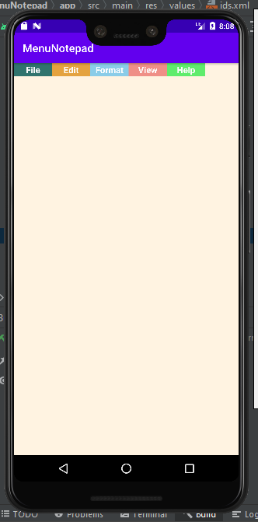

1. Write a program to demonstrate Popup Menu in android for cut, copy and paste options in it and display appropriate information related to operation.

Code:

**MainActivity.java**

package com.rushikeshnarkhede.popmenu;  
  
import androidx.appcompat.app.AppCompatActivity;  
  
import android.os.Bundle;  
import android.view.MenuItem;  
import android.view.View;  
import android.widget.Button;  
import android.widget.PopupMenu;  
import android.widget.Toast;  
  
public class MainActivity extends AppCompatActivity {  
 Button clickme;  
 @Override  
 protected void onCreate(Bundle savedInstanceState) {  
 super.onCreate(savedInstanceState);  
 setContentView(R.layout.*activity_main*);  
 clickme = (Button)findViewById(R.id.*clickme*);  
  
 clickme.setOnClickListener(new View.OnClickListener() {  
 @Override  
 public void onClick(View view) {  
 PopupMenu popupMenu = new PopupMenu(getApplicationContext(),clickme);  
 popupMenu.getMenuInflater().inflate(R.menu.*menu*,popupMenu.getMenu());  
 popupMenu.setOnMenuItemClickListener(new PopupMenu.OnMenuItemClickListener() {  
 @Override  
 public boolean onMenuItemClick(MenuItem menuItem) {  
 Toast.*makeText*(getApplicationContext(),"You hav selected "+menuItem.getTitle(),Toast.*LENGTH_LONG*).show();  
 return true;  
 }  
 });  
 popupMenu.show();  
 }  
 });  
 }  
}

**AndroidMainfest.xml**

<?xml version="1.0" encoding="utf-8"?>  
<manifest xmlns:android="http://schemas.android.com/apk/res/android"  
 package="com.rushikeshnarkhede.popmenu">  
  
 <application  
 android:allowBackup="true"  
 android:icon="@mipmap/ic_launcher"  
 android:label="@string/app_name"  
 android:roundIcon="@mipmap/ic_launcher_round"  
 android:supportsRtl="true"  
 android:theme="@style/Theme.PopMenu">  
 <activity  
 android:name=".MainActivity"  
 android:exported="true">  
 <intent-filter>  
 <action android:name="android.intent.action.MAIN" />  
  
 <category android:name="android.intent.category.LAUNCHER" />  
 </intent-filter>  
 </activity>  
 </application>  
  
</manifest>

**activity_main.xml**

<?xml version="1.0" encoding="utf-8"?>  
<androidx.constraintlayout.widget.ConstraintLayout xmlns:android="http://schemas.android.com/apk/res/android"  
 xmlns:app="http://schemas.android.com/apk/res-auto"  
 xmlns:tools="http://schemas.android.com/tools"  
 android:layout_width="match_parent"  
 android:layout_height="match_parent"  
 tools:context=".MainActivity">  
  
 <TextView  
 android:layout_width="wrap_content"  
 android:layout_height="wrap_content"  
 android:text="Click on below button to check the options."  
 android:textAlignment="center"  
 android:textSize="30sp"  
 android:textStyle="bold"  
 app:layout_constraintBottom_toBottomOf="parent"  
 app:layout_constraintHorizontal_bias="0.0"  
 app:layout_constraintLeft_toLeftOf="parent"  
 app:layout_constraintRight_toRightOf="parent"  
 app:layout_constraintTop_toTopOf="parent"  
 app:layout_constraintVertical_bias="0.307" />  
  
 <Button  
 android:id="@+id/clickme"  
 android:layout_width="wrap_content"  
 android:layout_height="wrap_content"  
 android:ems="7"  
 android:text="Click me"  
 app:layout_constraintBottom_toBottomOf="parent"  
 app:layout_constraintEnd_toEndOf="parent"  
 app:layout_constraintStart_toStartOf="parent"  
 app:layout_constraintTop_toTopOf="parent" />  
  
  
</androidx.constraintlayout.widget.ConstraintLayout>

OUTPUT:

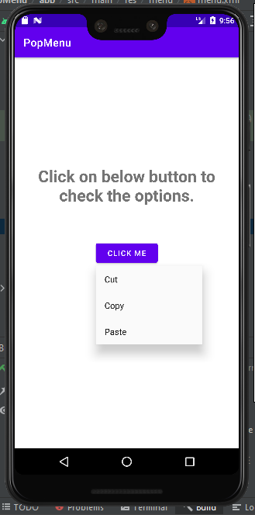

1. Write an application to produce Notification.

Code:

**MainActivity.java**

package com.rushikeshnarkhede.notification;  
  
import androidx.appcompat.app.AppCompatActivity;  
  
import android.os.Bundle;  
import androidx.core.app.NotificationCompat;  
import androidx.core.app.NotificationManagerCompat;  
  
import android.app.NotificationChannel;  
import android.app.NotificationManager;  
  
import android.os.Build;  
import android.view.View;  
import android.widget.Button;  
  
public class MainActivity extends AppCompatActivity {  
 Button b;  
 @Override  
 protected void onCreate(Bundle savedInstanceState) {  
 super.onCreate(savedInstanceState);  
 setContentView(R.layout.*activity_main*);  
 b=findViewById(R.id.*btn*);  
 b.setOnClickListener(new View.OnClickListener() {  
 @Override  
 public void onClick(View view) {  
 notification();  
 }  
 });  
 }  
 private void notification(){  
 if(Build.VERSION.*SDK_INT*>=Build.VERSION_CODES.*O*)  
 {  
 NotificationChannel notificationChannel=new NotificationChannel("n","n", NotificationManager.*IMPORTANCE_DEFAULT*);  
 NotificationManager manager=getSystemService(NotificationManager.class);  
 manager.createNotificationChannel(notificationChannel);  
 }  
 NotificationCompat.Builder builder=new NotificationCompat.Builder(this,"n")  
 .setContentText("Hello")  
 .setSmallIcon(R.drawable.*notify*)  
 .setAutoCancel(true)  
 .setContentText("This is notification text");  
 NotificationManagerCompat managerCompat=NotificationManagerCompat.*from*(this);  
 managerCompat.notify(999,builder.build());  
 }  
}

**AndroidMainfest.xml**

<?xml version="1.0" encoding="utf-8"?>  
<manifest xmlns:android="http://schemas.android.com/apk/res/android"  
 package="com.rushikeshnarkhede.notification">  
  
 <application  
 android:allowBackup="true"  
 android:icon="@mipmap/ic_launcher"  
 android:label="@string/app_name"  
 android:roundIcon="@mipmap/ic_launcher_round"  
 android:supportsRtl="true"  
 android:theme="@style/Theme.Notification">  
 <activity  
 android:name=".MainActivity"  
 android:exported="true">  
 <intent-filter>  
 <action android:name="android.intent.action.MAIN" />  
  
 <category android:name="android.intent.category.LAUNCHER" />  
 </intent-filter>  
 </activity>  
 </application>  
  
</manifest>

**activity_main.xml**

<?xml version="1.0" encoding="utf-8"?>  
<androidx.constraintlayout.widget.ConstraintLayout xmlns:android="http://schemas.android.com/apk/res/android"  
 xmlns:app="http://schemas.android.com/apk/res-auto"  
 xmlns:tools="http://schemas.android.com/tools"  
 android:layout_width="match_parent"  
 android:layout_height="match_parent"  
 tools:context=".MainActivity">  
  
 <Button  
 android:id="@+id/btn"  
 android:layout_width="166dp"  
 android:layout_height="55dp"  
 android:text="Notify"  
 app:layout_constraintBottom_toBottomOf="parent"  
 app:layout_constraintLeft_toLeftOf="parent"  
 app:layout_constraintRight_toRightOf="parent"  
 app:layout_constraintTop_toTopOf="parent" />  
  
</androidx.constraintlayout.widget.ConstraintLayout>

OUTPUT:

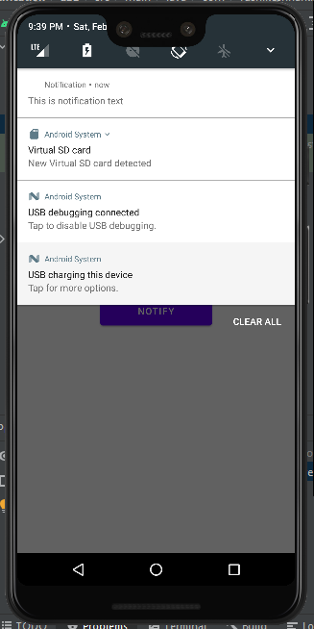

1. Write an android application using shared preference to save score of a game.

Code:

**MainActivity.java**

package com.rushikeshnarkhede.sharedpreference;  
  
import androidx.appcompat.app.AppCompatActivity;  
  
import android.content.SharedPreferences;  
import android.os.Bundle;  
  
import android.view.View;  
import android.widget.Button;  
import android.widget.EditText;  
import android.widget.TextView;  
  
public class MainActivity extends AppCompatActivity {  
 TextView textView;  
 EditText editText;  
 Button button;  
  
  
 @Override  
 protected void onCreate(Bundle savedInstanceState) {  
 super.onCreate(savedInstanceState);  
 setContentView(R.layout.*activity_main*);  
 editText = findViewById(R.id.*editText*);  
 textView = findViewById(R.id.*textView*);  
  
 button = findViewById(R.id.*button*);  
  
 SharedPreferences sP = getSharedPreferences("MyPref", *MODE_PRIVATE*);  
 String editVal = sP.getString("name", "No value as of now");  
 textView.setText(editVal);  
  
  
 button.setOnClickListener(new View.OnClickListener() {  
 @Override  
 public void onClick(View v) {  
 String val = editText.getText().toString();  
 SharedPreferences sP = getSharedPreferences("MyPref", *MODE_PRIVATE*);  
 SharedPreferences.Editor ed = sP.edit();  
 ed.putString("name", val);  
 ed.apply();  
 textView.setText(val);  
  
 }  
 });  
  
 }  
}

**AndroidMainfest.xml**

<?xml version="1.0" encoding="utf-8"?>  
<manifest xmlns:android="http://schemas.android.com/apk/res/android"  
 package="com.rushikeshnarkhede.sharedpreference">  
  
 <application  
 android:allowBackup="true"  
 android:icon="@mipmap/ic_launcher"  
 android:label="@string/app_name"  
 android:roundIcon="@mipmap/ic_launcher_round"  
 android:supportsRtl="true"  
 android:theme="@style/Theme.SharedPreference">  
 <activity  
 android:name=".MainActivity"  
 android:exported="true">  
 <intent-filter>  
 <action android:name="android.intent.action.MAIN" />  
  
 <category android:name="android.intent.category.LAUNCHER" />  
 </intent-filter>  
 </activity>  
 </application>  
  
</manifest>

**activity_main.xml**

<?xml version="1.0" encoding="utf-8"?>  
<androidx.constraintlayout.widget.ConstraintLayout xmlns:android="http://schemas.android.com/apk/res/android"  
 xmlns:app="http://schemas.android.com/apk/res-auto"  
 xmlns:tools="http://schemas.android.com/tools"  
 android:layout_width="match_parent"  
 android:layout_height="match_parent"  
 android:background="@drawable/img5"  
 tools:context=".MainActivity"  
 tools:ignore="HardcodedText">  
  
 <!--EditText to take the data from the user  
 and save the data in SharedPreferences-->  
  
 <TextView  
 android:id="@+id/textview"  
 android:layout_width="wrap_content"  
 android:layout_height="wrap_content"  
 android:layout_centerHorizontal="true"  
 android:text="Shared Preferences "  
 android:textColor="@android:color/black"  
 android:textSize="24sp"  
 app:layout_constraintBottom_toBottomOf="parent"  
 app:layout_constraintEnd_toEndOf="parent"  
 app:layout_constraintHorizontal_bias="0.497"  
 app:layout_constraintStart_toStartOf="parent"  
 app:layout_constraintTop_toTopOf="parent"  
 app:layout_constraintVertical_bias="0.114" />  
  
 <EditText  
 android:id="@+id/editText"  
 android:layout_width="353dp"  
 android:layout_height="50dp"  
 android:layout_below="@+id/textview"  
 android:hint="Enter Game/Score"  
 android:padding="10dp"  
 app:layout_constraintBottom_toBottomOf="parent"  
 app:layout_constraintEnd_toEndOf="parent"  
 app:layout_constraintStart_toStartOf="parent"  
 app:layout_constraintTop_toBottomOf="@+id/textview"  
 app:layout_constraintVertical_bias="0.112" />  
  
 <TextView  
 android:id="@+id/textView"  
 android:layout_width="190dp"  
 android:layout_height="33dp"  
 android:textColor="#000000"  
 android:textSize="20sp"  
 android:textStyle="bold"  
 app:layout_constraintBottom_toBottomOf="parent"  
 app:layout_constraintEnd_toEndOf="parent"  
 app:layout_constraintHorizontal_bias="0.446"  
 app:layout_constraintStart_toStartOf="parent"  
 app:layout_constraintTop_toBottomOf="@+id/editText"  
 app:layout_constraintVertical_bias="0.193" />  
  
 <Button  
 android:id="@+id/button"  
 android:layout_width="wrap_content"  
 android:layout_height="wrap_content"  
 android:text="SUBMIT"  
 app:layout_constraintBottom_toBottomOf="parent"  
 app:layout_constraintEnd_toEndOf="parent"  
 app:layout_constraintHorizontal_bias="0.468"  
 app:layout_constraintStart_toStartOf="parent"  
 app:layout_constraintTop_toTopOf="@+id/textView"  
 app:layout_constraintVertical_bias="0.432" />  
  
 <!--EditText to take the data from the user and  
 save the data in SharedPreferences-->  
  
</androidx.constraintlayout.widget.ConstraintLayout>

OUTPUT:

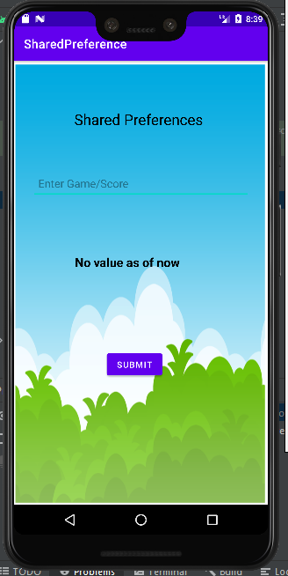

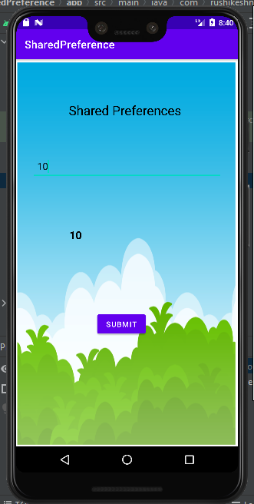

1. Write an android application using SQLite to create table, add employee details and display in logcat.

Code:

**MainActivity.java**

package com.rushikeshnarkhede.employee;  
  
import androidx.appcompat.app.AppCompatActivity;  
  
import android.os.Bundle;  
  
public class MainActivity extends AppCompatActivity {  
  
 @Override  
 protected void onCreate(Bundle savedInstanceState) {  
 super.onCreate(savedInstanceState);  
 setContentView(R.layout.*activity_main*);  
 DBHandler dbHandler= new DBHandler(this,"empdb",null,1);  
 dbHandler.addEmployee(new Employee(1,"Rushikesh",121.1));  
 dbHandler.getEmployee(1);  
 dbHandler.close();  
 }  
}

**AndroidMainfest.xml**

<?xml version="1.0" encoding="utf-8"?>  
<manifest xmlns:android="http://schemas.android.com/apk/res/android"  
 package="com.rushikeshnarkhede.employee">  
  
 <application  
 android:allowBackup="true"  
 android:icon="@mipmap/ic_launcher"  
 android:label="@string/app_name"  
 android:roundIcon="@mipmap/ic_launcher_round"  
 android:supportsRtl="true"  
 android:theme="@style/Theme.Employee">  
 <activity  
 android:name=".MainActivity"  
 android:exported="true">  
 <intent-filter>  
 <action android:name="android.intent.action.MAIN" />  
  
 <category android:name="android.intent.category.LAUNCHER" />  
 </intent-filter>  
 </activity>  
 </application>  
  
</manifest>

**activity_main.xml**

<?xml version="1.0" encoding="utf-8"?>  
<androidx.constraintlayout.widget.ConstraintLayout xmlns:android="http://schemas.android.com/apk/res/android"  
 xmlns:app="http://schemas.android.com/apk/res-auto"  
 xmlns:tools="http://schemas.android.com/tools"  
 android:layout_width="match_parent"  
 android:layout_height="match_parent"  
 tools:context=".MainActivity">  
  
 <TextView  
 android:layout_width="wrap_content"  
 android:layout_height="wrap_content"  
 android:text="Hello World!"  
 app:layout_constraintBottom_toBottomOf="parent"  
 app:layout_constraintLeft_toLeftOf="parent"  
 app:layout_constraintRight_toRightOf="parent"  
 app:layout_constraintTop_toTopOf="parent" />  
  
</androidx.constraintlayout.widget.ConstraintLayout>

OUTPUT:

1. Write an android application using SQLite to create table and perform CRUD operations (Example. COURSE table (ID, Name, Duration, Description), perform ADD, UPDATE, DELETE and READ operations).

Code:

**MainActivity.java**

package com.example.dancedb;  
  
import androidx.appcompat.app.AppCompatActivity;  
  
import com.example.course24db.R;  
  
import android.content.Intent;  
import android.os.Bundle;  
import android.view.View;  
import android.widget.AdapterView;  
import android.widget.ArrayAdapter;  
import android.widget.Button;  
import android.widget.EditText;  
import android.widget.Spinner;  
import android.widget.Toast;  
  
public class MainActivity extends AppCompatActivity {  
 EditText id, name, mob, dtype;  
 Spinner dp;  
 Button saveBtn, lstBtn, showBtn, updateBtn, deleteBtn;  
 Intent intent;  
 String str;  
 DatabaseHandler db;  
 String uid, uname, umob, udan;  
 String []country={"Hip Hop","Free Style","Manipuri","Bharatanatyam"};  
 @Override  
 protected void onCreate(Bundle savedInstanceState) {  
 super.onCreate(savedInstanceState);  
 setContentView(R.layout.*activity_main*);  
  
 db = new DatabaseHandler(this);  
 id = findViewById(R.id.*txtId*);  
 name = findViewById(R.id.*txtName*);  
 mob = findViewById(R.id.*txtdrtn*);  
 dp=findViewById(R.id.*spinner2*);  
 saveBtn = findViewById(R.id.*btnSave*);  
 lstBtn = findViewById(R.id.*btnList*);  
 updateBtn = findViewById(R.id.*btnUpdate*);  
 deleteBtn = findViewById(R.id.*btnDelete*);  
 showBtn = findViewById(R.id.*btnShowRec*);  
 ArrayAdapter aa=new ArrayAdapter(this,android.R.layout.*simple_spinner_dropdown_item*,country);  
 dp.setAdapter(aa);  
 dp.setOnItemSelectedListener(new AdapterView.OnItemSelectedListener() {  
 @Override  
 public void onItemSelected(AdapterView<?> adapterView, View view, int position, long l) {  
  
 str=country[position];  
  
 }  
  
  
  
 @Override  
 public void onNothingSelected(AdapterView<?> adapterView) {  
  
 }  
 });  
 //Save record  
 saveBtn.setOnClickListener(new View.OnClickListener() {  
 @Override  
 public void onClick(View view) {  
 uid = id.getText().toString();  
 uname = name.getText().toString();  
 umob = mob.getText().toString();  
 udan = str;  
  
 try {  
 db.addDance(new Dance(Integer.*parseInt*(uid),uname,umob,udan));  
 Toast.*makeText*(getApplicationContext(), "Record Added", Toast.*LENGTH_SHORT*).show();  
 id.setText("");  
 name.setText("");  
 mob.setText("");  
 } catch (Exception e) {  
 e.printStackTrace();  
 }  
 }  
 });  
 updateBtn.setOnClickListener(new View.OnClickListener() {  
 @Override  
 public void onClick(View v) {  
 uid = id.getText().toString();  
 uname = name.getText().toString();  
 umob= mob.getText().toString();  
 udan=str;  
 try {  
 db.updateDance(new Dance(Integer.*parseInt*(uid), uname, umob,udan));  
 Toast.*makeText*(getApplicationContext(), "Record Updated",  
 Toast.*LENGTH_LONG*).show();  
 } catch (Exception e) {  
 e.printStackTrace();  
 }  
 }  
 });  
  
 deleteBtn.setOnClickListener(new View.OnClickListener() {  
 @Override  
 public void onClick(View v) {  
 uid = id.getText().toString();  
 try {  
 db.deleteDance(Integer.*parseInt*(uid));  
 Toast.*makeText*(getApplicationContext(), "Record Deleted",  
 Toast.*LENGTH_LONG*).show();  
 } catch (Exception e) {  
 e.printStackTrace();  
 }  
 }  
 });  
  
 // To Display all records from table  
 lstBtn.setOnClickListener(new View.OnClickListener() {  
 @Override  
 public void onClick(View view) {  
 intent = new Intent(MainActivity.this, DetailsActivity.class);  
 startActivity(intent);  
 }  
 });  
  
 // To Display a single record from table  
 showBtn.setOnClickListener(new View.OnClickListener() {  
 @Override  
 public void onClick(View view) {  
 uid = id.getText().toString();  
 intent = new Intent(MainActivity.this, DetailsActivity.class);  
 intent.putExtra("userid", uid);  
 startActivity(intent);  
 }  
 });  
  
 }  
}

**AndroidMainfest.xml**

<?xml version="1.0" encoding="utf-8"?>  
<manifest xmlns:android="http://schemas.android.com/apk/res/android"  
 package="com.example.course24db">  
  
 <application  
 android:allowBackup="true"  
 android:icon="@mipmap/ic_launcher"  
 android:label="@string/app_name"  
 android:roundIcon="@mipmap/ic_launcher_round"  
 android:supportsRtl="true"  
 android:theme="@style/Theme.Course24db">  
 <activity  
 android:name="com.example.dancedb.DetailsActivity"  
 android:exported="false"  
 android:parentActivityName="com.example.dancedb.MainActivity" />  
 <activity  
 android:name="com.example.dancedb.MainActivity"  
 android:exported="true">  
 <intent-filter>  
 <action android:name="android.intent.action.MAIN" />  
  
 <category android:name="android.intent.category.LAUNCHER" />  
 </intent-filter>  
 </activity>  
  
 <meta-data  
 android:name="preloaded_fonts"  
 android:resource="@array/preloaded_fonts" />  
 </application>  
  
</manifest>

**activity_main.xml**

<?xml version="1.0" encoding="utf-8"?>  
<LinearLayout xmlns:android="http://schemas.android.com/apk/res/android"  
 xmlns:app="http://schemas.android.com/apk/res-auto"  
 xmlns:tools="http://schemas.android.com/tools"  
 android:layout_width="match_parent"  
 android:layout_height="match_parent"  
 android:background="#C2F1ED"  
 android:orientation="vertical"  
 tools:context="com.example.dancedb.MainActivity">  
  
 <TextView  
 android:id="@+id/Txt"  
 android:layout_width="wrap_content"  
 android:layout_height="wrap_content"  
 android:layout_marginLeft="30dp"  
 android:layout_marginTop="100dp"  
 android:fontFamily="@font/arbutus_slab"  
 android:text="Dance Competetion Details:"  
 android:textAlignment="center"  
 android:textSize="20sp"  
 android:textStyle="bold" />  
  
 <TextView  
 android:id="@+id/fstTxt"  
 android:textStyle="bold"  
 android:layout_width="wrap_content"  
 android:layout_height="wrap_content"  
 android:layout_marginLeft="30dp"  
 android:layout_marginTop="50dp"  
 android:text="ID" />  
  
 <EditText  
 android:id="@+id/txtId"  
 android:layout_width="wrap_content"  
 android:layout_height="wrap_content"  
 android:layout_marginLeft="30dp"  
 android:ems="10"  
 android:minHeight="48dp"  
 tools:ignore="SpeakableTextPresentCheck" />  
  
 <TextView  
 android:textStyle="bold"  
 android:id="@+id/secTxt"  
 android:layout_width="wrap_content"  
  
 android:layout_height="wrap_content"  
  
 android:layout_marginLeft="30dp"  
 android:text="Name" />  
  
 <EditText  
 android:id="@+id/txtName"  
 android:layout_width="wrap_content"  
 android:layout_height="wrap_content"  
 android:layout_marginLeft="30dp"  
 android:ems="10"  
 android:minHeight="48dp"  
 tools:ignore="SpeakableTextPresentCheck" />  
  
 <TextView  
 android:id="@+id/thirdTxt"  
 android:layout_width="wrap_content"  
 android:layout_height="wrap_content"  
 android:layout_marginLeft="30dp"  
 android:text="Mobile Number:"  
 android:textStyle="bold" />  
  
 <EditText  
 android:id="@+id/txtdrtn"  
 android:layout_width="wrap_content"  
 android:layout_height="wrap_content"  
 android:layout_marginLeft="30dp"  
 android:ems="10"  
 android:inputType="phone"  
 android:minHeight="48dp"  
 tools:ignore="SpeakableTextPresentCheck" />  
  
 <TextView  
 android:id="@+id/fourthTxt"  
 android:layout_width="wrap_content"  
 android:layout_height="wrap_content"  
 android:layout_marginLeft="30dp"  
 android:text="Dance Type:"  
 android:textStyle="bold" />  
  
 <Spinner  
 android:id="@+id/spinner2"  
 android:layout_width="215dp"  
 android:layout_height="48dp"  
 android:layout_marginLeft="30dp" />  
  
 <LinearLayout  
 android:layout_width="wrap_content"  
 android:layout_height="wrap_content"  
 android:orientation="horizontal"  
 android:layout_marginStart="30dp">  
  
 <Button  
 android:id="@+id/btnSave"  
 android:layout_width="wrap_content"  
 android:layout_height="wrap_content"  
 android:layout_marginLeft="10dp"  
 android:text="Save" />  
  
 <Button  
 android:id="@+id/btnUpdate"  
 android:layout_width="wrap_content"  
 android:layout_height="wrap_content"  
 android:layout_marginLeft="10dp"  
 android:text="Modify" />  
  
 <Button  
 android:id="@+id/btnDelete"  
 android:layout_width="wrap_content"  
  
 android:layout_height="wrap_content"  
 android:layout_marginStart="10dp"  
 android:text="Delete" />  
 </LinearLayout>  
  
 <LinearLayout  
 android:layout_width="wrap_content"  
 android:layout_height="wrap_content"  
 android:orientation="horizontal"  
 android:layout_marginStart="30dp">  
  
 <Button  
 android:id="@+id/btnShowRec"  
 android:layout_width="wrap_content"  
 android:layout_height="wrap_content"  
 android:layout_marginLeft="10dp"  
 android:text="Show Record" />  
  
 <Button  
 android:id="@+id/btnList"  
 android:layout_width="wrap_content"  
 android:layout_height="wrap_content"  
 android:layout_marginLeft="10dp"  
 android:text="List all" />  
  
 </LinearLayout>  
  
</LinearLayout>

OUTPUT:

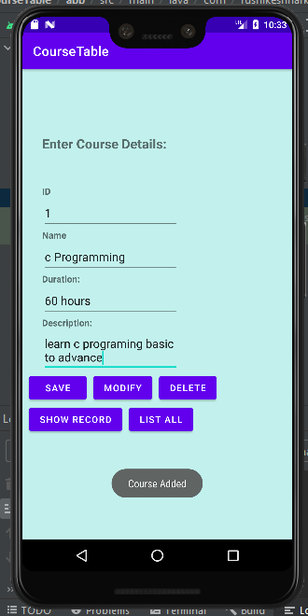

1. Write an android application using SQLite to create table and perform CRUD operations for a registration form Dance competition.

Code:

**MainActivity.java**

package com.example.dancedb;  
  
import androidx.appcompat.app.AppCompatActivity;  
  
import com.example.course24db.R;  
  
import android.content.Intent;  
import android.os.Bundle;  
import android.view.View;  
import android.widget.AdapterView;  
import android.widget.ArrayAdapter;  
import android.widget.Button;  
import android.widget.EditText;  
import android.widget.Spinner;  
import android.widget.Toast;  
  
public class MainActivity extends AppCompatActivity {  
 EditText id, name, mob, dtype;  
 Spinner dp;  
 Button saveBtn, lstBtn, showBtn, updateBtn, deleteBtn;  
 Intent intent;  
 String str;  
 DatabaseHandler db;  
 String uid, uname, umob, udan;  
 String []country={"Hip Hop","Free Style","Manipuri","Bharatanatyam"};  
 @Override  
 protected void onCreate(Bundle savedInstanceState) {  
 super.onCreate(savedInstanceState);  
 setContentView(R.layout.*activity_main*);  
  
 db = new DatabaseHandler(this);  
 id = findViewById(R.id.*txtId*);  
 name = findViewById(R.id.*txtName*);  
 mob = findViewById(R.id.*txtdrtn*);  
 dp=findViewById(R.id.*spinner2*);  
 saveBtn = findViewById(R.id.*btnSave*);  
 lstBtn = findViewById(R.id.*btnList*);  
 updateBtn = findViewById(R.id.*btnUpdate*);  
 deleteBtn = findViewById(R.id.*btnDelete*);  
 showBtn = findViewById(R.id.*btnShowRec*);  
 ArrayAdapter aa=new ArrayAdapter(this,android.R.layout.*simple_spinner_dropdown_item*,country);  
 dp.setAdapter(aa);  
 dp.setOnItemSelectedListener(new AdapterView.OnItemSelectedListener() {  
 @Override  
 public void onItemSelected(AdapterView<?> adapterView, View view, int position, long l) {  
  
 str=country[position];  
  
 }  
  
  
  
 @Override  
 public void onNothingSelected(AdapterView<?> adapterView) {  
  
 }  
 });  
 //Save record  
 saveBtn.setOnClickListener(new View.OnClickListener() {  
 @Override  
 public void onClick(View view) {  
 uid = id.getText().toString();  
 uname = name.getText().toString();  
 umob = mob.getText().toString();  
 udan = str;  
  
 try {  
 db.addDance(new Dance(Integer.*parseInt*(uid),uname,umob,udan));  
 Toast.*makeText*(getApplicationContext(), "Record Added", Toast.*LENGTH_SHORT*).show();  
 id.setText("");  
 name.setText("");  
 mob.setText("");  
 } catch (Exception e) {  
 e.printStackTrace();  
 }  
 }  
 });  
 updateBtn.setOnClickListener(new View.OnClickListener() {  
 @Override  
 public void onClick(View v) {  
 uid = id.getText().toString();  
 uname = name.getText().toString();  
 umob= mob.getText().toString();  
 udan=str;  
 try {  
 db.updateDance(new Dance(Integer.*parseInt*(uid), uname, umob,udan));  
 Toast.*makeText*(getApplicationContext(), "Record Updated",  
 Toast.*LENGTH_LONG*).show();  
 } catch (Exception e) {  
 e.printStackTrace();  
 }  
 }  
 });  
  
 deleteBtn.setOnClickListener(new View.OnClickListener() {  
 @Override  
 public void onClick(View v) {  
 uid = id.getText().toString();  
 try {  
 db.deleteDance(Integer.*parseInt*(uid));  
 Toast.*makeText*(getApplicationContext(), "Record Deleted",  
 Toast.*LENGTH_LONG*).show();  
 } catch (Exception e) {  
 e.printStackTrace();  
 }  
 }  
 });  
  
 // To Display all records from table  
 lstBtn.setOnClickListener(new View.OnClickListener() {  
 @Override  
 public void onClick(View view) {  
 intent = new Intent(MainActivity.this, DetailsActivity.class);  
 startActivity(intent);  
 }  
 });  
  
 // To Display a single record from table  
 showBtn.setOnClickListener(new View.OnClickListener() {  
 @Override  
 public void onClick(View view) {  
 uid = id.getText().toString();  
 intent = new Intent(MainActivity.this, DetailsActivity.class);  
 intent.putExtra("userid", uid);  
 startActivity(intent);  
 }  
 });  
  
 }  
}

**activity_main.xml**

<?xml version="1.0" encoding="utf-8"?>  
<LinearLayout xmlns:android="http://schemas.android.com/apk/res/android"  
 xmlns:app="http://schemas.android.com/apk/res-auto"  
 xmlns:tools="http://schemas.android.com/tools"  
 android:layout_width="match_parent"  
 android:layout_height="match_parent"  
 android:background="#C2F1ED"  
 android:orientation="vertical"  
 tools:context="com.example.dancedb.MainActivity">  
  
 <TextView  
 android:id="@+id/Txt"  
 android:layout_width="wrap_content"  
 android:layout_height="wrap_content"  
 android:layout_marginLeft="30dp"  
 android:layout_marginTop="100dp"  
 android:fontFamily="@font/arbutus_slab"  
 android:text="Dance Competetion Details:"  
 android:textAlignment="center"  
 android:textSize="20sp"  
 android:textStyle="bold" />  
  
 <TextView  
 android:id="@+id/fstTxt"  
 android:textStyle="bold"  
 android:layout_width="wrap_content"  
 android:layout_height="wrap_content"  
 android:layout_marginLeft="30dp"  
 android:layout_marginTop="50dp"  
 android:text="ID" />  
  
 <EditText  
 android:id="@+id/txtId"  
 android:layout_width="wrap_content"  
 android:layout_height="wrap_content"  
 android:layout_marginLeft="30dp"  
 android:ems="10"  
 android:minHeight="48dp"  
 tools:ignore="SpeakableTextPresentCheck" />  
  
 <TextView  
 android:textStyle="bold"  
 android:id="@+id/secTxt"  
 android:layout_width="wrap_content"  
  
 android:layout_height="wrap_content"  
  
 android:layout_marginLeft="30dp"  
 android:text="Name" />  
  
 <EditText  
 android:id="@+id/txtName"  
 android:layout_width="wrap_content"  
 android:layout_height="wrap_content"  
 android:layout_marginLeft="30dp"  
 android:ems="10"  
 android:minHeight="48dp"  
 tools:ignore="SpeakableTextPresentCheck" />  
  
 <TextView  
 android:id="@+id/thirdTxt"  
 android:layout_width="wrap_content"  
 android:layout_height="wrap_content"  
 android:layout_marginLeft="30dp"  
 android:text="Mobile Number:"  
 android:textStyle="bold" />  
  
 <EditText  
 android:id="@+id/txtdrtn"  
 android:layout_width="wrap_content"  
 android:layout_height="wrap_content"  
 android:layout_marginLeft="30dp"  
 android:ems="10"  
 android:inputType="phone"  
 android:minHeight="48dp"  
 tools:ignore="SpeakableTextPresentCheck" />  
  
 <TextView  
 android:id="@+id/fourthTxt"  
 android:layout_width="wrap_content"  
 android:layout_height="wrap_content"  
 android:layout_marginLeft="30dp"  
 android:text="Dance Type:"  
 android:textStyle="bold" />  
  
 <Spinner  
 android:id="@+id/spinner2"  
 android:layout_width="215dp"  
 android:layout_height="48dp"  
 android:layout_marginLeft="30dp" />  
  
 <LinearLayout  
 android:layout_width="wrap_content"  
 android:layout_height="wrap_content"  
 android:orientation="horizontal"  
 android:layout_marginStart="30dp">  
  
 <Button  
 android:id="@+id/btnSave"  
 android:layout_width="wrap_content"  
 android:layout_height="wrap_content"  
 android:layout_marginLeft="10dp"  
 android:text="Save" />  
  
 <Button  
 android:id="@+id/btnUpdate"  
 android:layout_width="wrap_content"  
 android:layout_height="wrap_content"  
 android:layout_marginLeft="10dp"  
 android:text="Modify" />  
  
 <Button  
 android:id="@+id/btnDelete"  
 android:layout_width="wrap_content"  
  
 android:layout_height="wrap_content"  
 android:layout_marginStart="10dp"  
 android:text="Delete" />  
 </LinearLayout>  
  
 <LinearLayout  
 android:layout_width="wrap_content"  
 android:layout_height="wrap_content"  
 android:orientation="horizontal"  
 android:layout_marginStart="30dp">  
  
 <Button  
 android:id="@+id/btnShowRec"  
 android:layout_width="wrap_content"  
 android:layout_height="wrap_content"  
 android:layout_marginLeft="10dp"  
 android:text="Show Record" />  
  
 <Button  
 android:id="@+id/btnList"  
 android:layout_width="wrap_content"  
 android:layout_height="wrap_content"  
 android:layout_marginLeft="10dp"  
 android:text="List all" />  
  
 </LinearLayout>  
  
</LinearLayout>

OUTPUT:

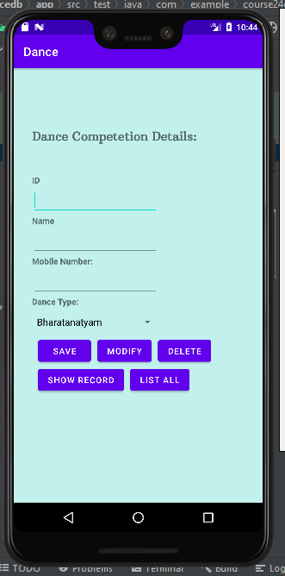

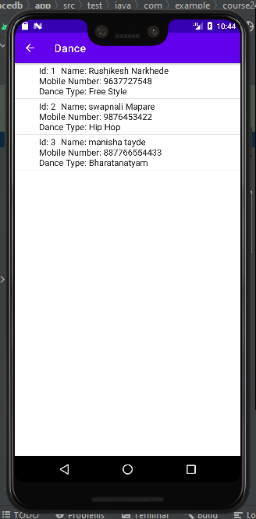

# MCA & Managment.jpgDr. D. Y. Patil Pratishthan’s

**D. Y. Patil Institute of Master of Computer Applications and Management**

(Approved by AICTE, New Delhi & Affiliated to Savitribai Phule Pune University)

# Dr. D. Y. Patil Educational Complex, Sector 29, Pradhikaran, Akurdi, Pune – 411 044

Tel No: (020)27640998, Website: [www.dypimca.ac.in,](http://www.dypimca.ac.in/) E-mail [director@dypimca.ac.in](mailto:director@dypimca.ac.in)

# Academic Year: 2021-22

# (Sem Jan-June 2022)

**Class: MCA-II Semester-III**

**Subject: IT31L - Practical based on Mob App Dev and KR&AI**

**KR&AI Journal Index**

|  |  |  |  |  |
| --- | --- | --- | --- | --- |
| **Sr.**  **No.** | **Title** | **Date** | **Page No.** | **Sign** |
| 1. 1 | Create a dataframe from dictionary of series. Perform column selection, column addition, column deletion, row addition and row deletion operations on it. | 13/12/2021 |  |  |
| 1. 2 | Find out the total number of rows, columns from insurance.csv and print first 10 records only.   1. Find out classes or data type of each attribute. 2. Rename column female and male with new value F, M 3. Check the missing data from the whole dataset 4. Find out the null value is present in age column 5. Replace the wrong data in correct format. | 17/12/2021 |  |  |
| 1. 3 | Use comapany_sales_data.csv and perform below operations:   1. Read Total profit of all months and show it using a line plot.  Read toothpaste sales data of each month and show it using a scatter plot.  1. Read face cream and facewash product sales data and show it using the bar chart. 2. Read sales data of bathing soap of all months and show it using a bar chart. 3. Calculate total sale data for last year for each product and show it using a Pie chart. | 20/12/2021 |  |  |
| 1. 4 | Find the correlation matrix for finding the correlation between variables and mentions your findings. Plot the heatmap. | 29/12/2021 |  |  |
| 1. 5 | Plot the correlation plot on dataset and visualize giving an overview of relationships among data on iris data. | 07/1/2022 |  |  |
| 1. 6 | Analysis of covariance: variance (ANOVA), if data have categorical variables on iris data. | 17/1/2022 |  |  |
| 1. 7 | Apply linear regression Model techniques to predict the data on dataset – House_price.csv | 24/1/2022 |  |  |
| 1. 8 | Apply logistic regression Model techniques to predict the data on dataset - social_network_ads.csv | 31/1/2022 |  |  |
|  | Apply Clustering algorithms for unsupervised classification on dataset - Mall_Customers_data.csv | 04/2/2022 |  |  |
|  | Implement Decision Tree algorithm on the dataset- iris.csv | 11/2/2022 |  |  |
|  | Apply Bayesian classification on dataset – play.csv | 21/2/2022 |  |  |
|  | Apply SVM classification on dataset - apples_and_oranges.csv | 22/2/2022 |  |  |
|  | Implement Association algorithms for supervised classification on dataset - retail.csv | 28/2/2022 |  |  |
|  | Text Mining algorithms on unstructured dataset. | 04/3/2022 |  |  |
|  | Plot the cluster data using python visualizations. | 07/3/2022 |  |  |
|  | Creating & Visualizing Neural Network for the given data. | 11/3/2022 |  |  |
|  | Recognize optical character using Artificial Neural Network (ANN). | 11/3/2022 |  |  |
|  | Write a program to implement Convolutional Neural Network (CNN). | 14/3/2022 |  |  |
|  | Write a program to implement Recurrent Neural Network (RNN). | 21/3/2022 |  |  |
|  | Write a program to implement Generative Adversarial network (GAN) | 21/3/2022 |  |  |
|  | Web scraping experiments (by using tools) | 25/3/2022 |  |  |

Journal

**Name- Rushikesh Dilip Narkhede**

**Roll No-49**

**Div- A**

**Class- SYMCA**

**Subject: KR & AI**

**Q1. Create a dataframe from dictionary of series. Perform column selection, column addition, column deletion, row addition and row deletion operations on it.**

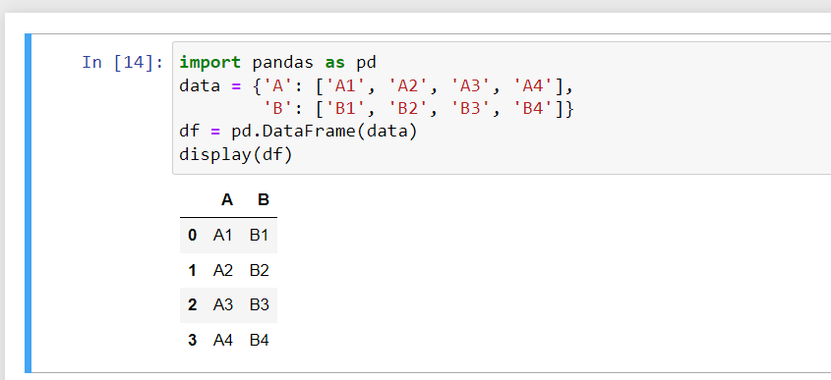

# Column Selection

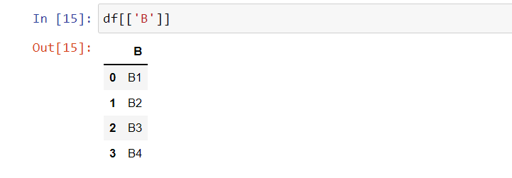

#Column Addition

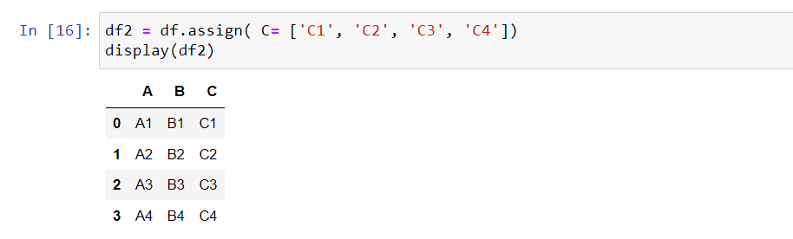

#Row Addition

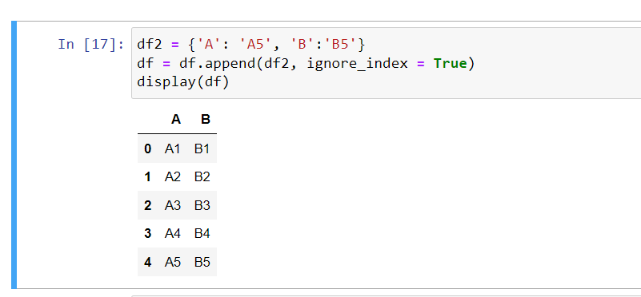

#Column Deletion

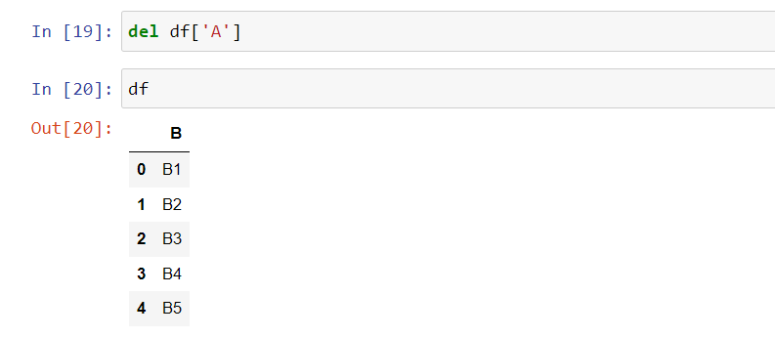

#Row Deletion

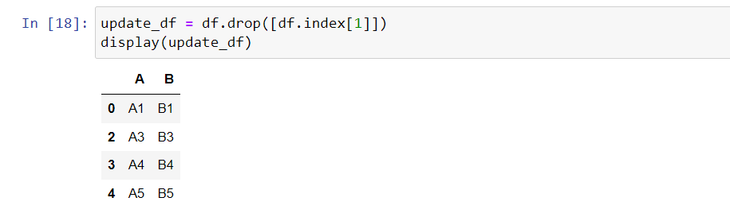

**Q.2 Find out the total number of rows, columns from insurance.csv and print first 10 records only.**

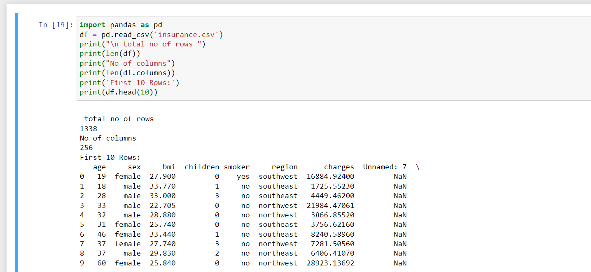

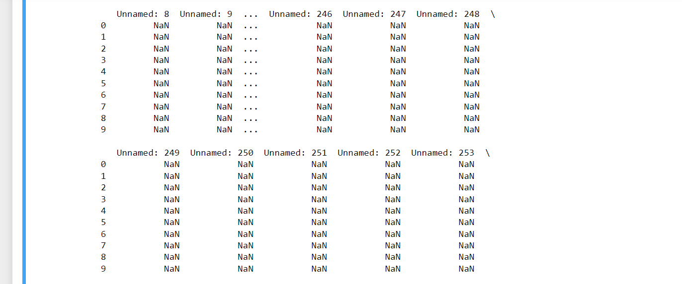

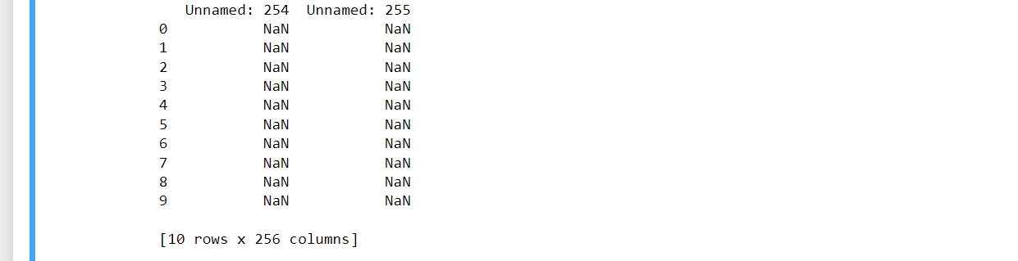

1. **Find out classes or data type of each attribute.**

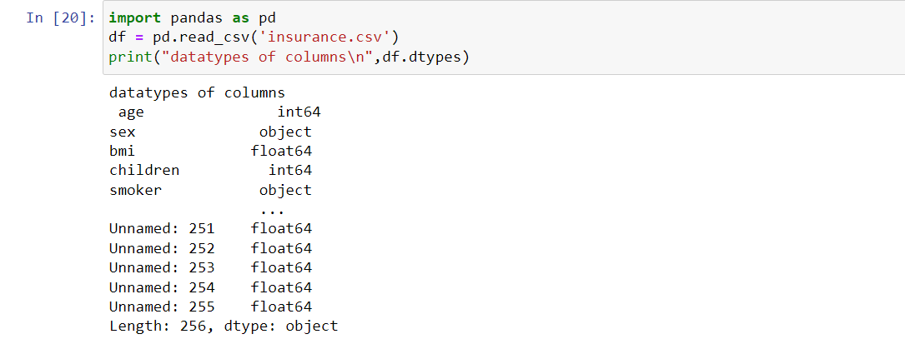

1. **Rename column female and male with new value F,M**

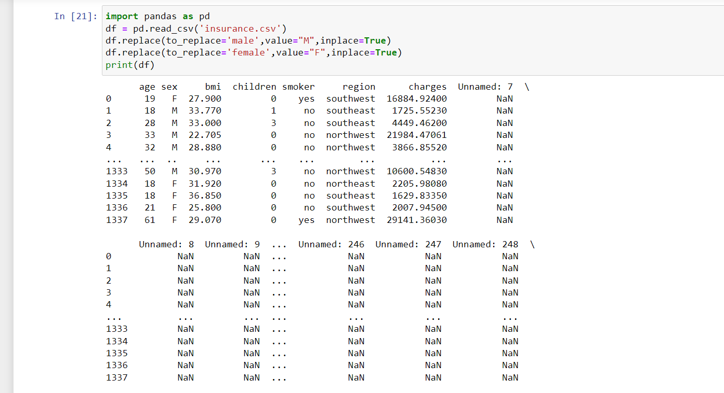

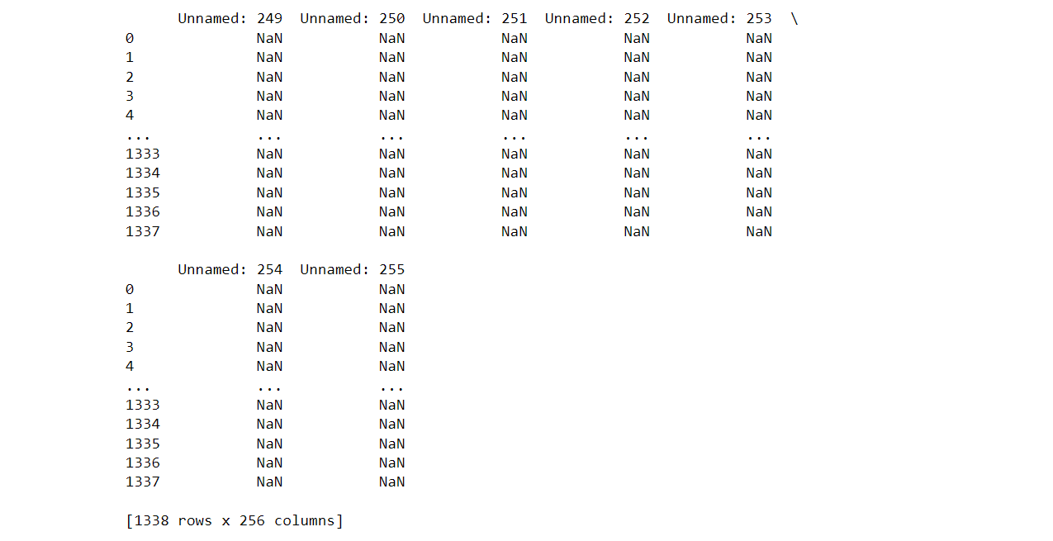

**3. Check the missing data from the whole dataset**

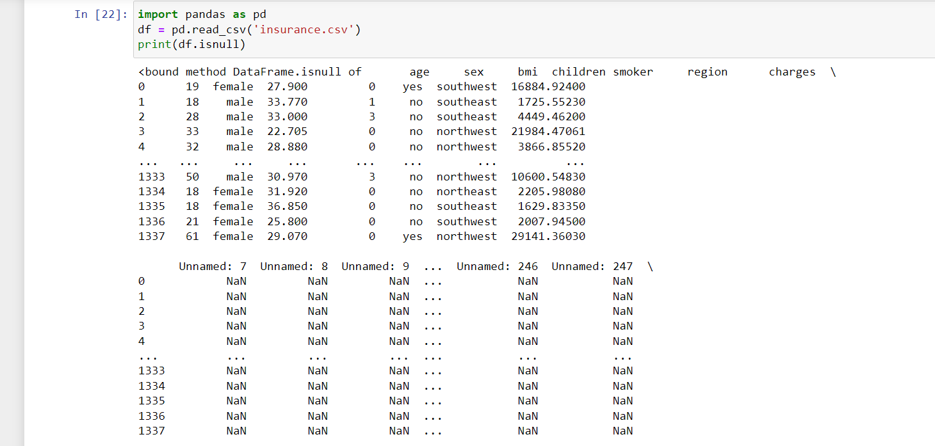

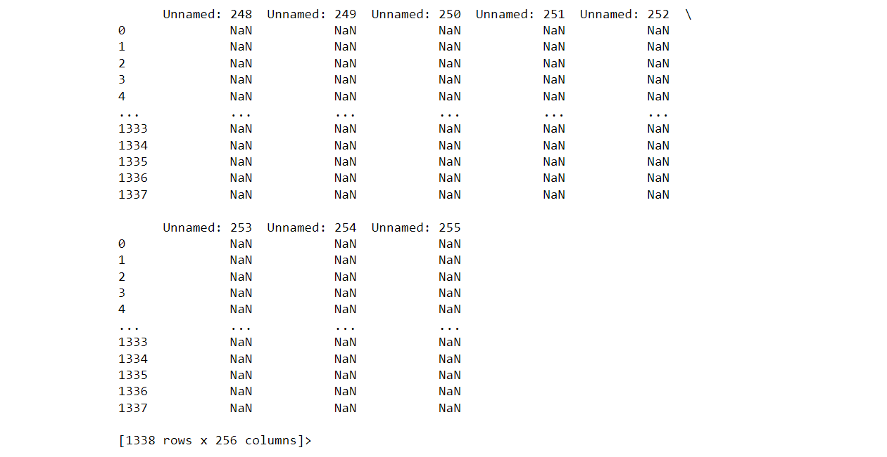

**4.Find out the null value is present in age column**

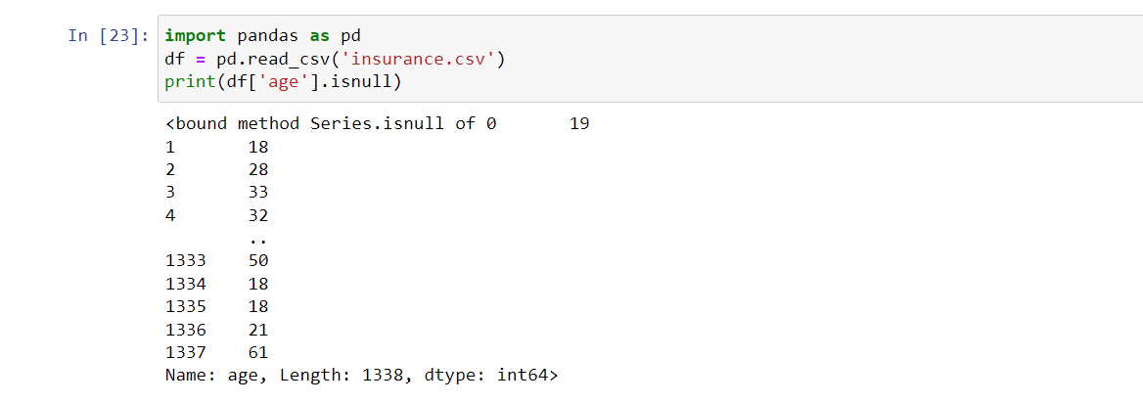

**5.Replace the wrong data in correct format.**

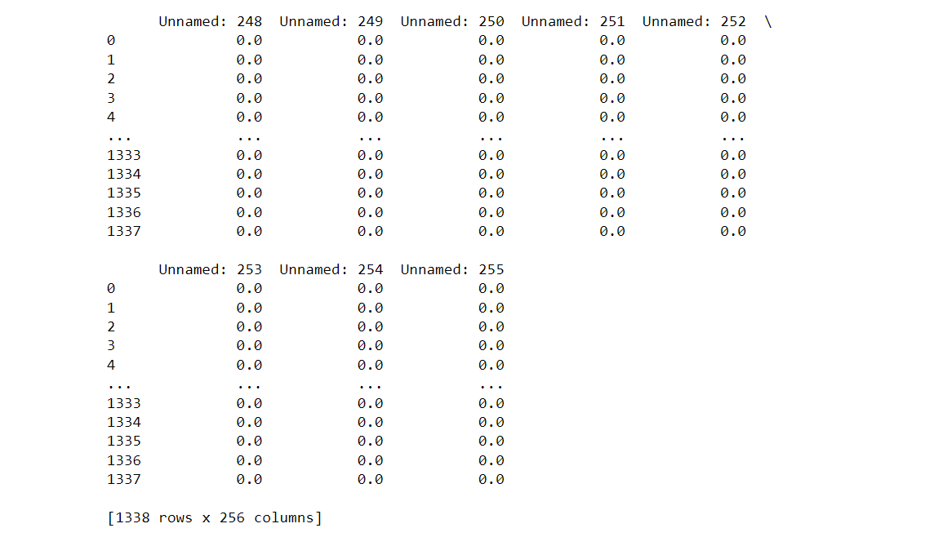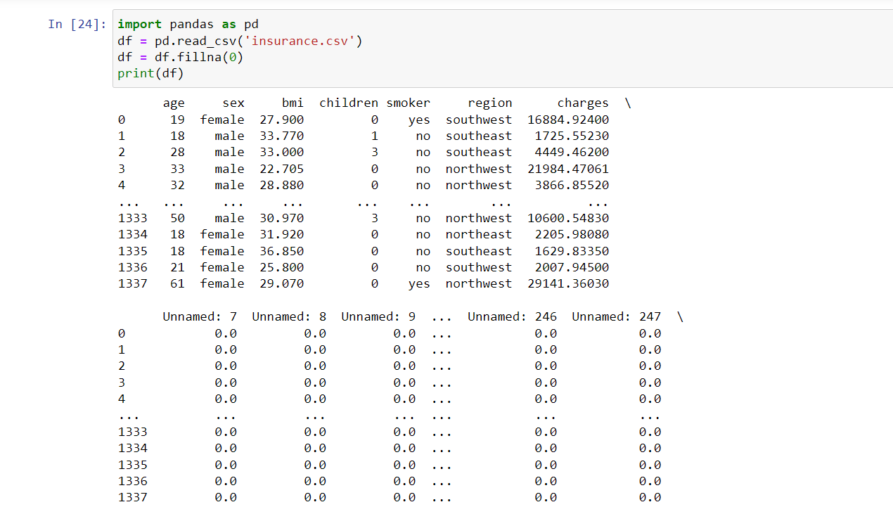

**Q.3 Use comapany_sales_data.csv and perform below operations:**

1. **Read Total profit of all months and show it using a line plot.**

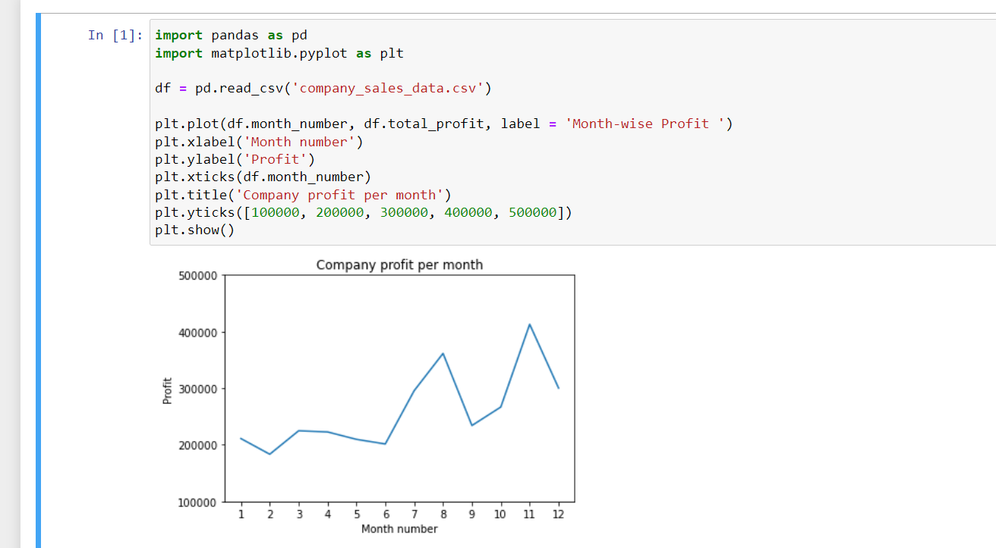

1. **Read toothpaste sales data of each month and show it using a scatter plot.**

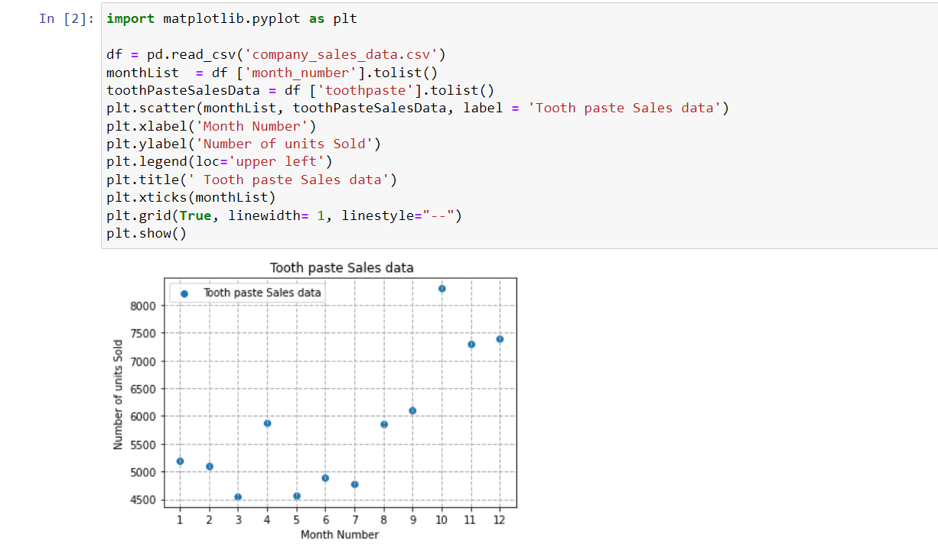

1. **Read face cream and facewash product sales data and show it using the bar chart.**

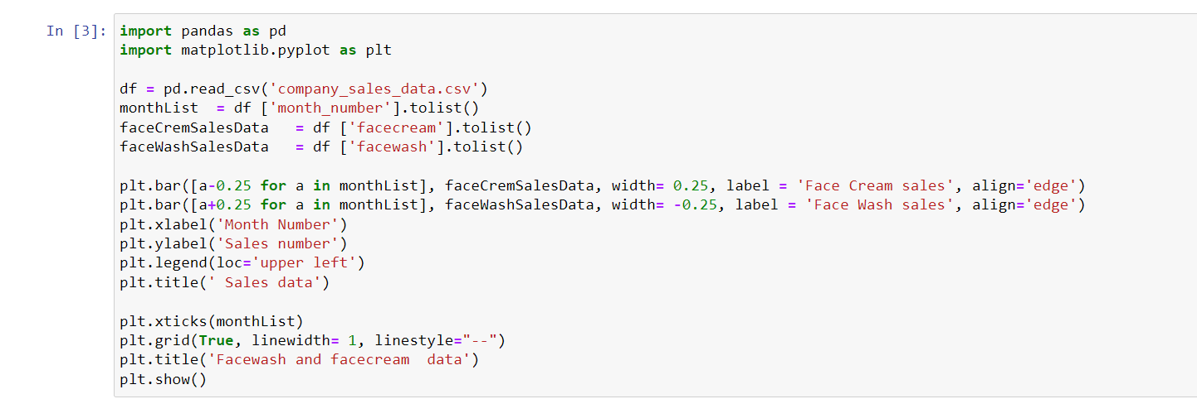

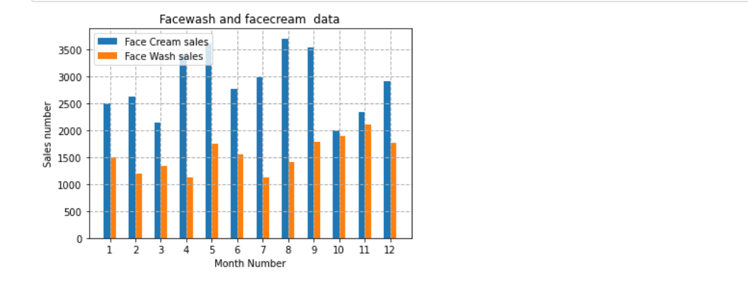

1. **Read sales data of bathing soap of all months and show it using a bar chart.**

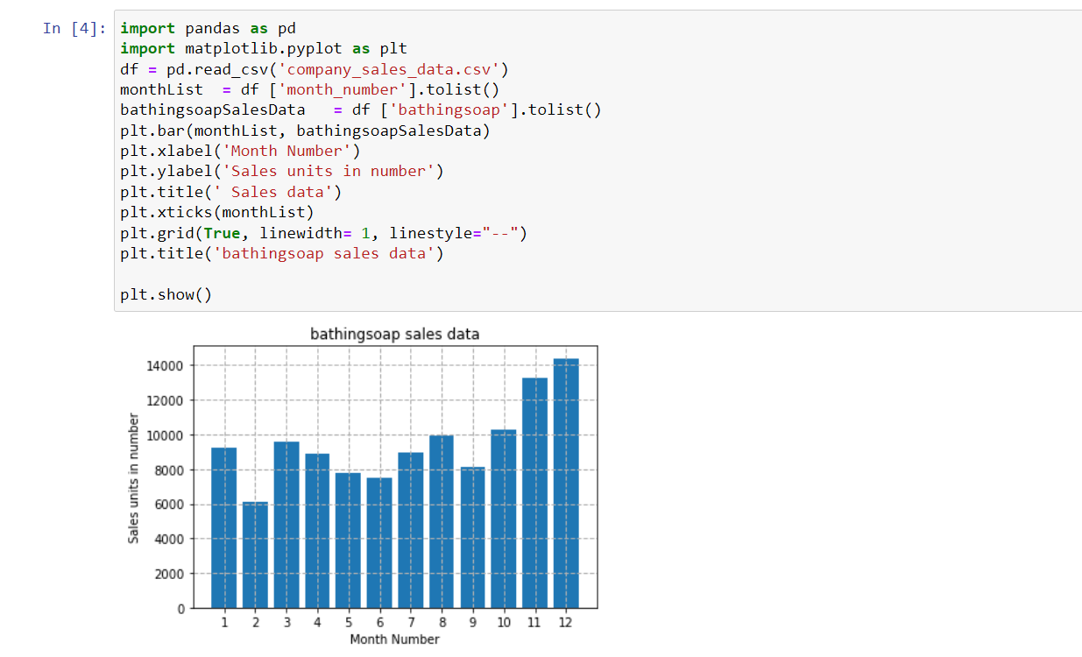

1. **Calculate total sale data for last year for each product and show it using a Pie chart.**

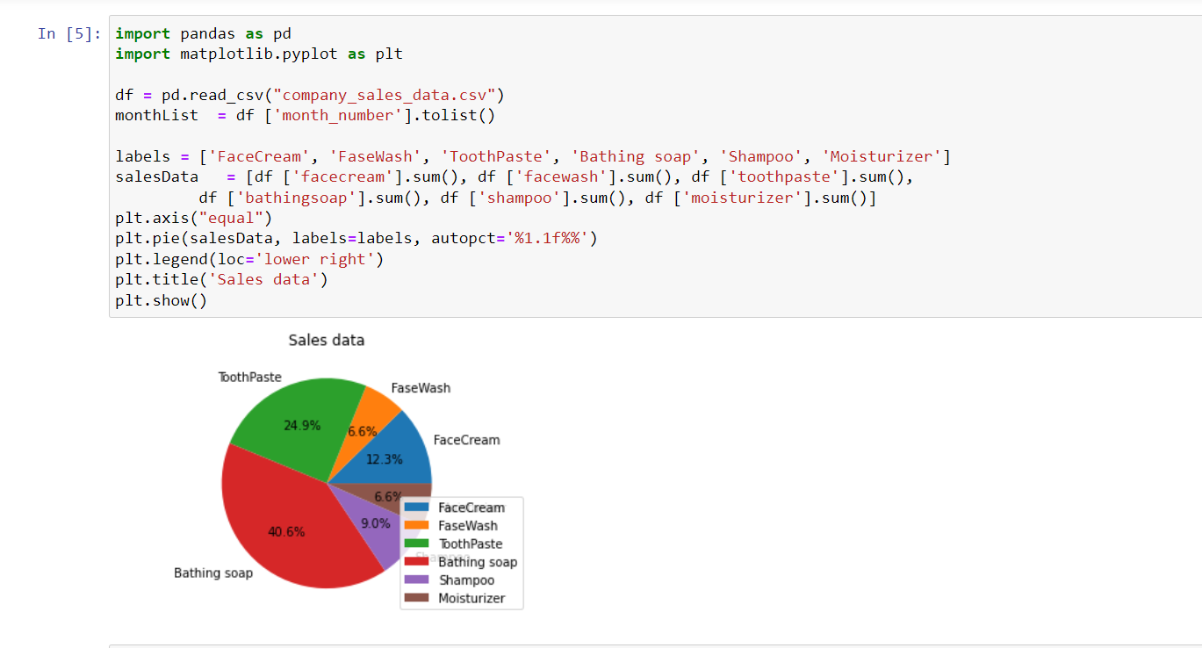

**Q.4 Find the correlation matrix for finding the correlation between variables and mention your findings. Plot the heatmap.**

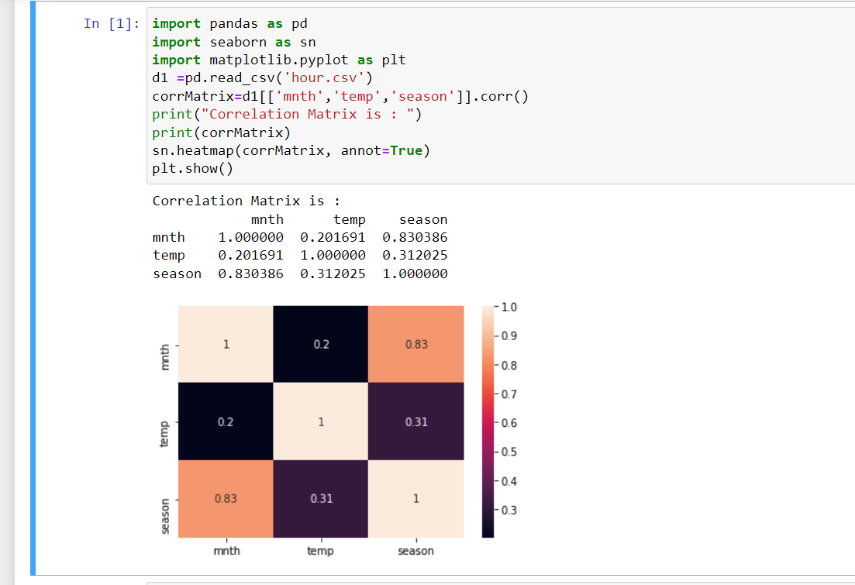

**Q.5 Plot the correlation plot on dataset and visualize giving an overview of relationships among data on iris data.**

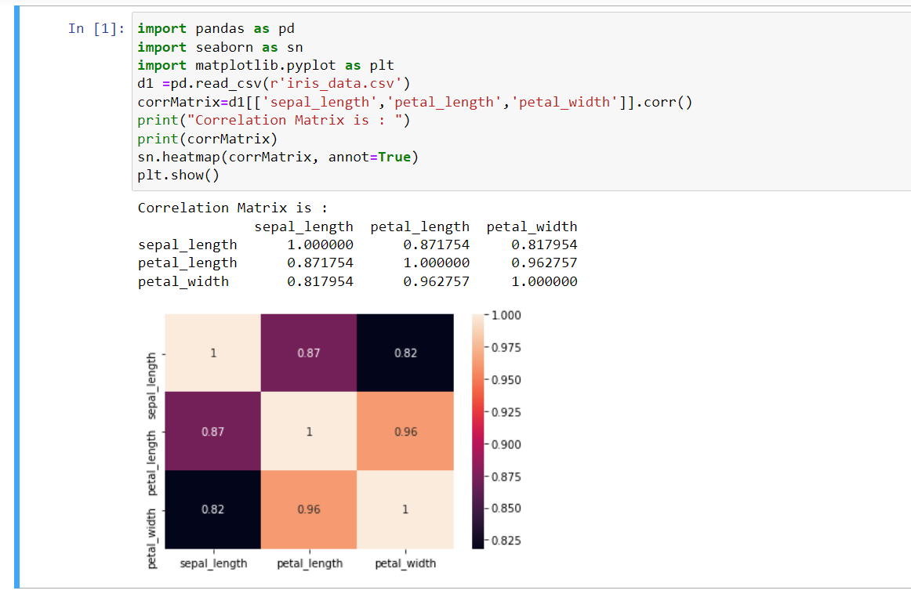

**Q.6 Analysis of covariance: variance (ANOVA), if data have categorical variables on iris data.**

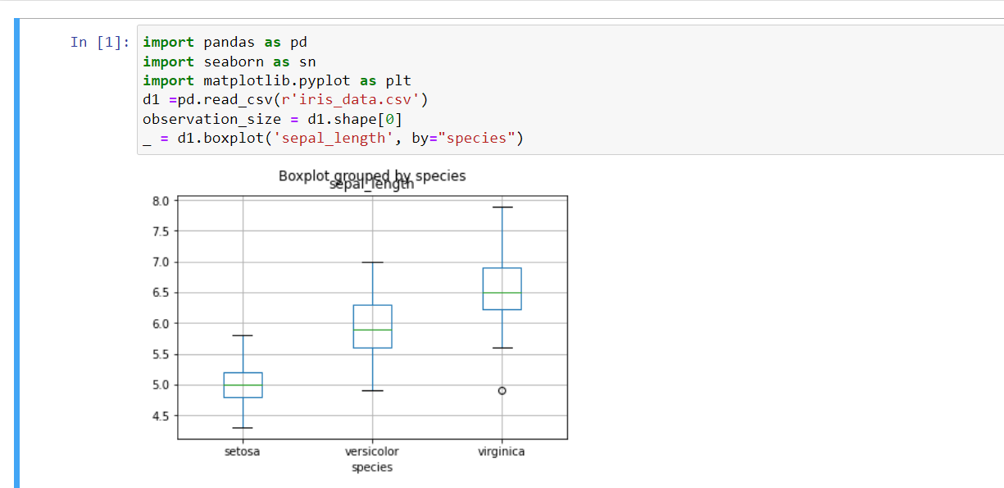

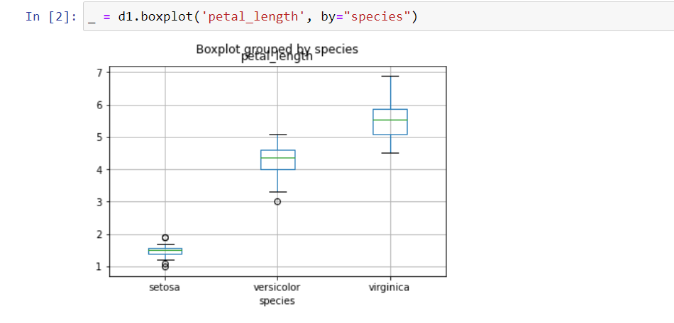

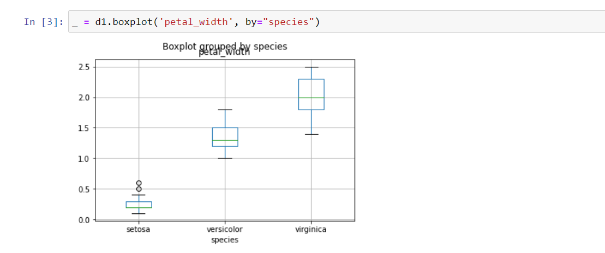

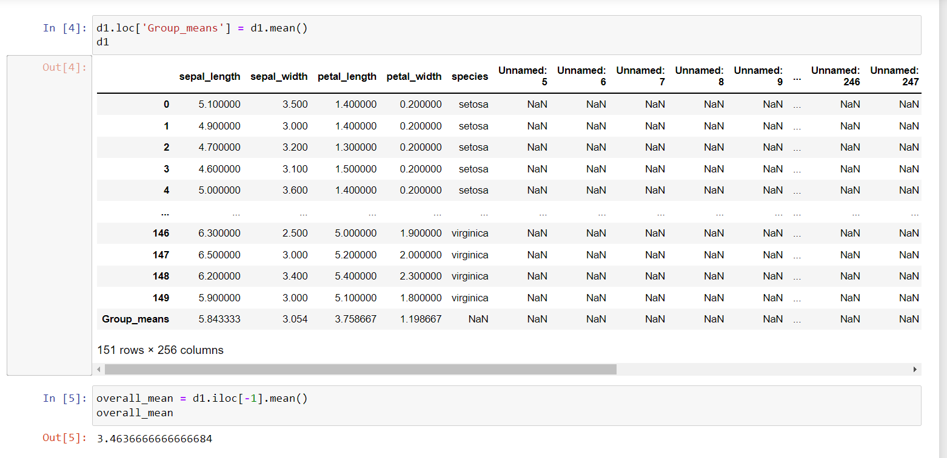

**Q7. Apply linear regression Model techniques to predict the data on dataset – House_price.csv.**

**Ans:**

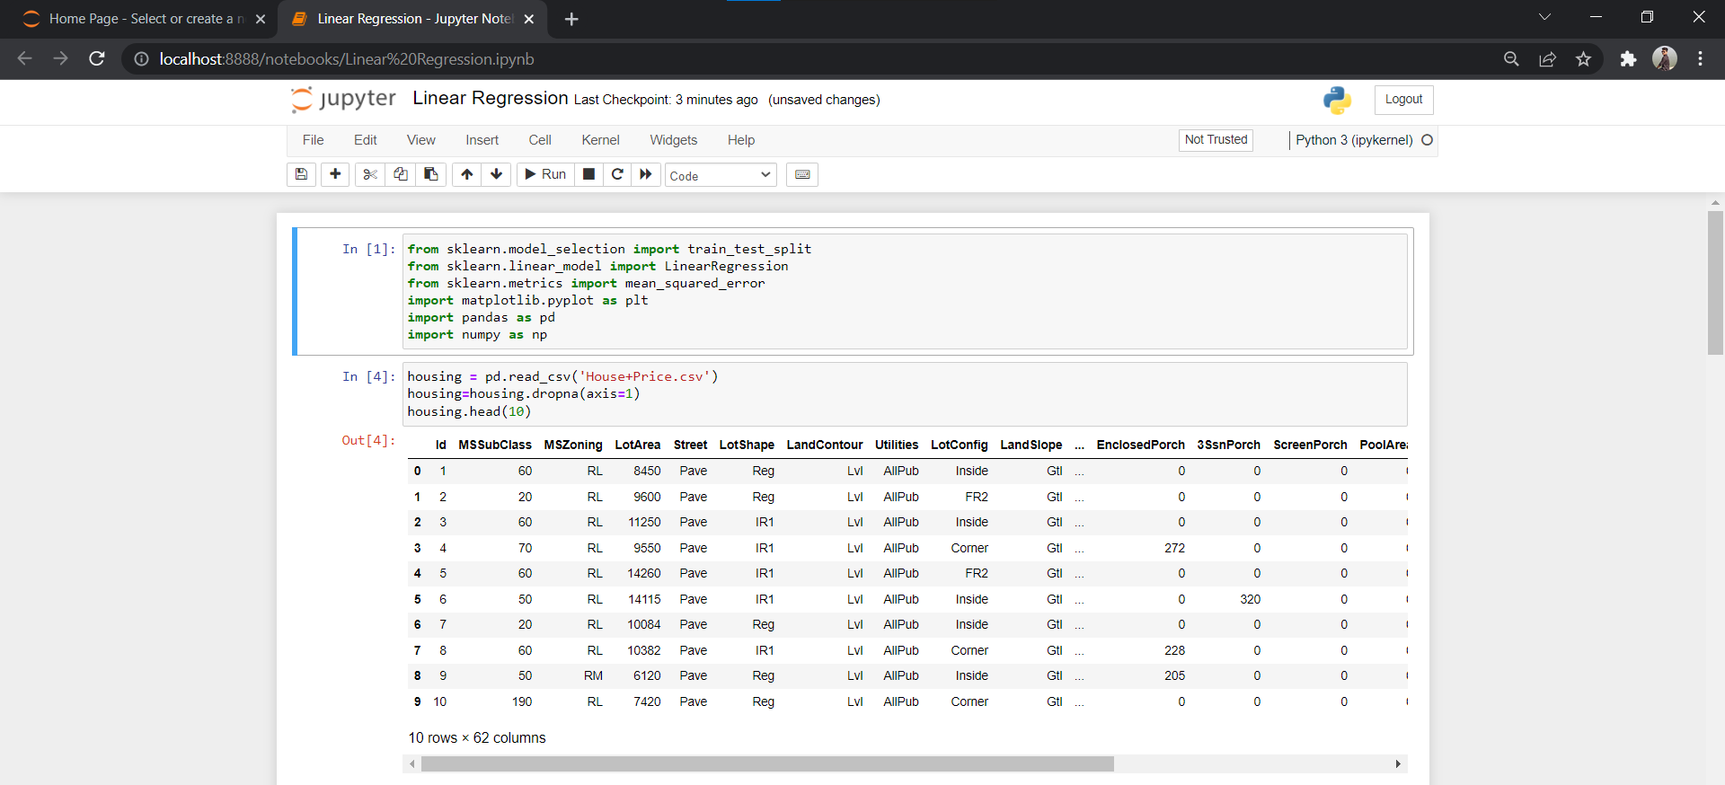 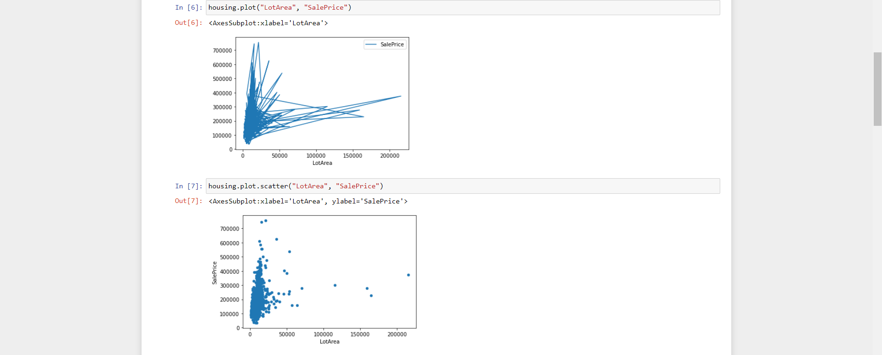 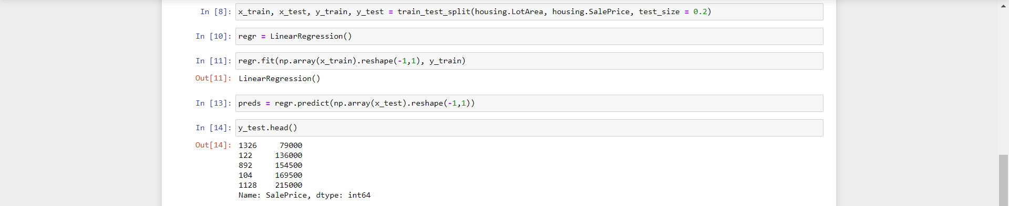 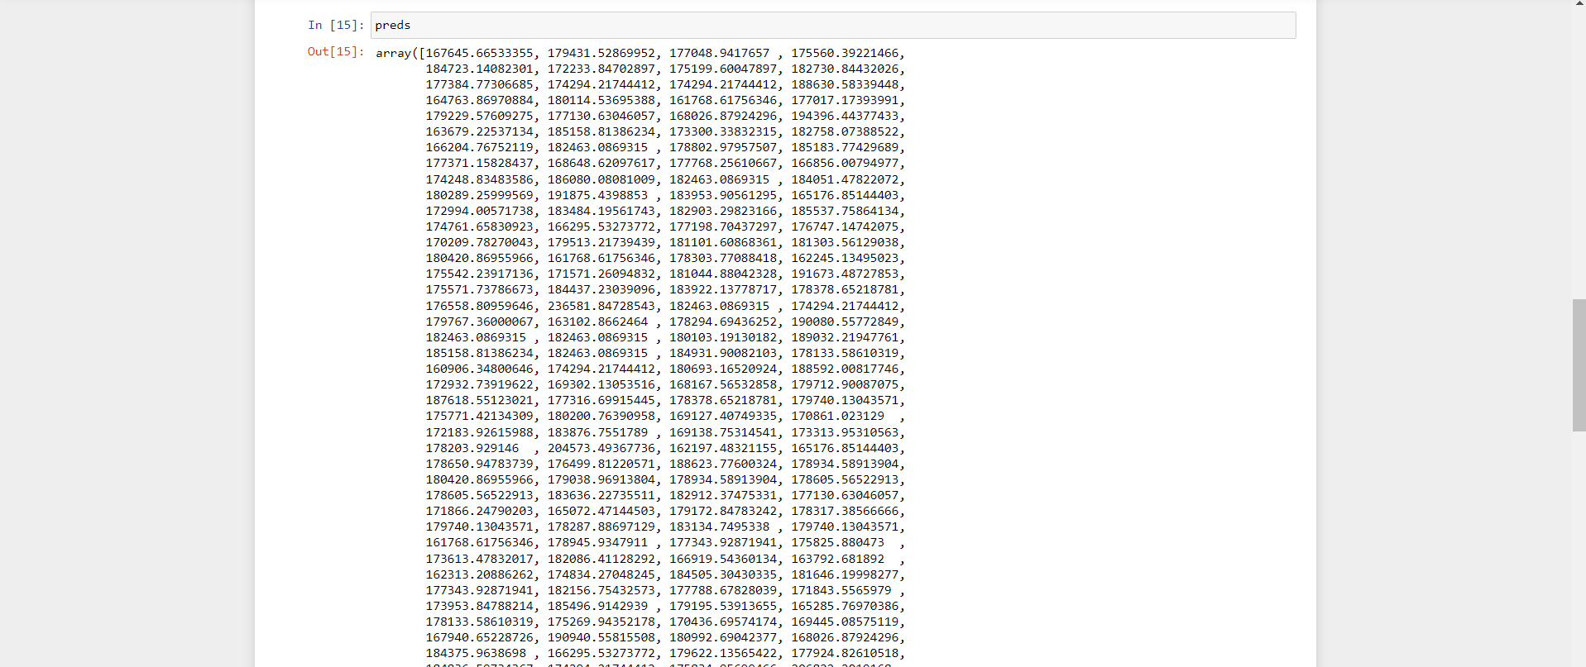 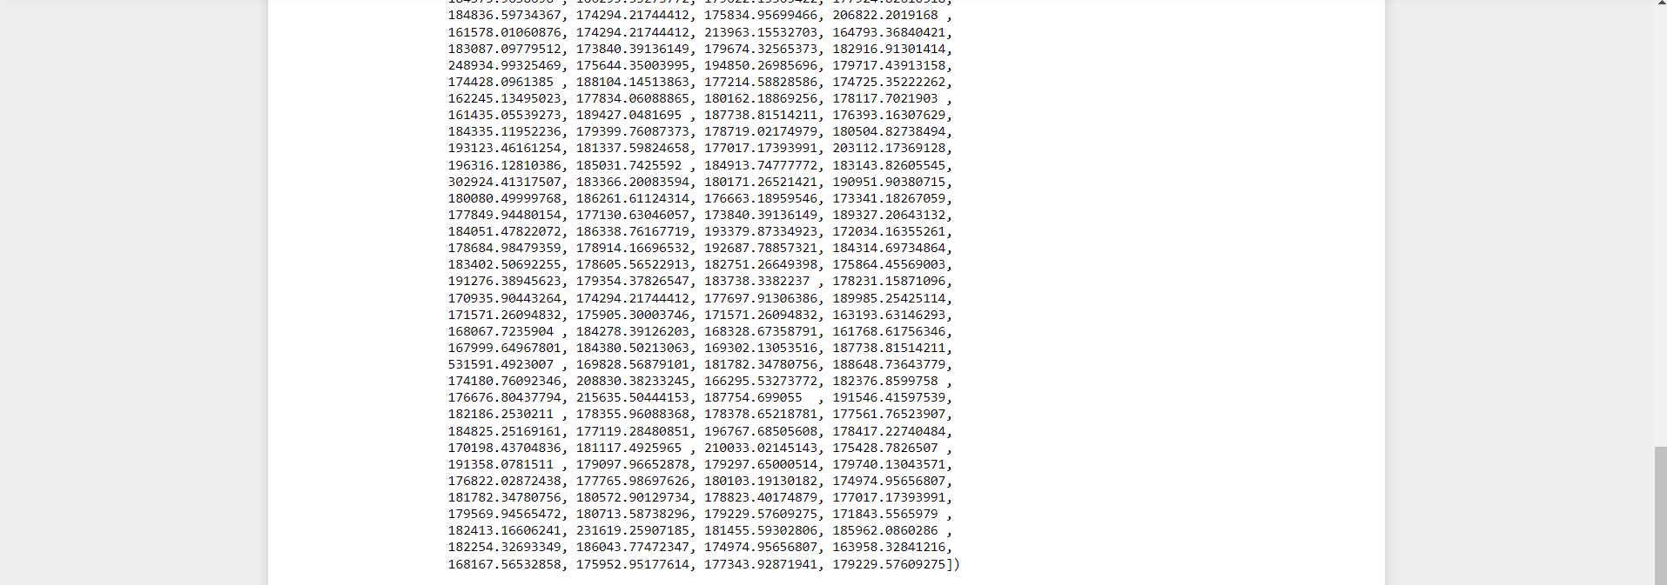 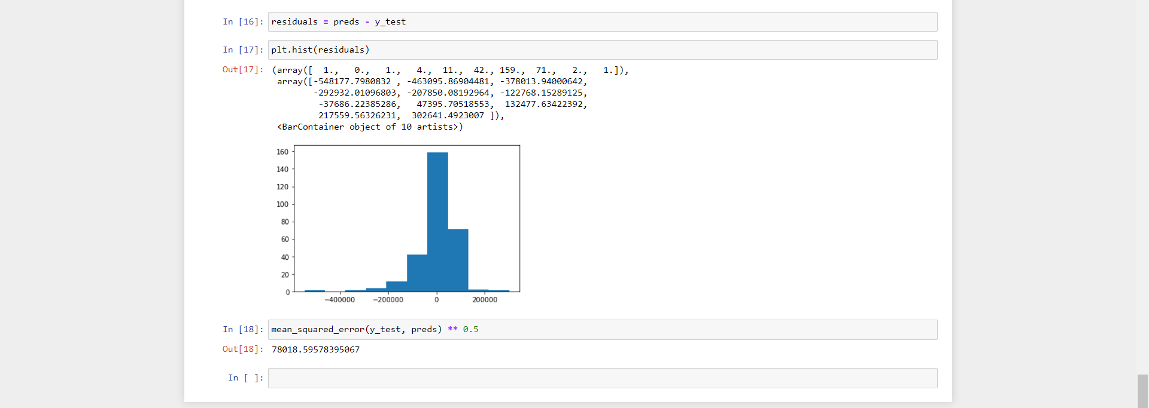

**Q8. Apply logistic regression Model techniques to predict the data on dataset - social_network_ads.csv.**

**Ans:**

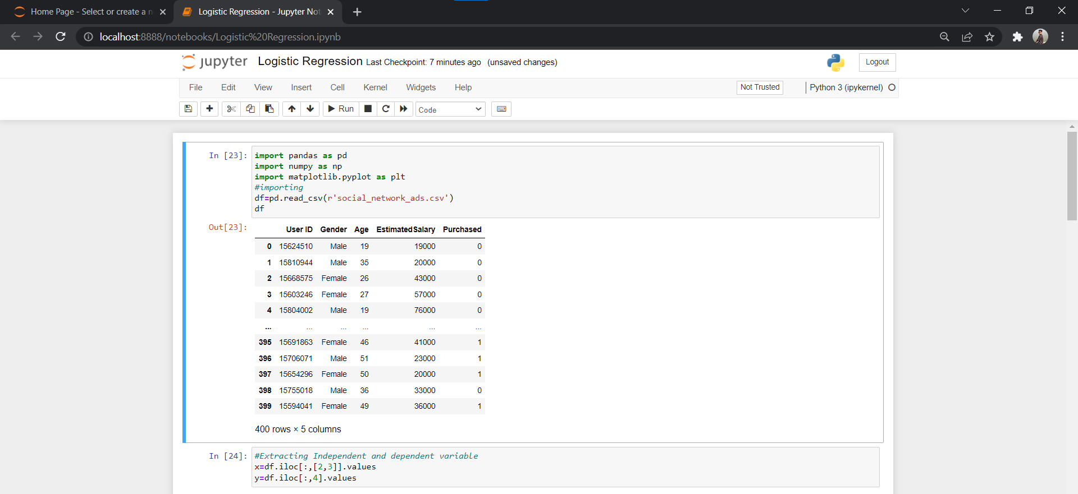 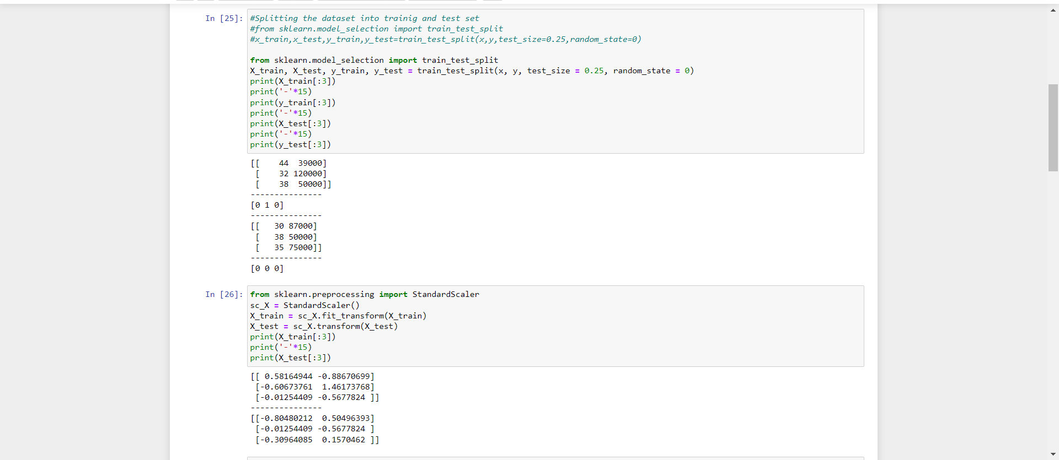 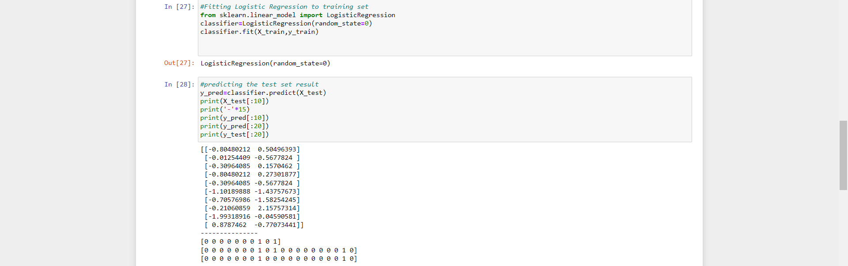 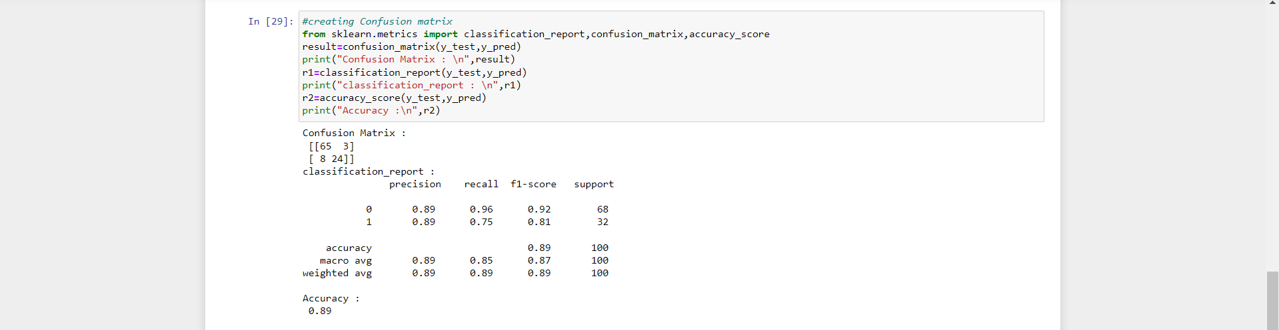 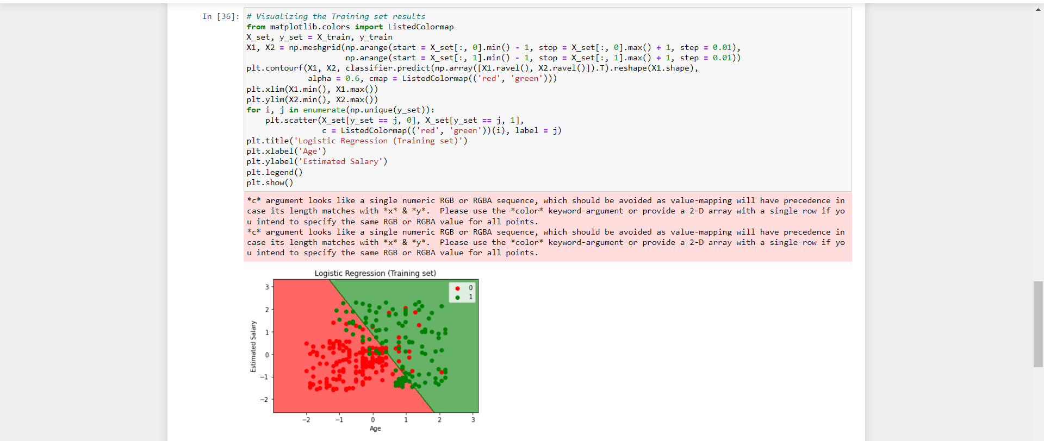 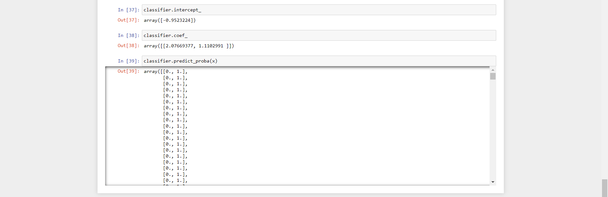

**Q9. Apply Clustering algorithms for unsupervised classification on dataset - Mall_Customers_data.csv**

**Ans:**

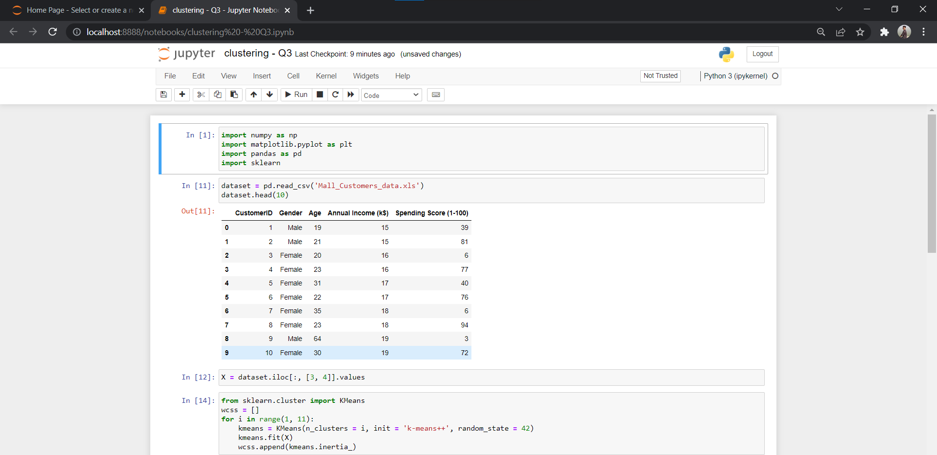 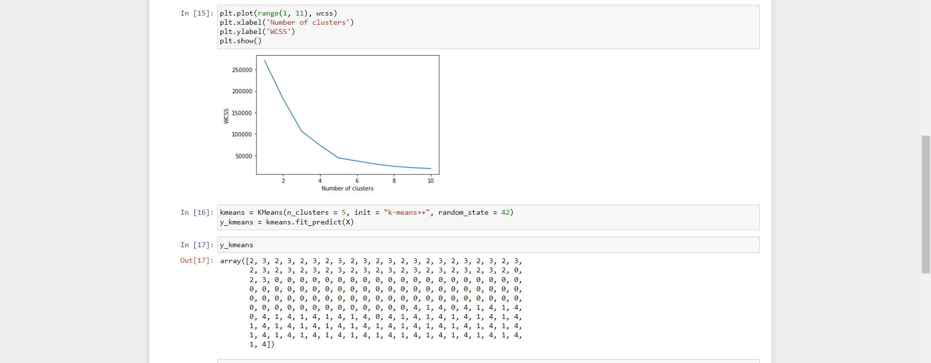 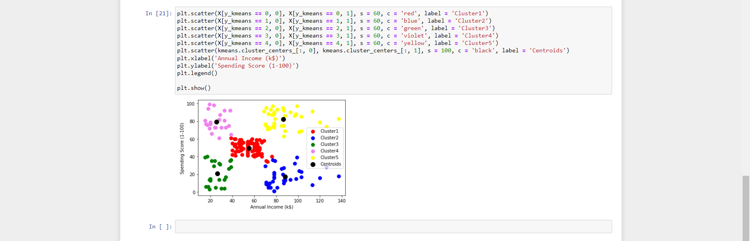

**Q10. Implement Decision Tree algorithm on the dataset- iris.csv**

**Ans:**

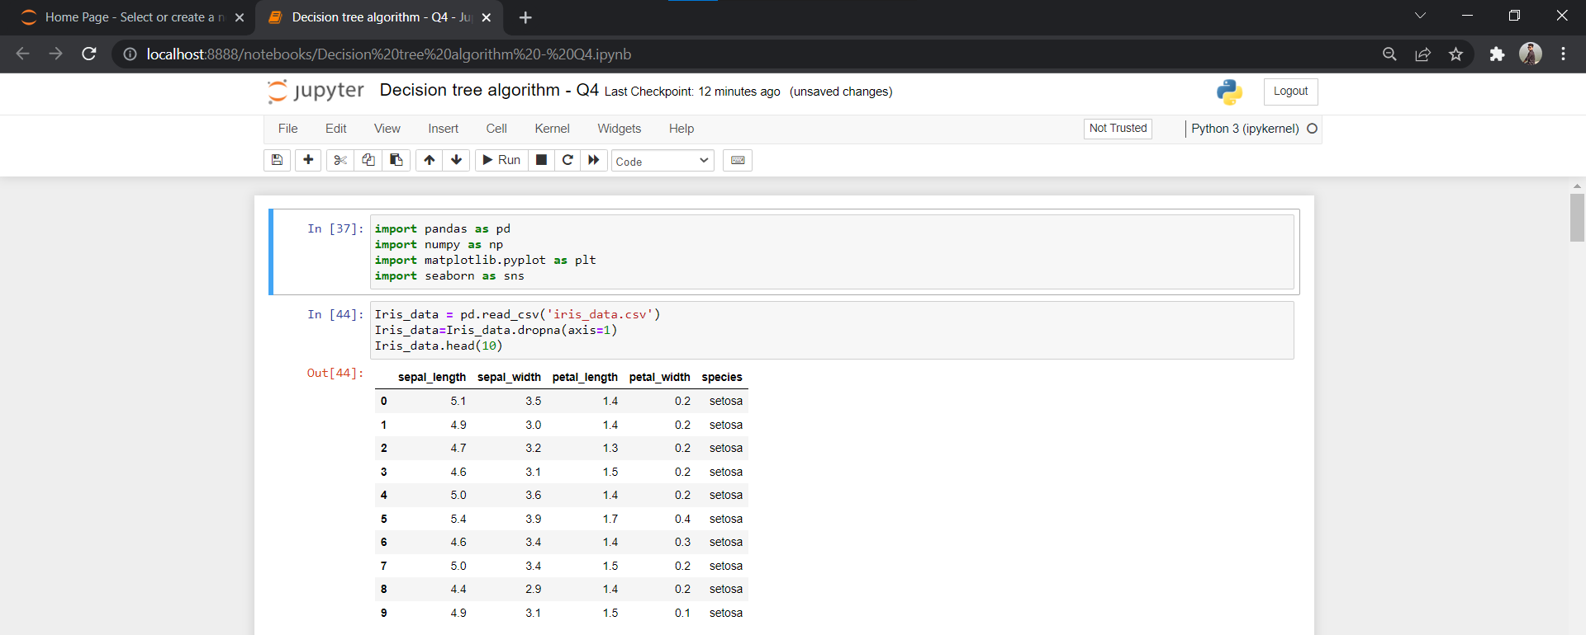 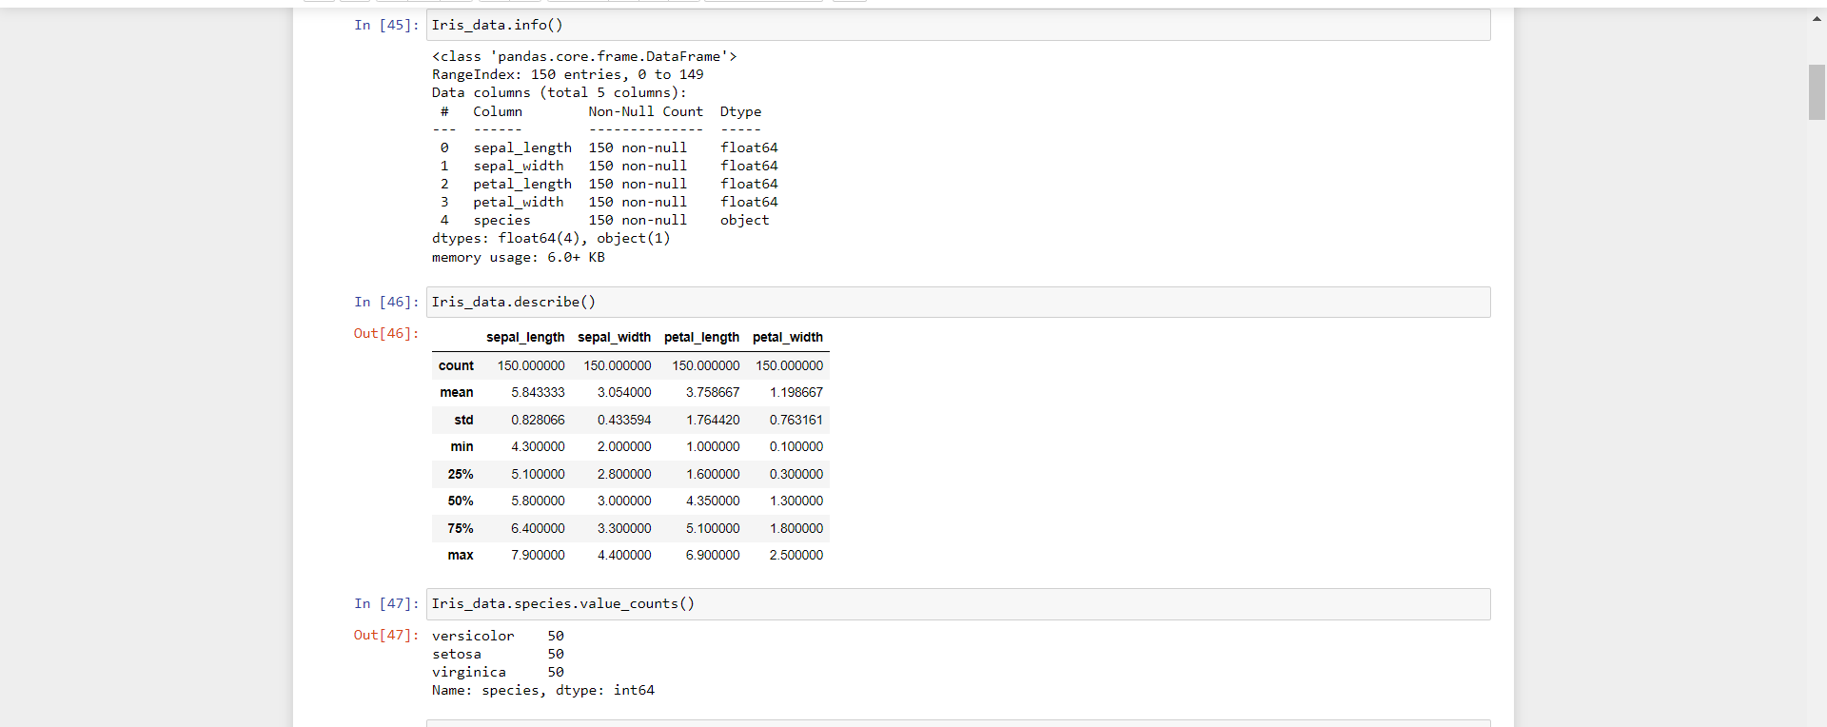 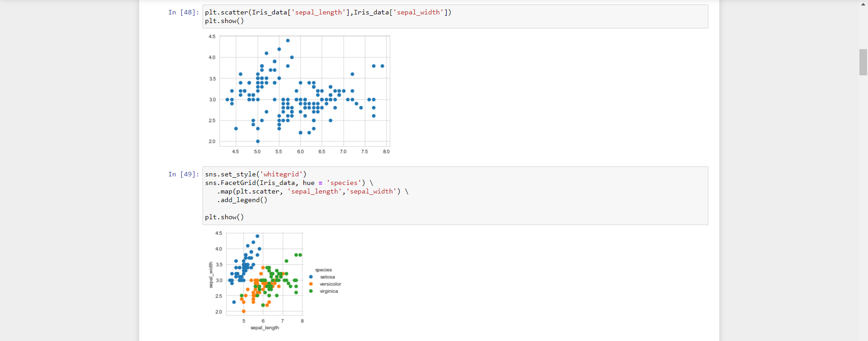 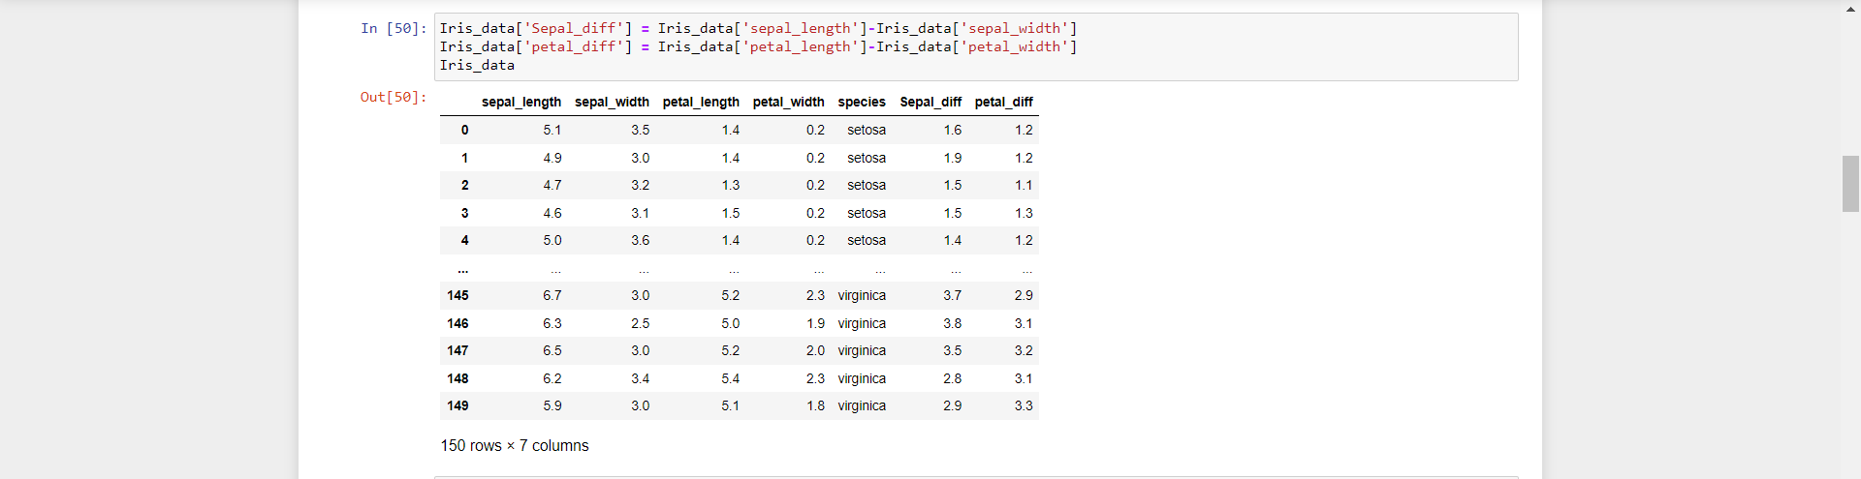 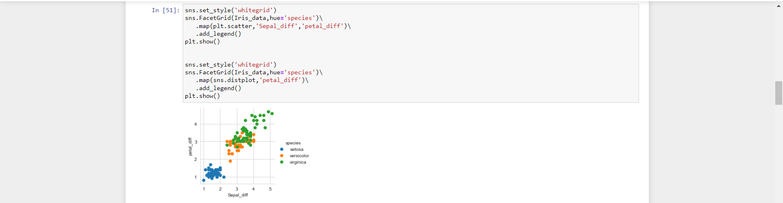 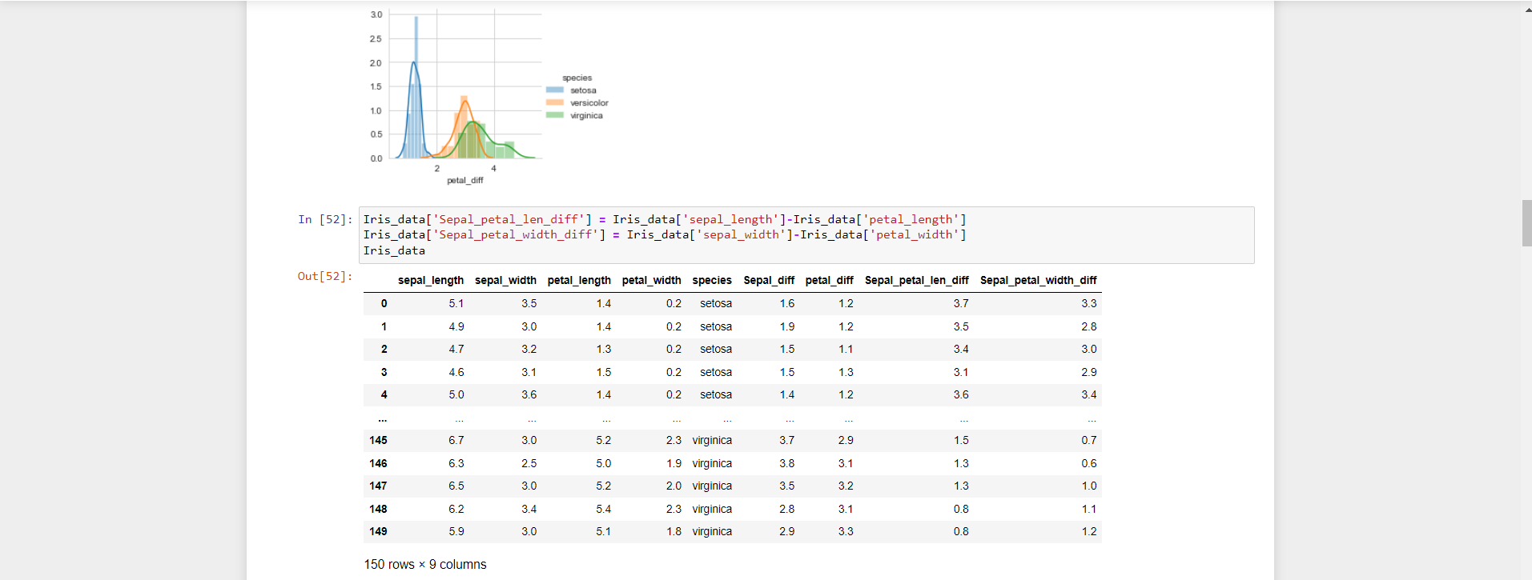 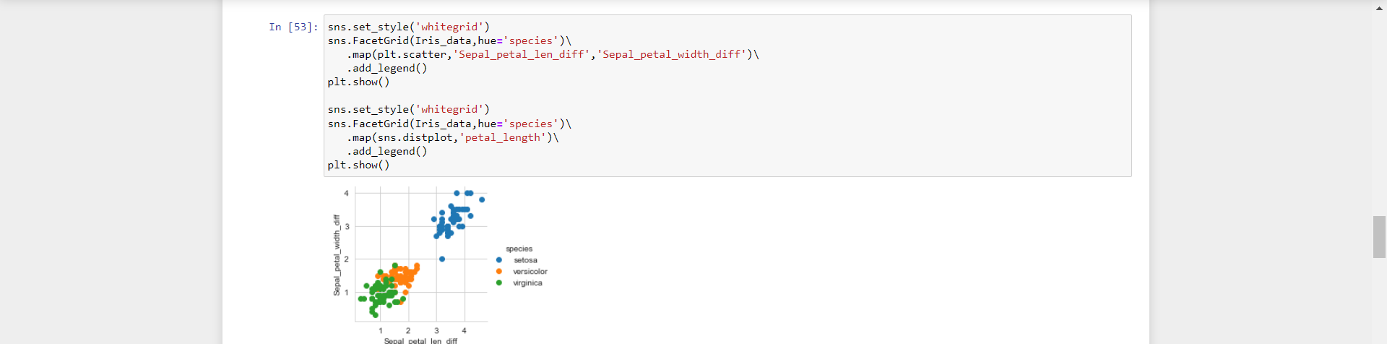 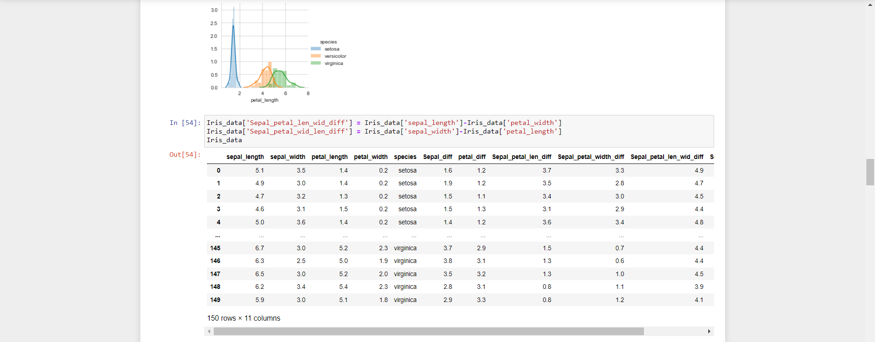 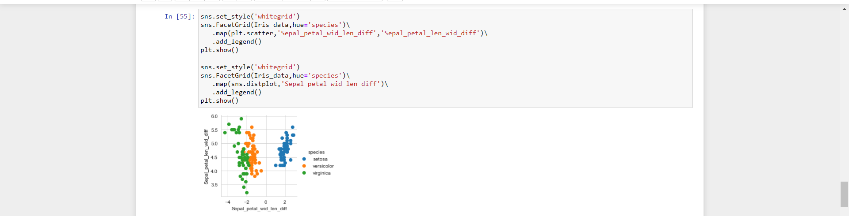 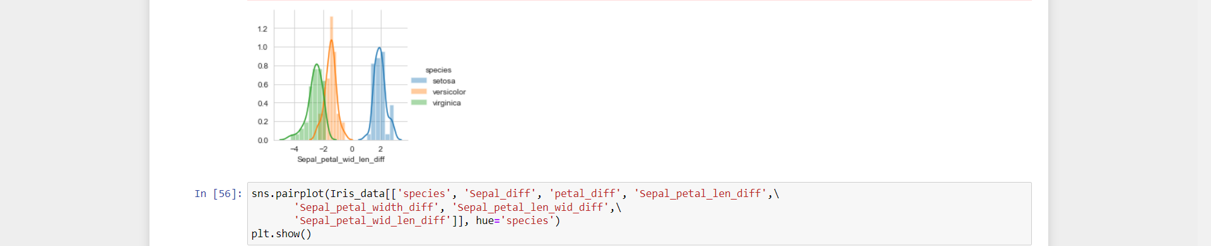 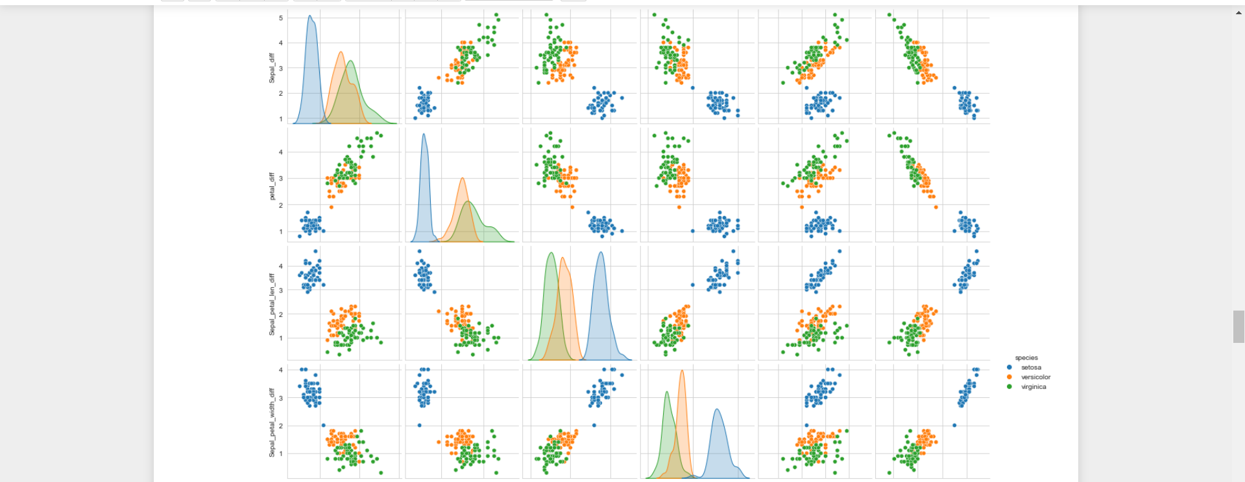 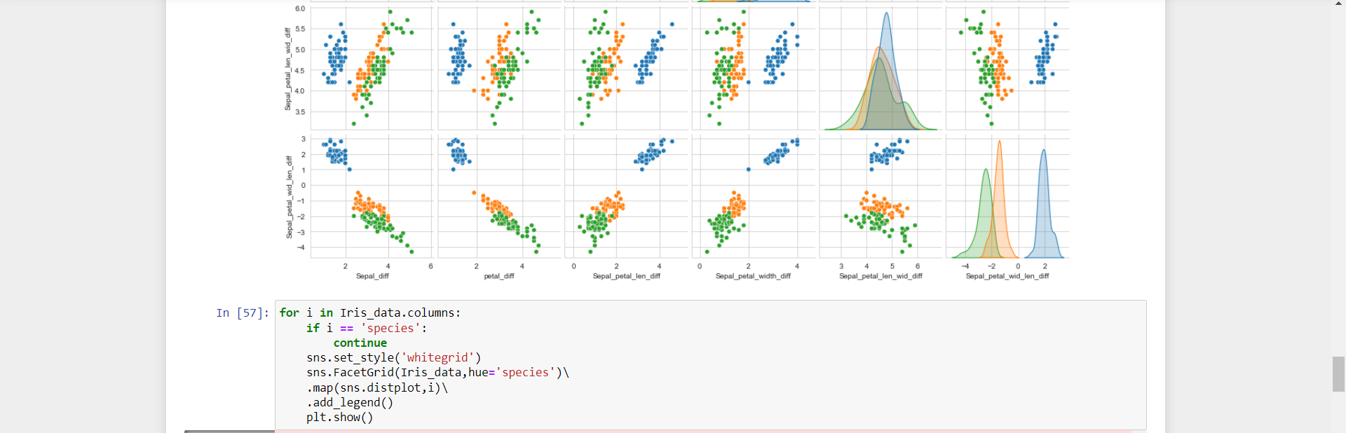 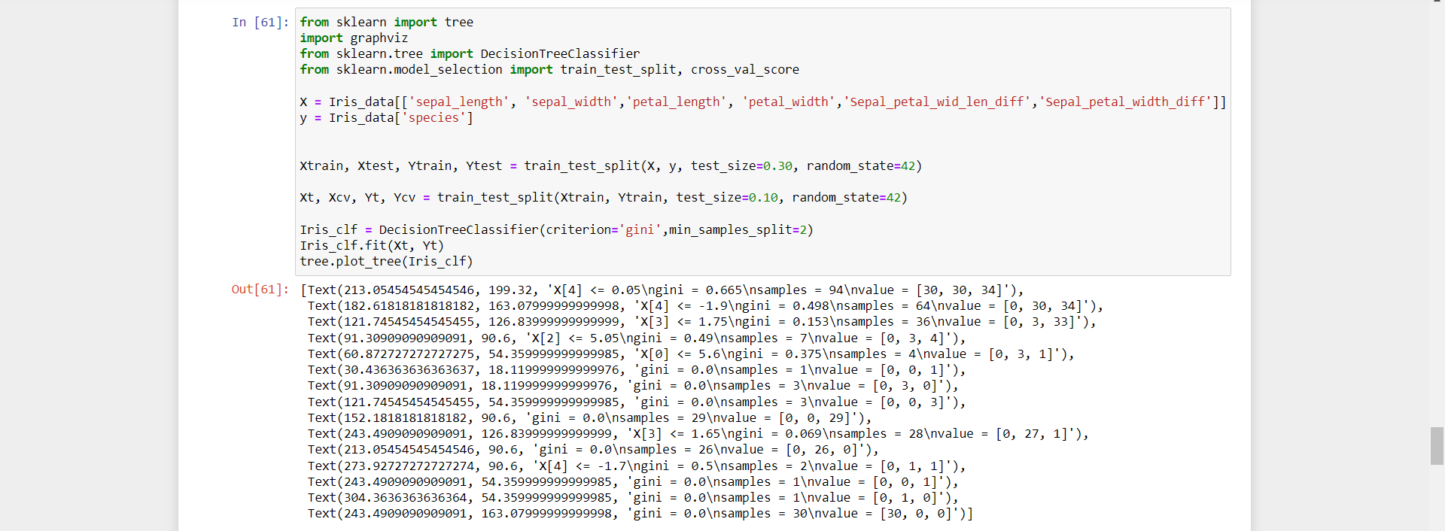 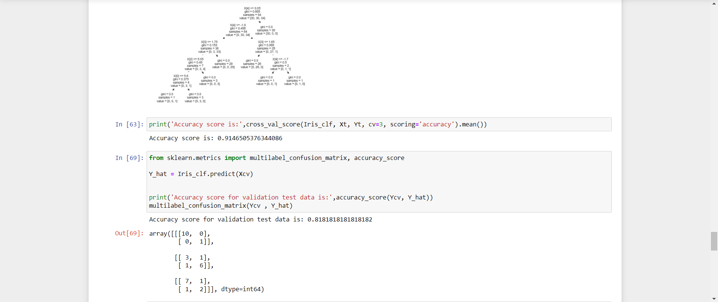 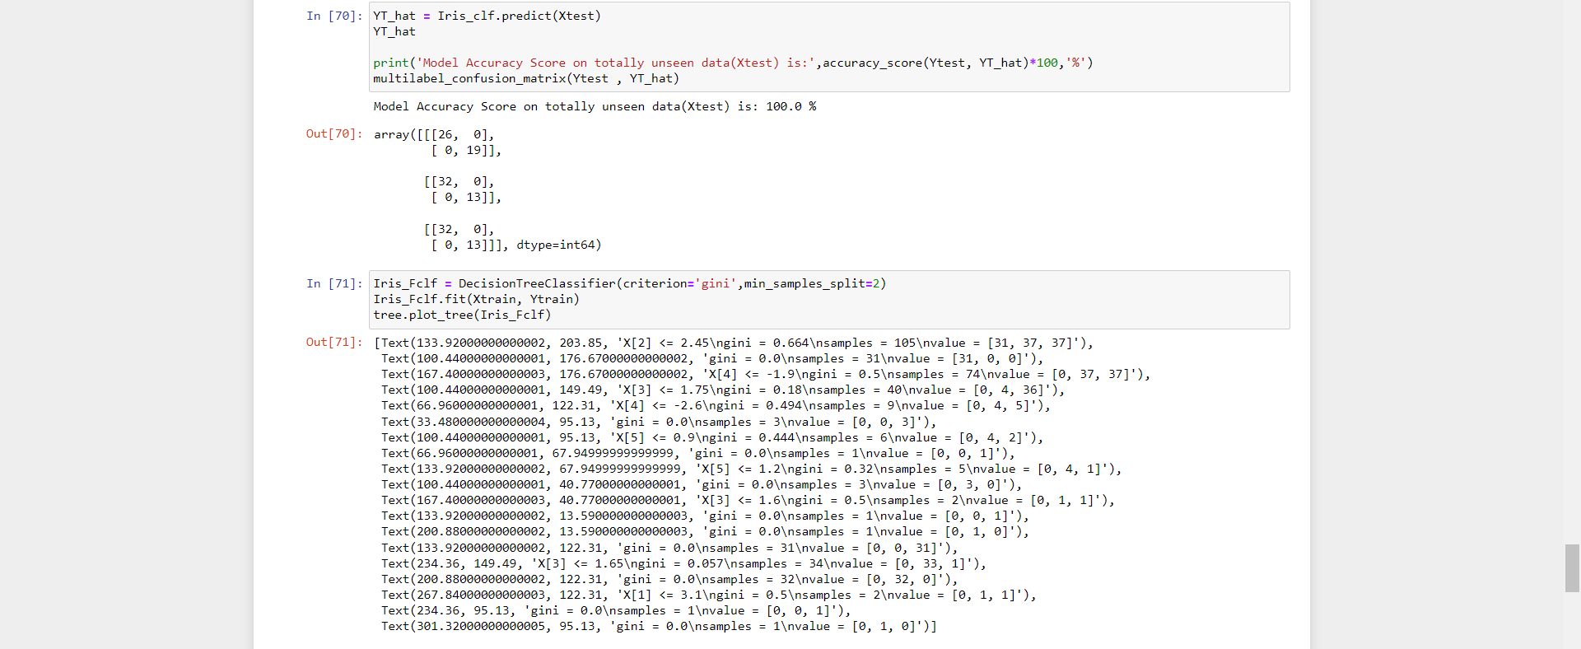 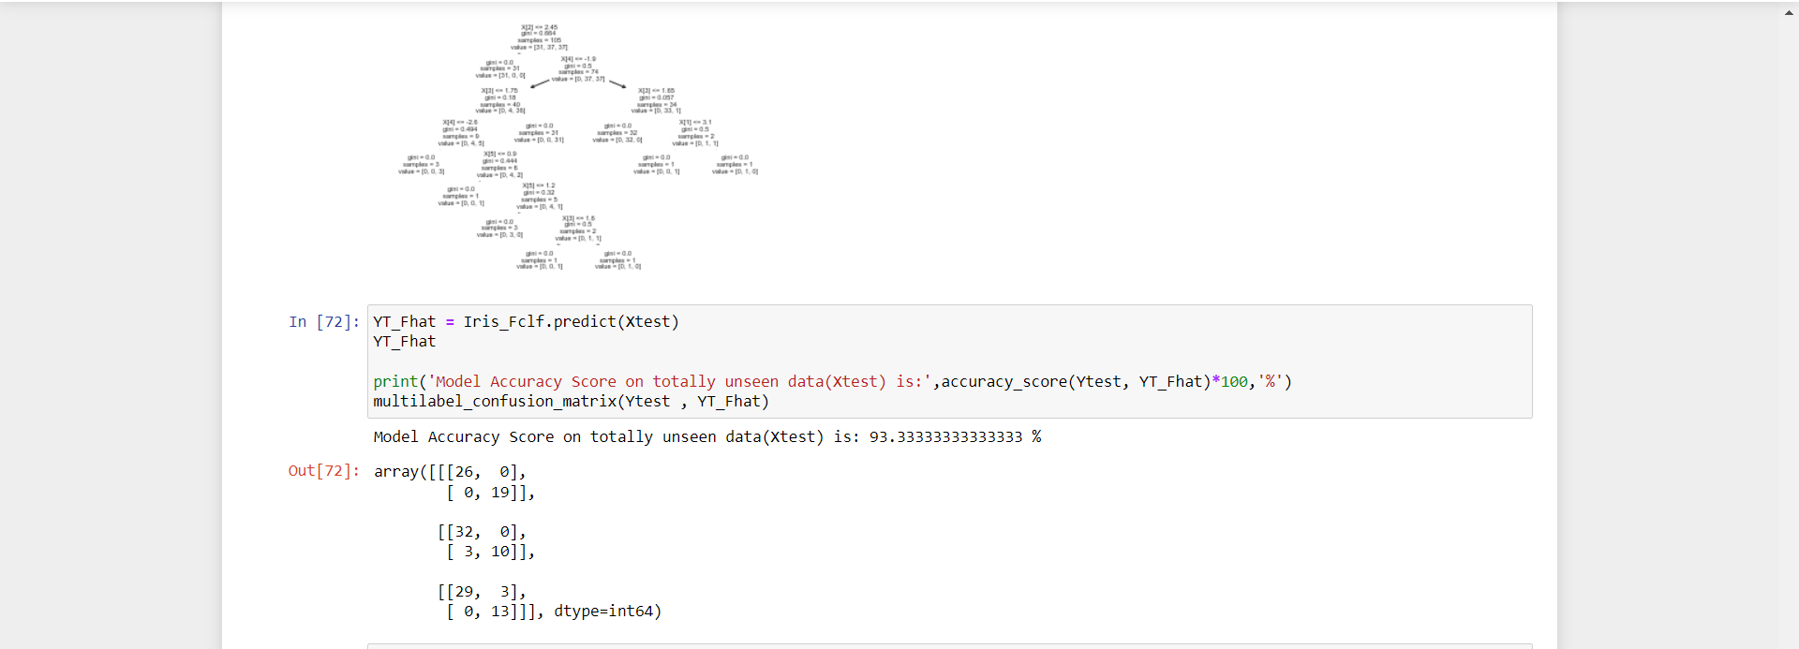 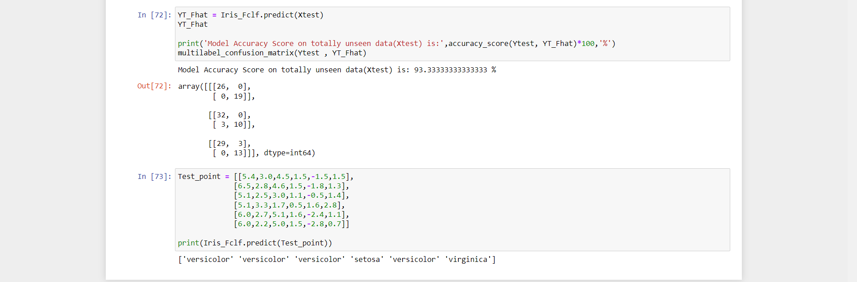

**Q11. Apply Bayesian classification on dataset – play.csv**

**Ans:**

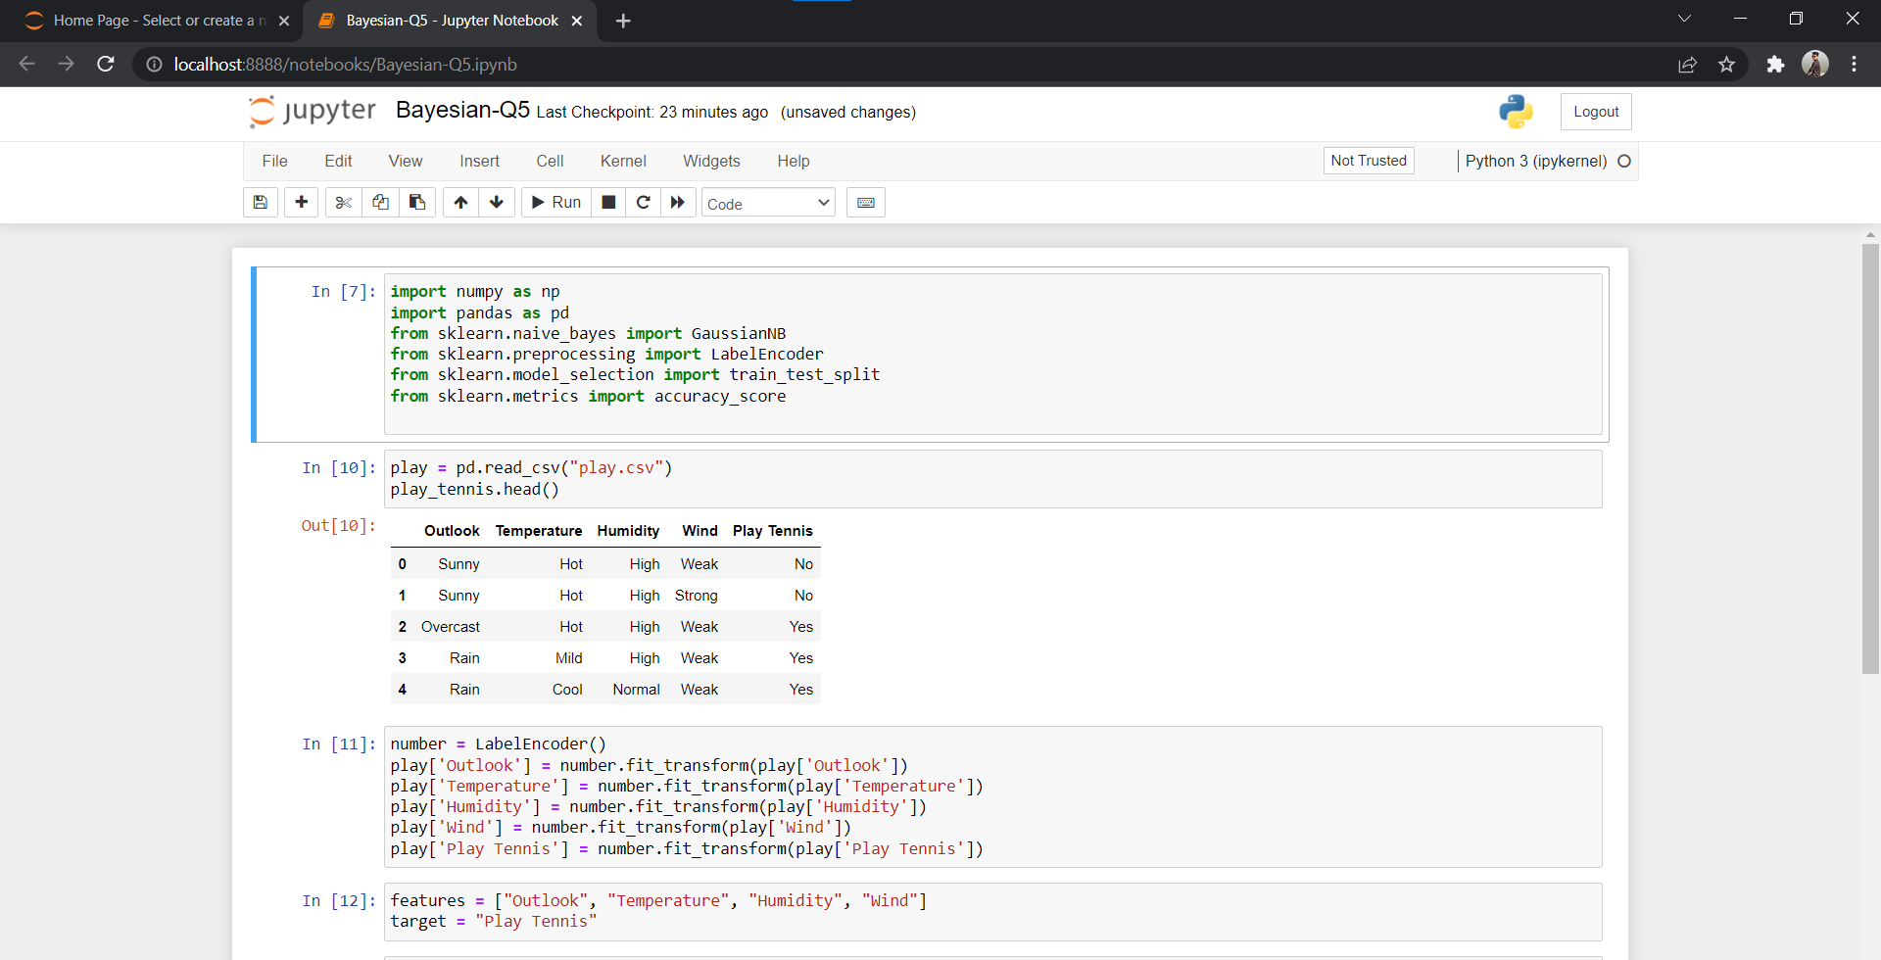 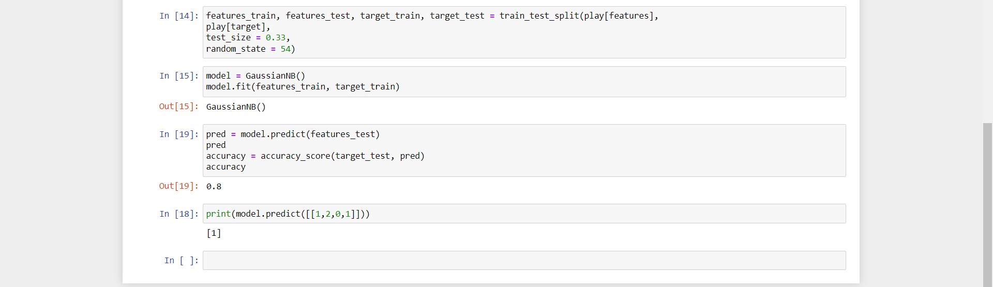

**Q12. Apply SVM classification on dataset - apples_and_oranges.csv**

**Ans:**

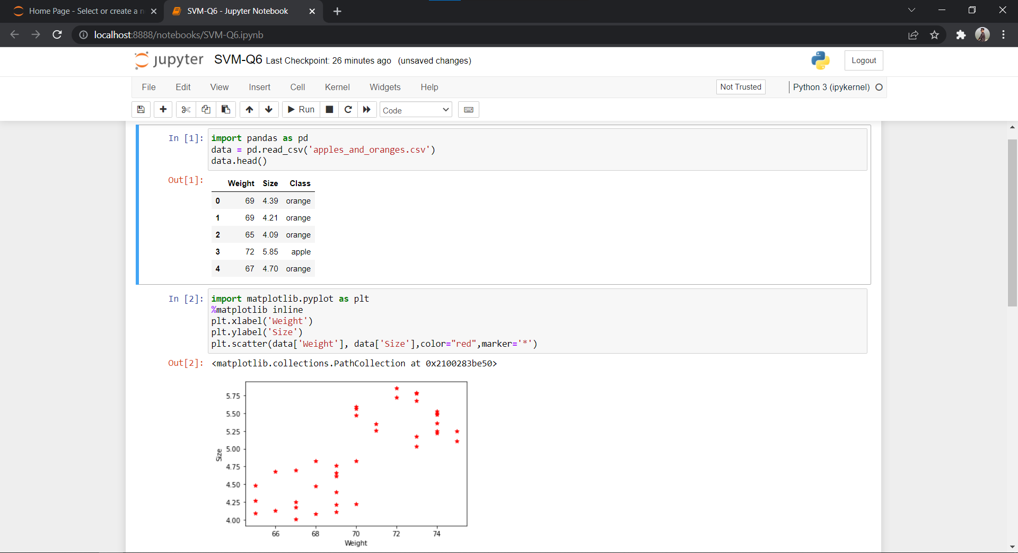

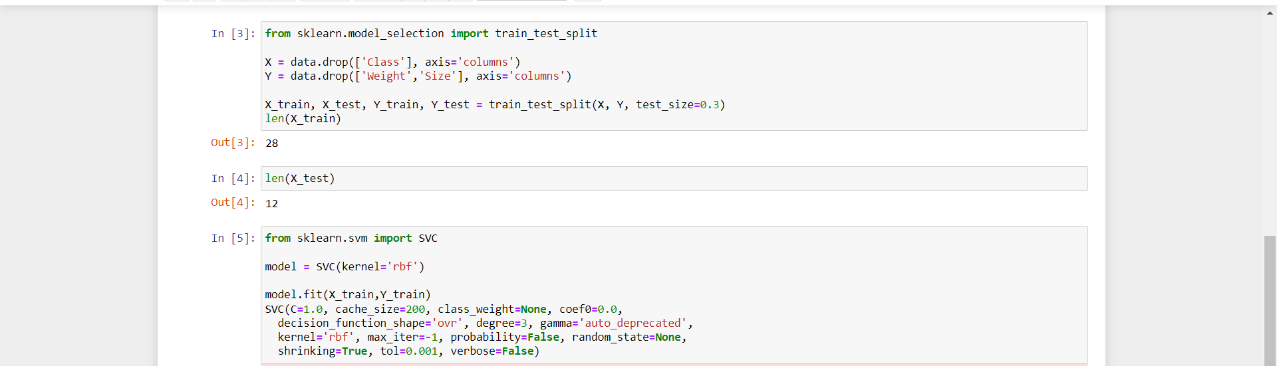 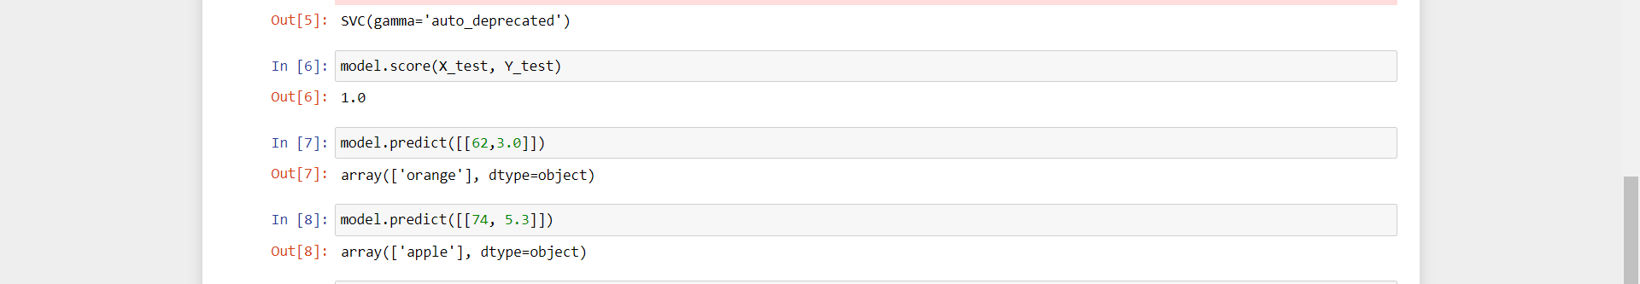

**Q13. Implement Association algorithms for supervised classification on dataset - retail.csv**

**Ans:**

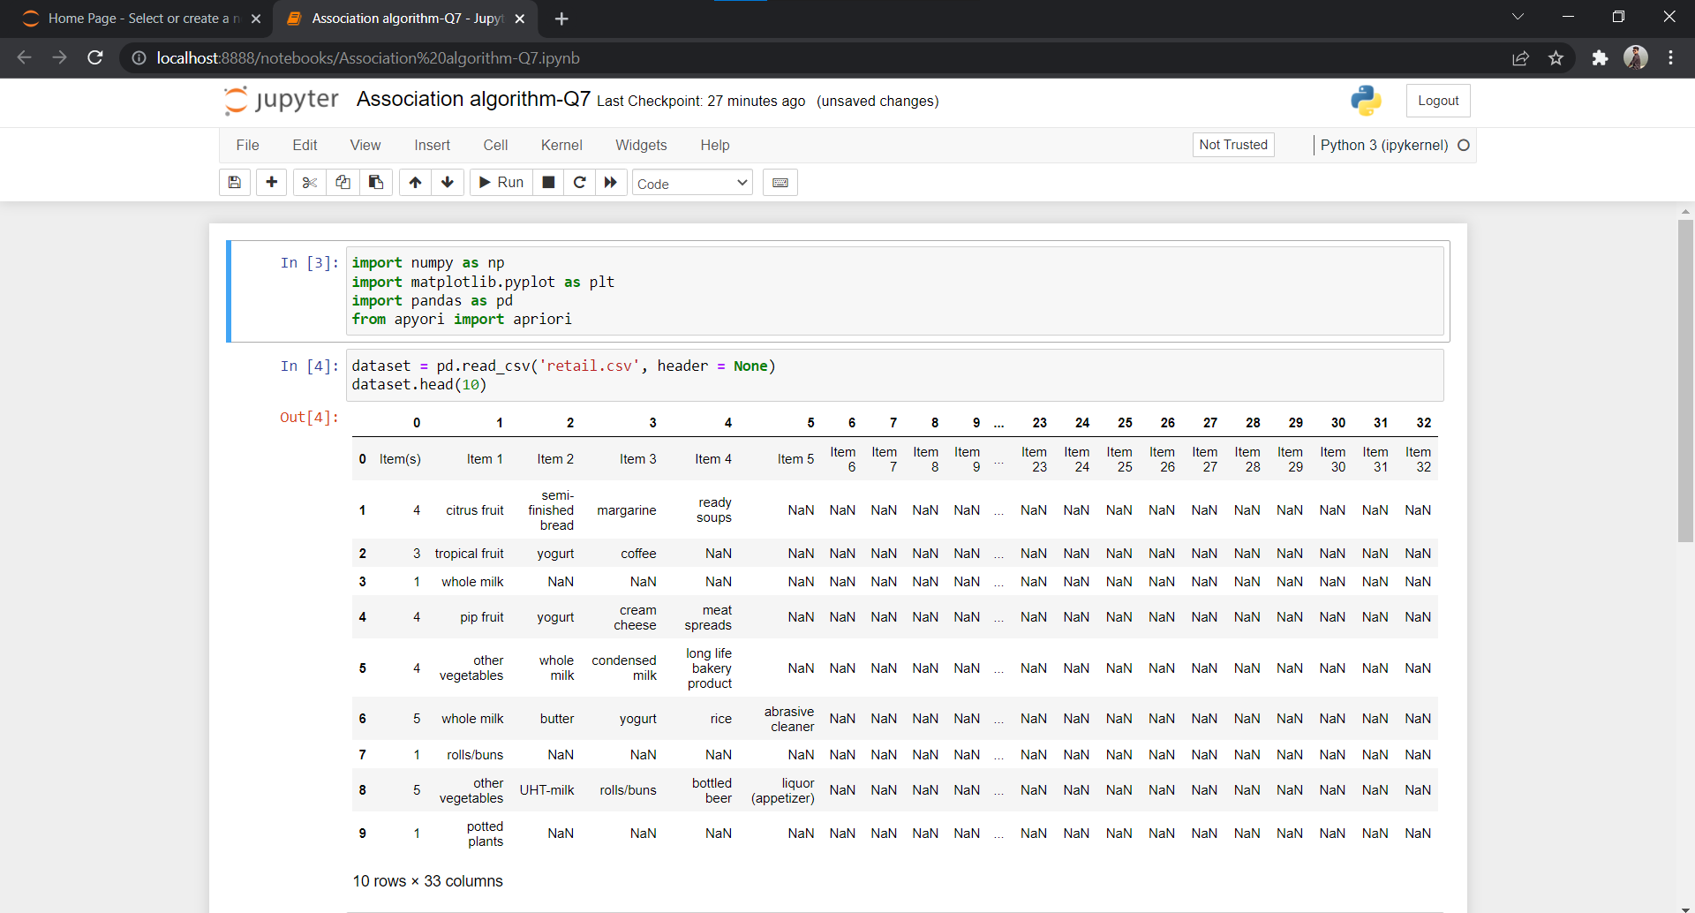 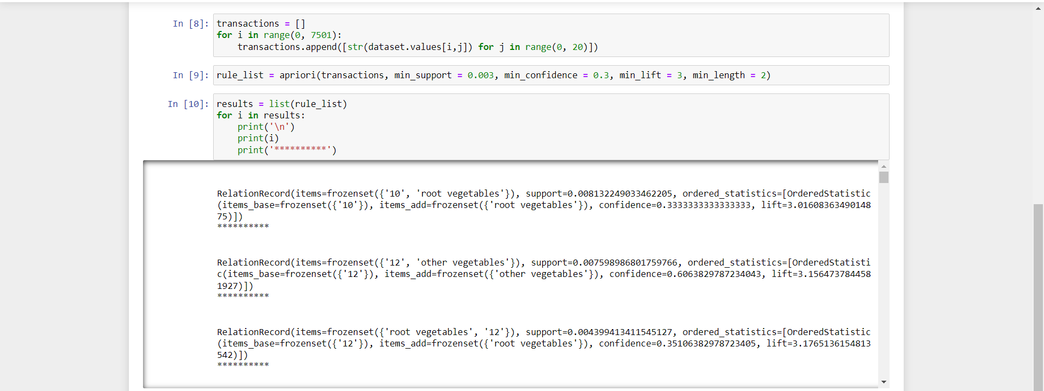 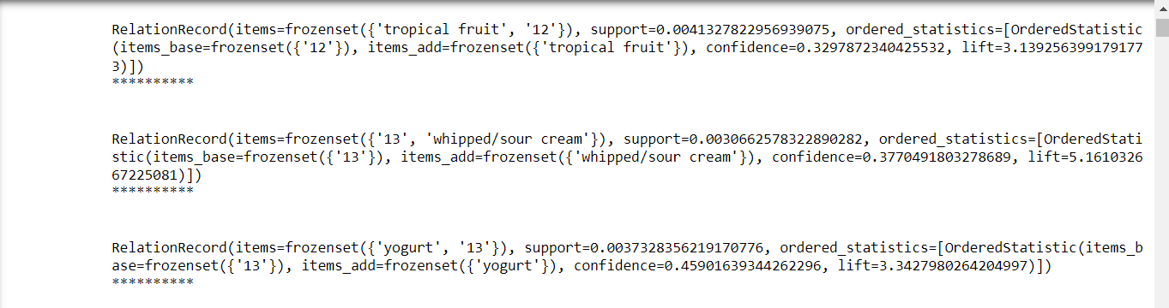 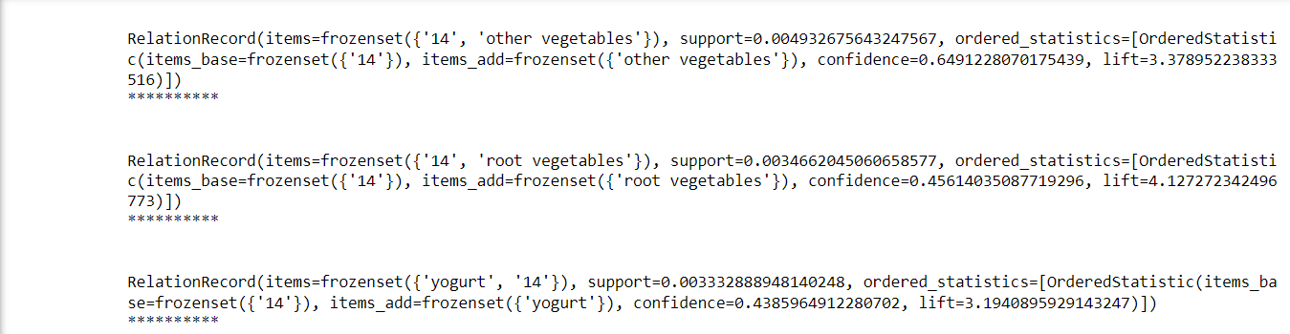 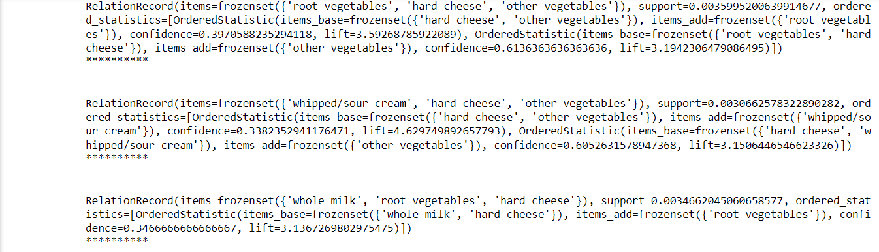 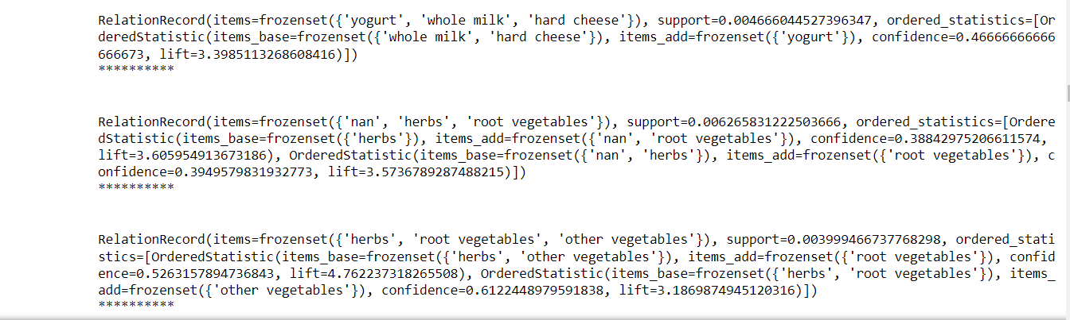 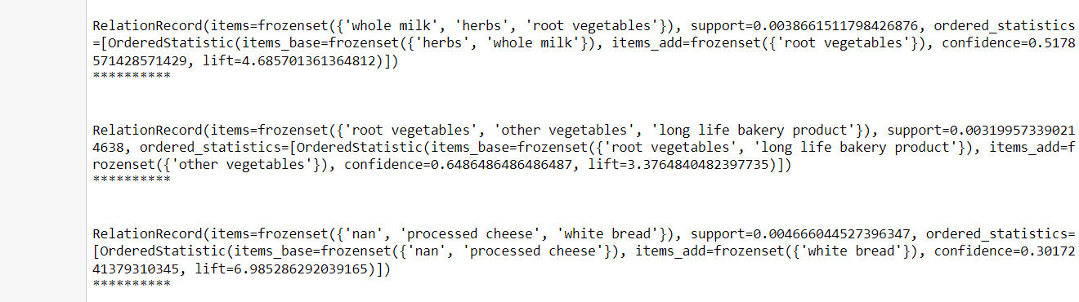 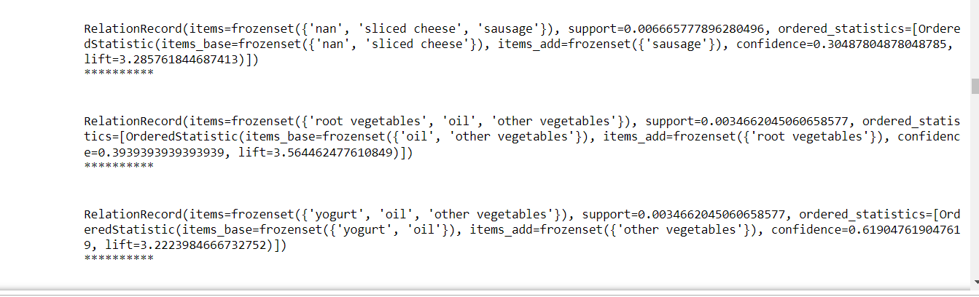

**Q.14 Text Mining algorithms on unstructured dataset.**

**Output:**

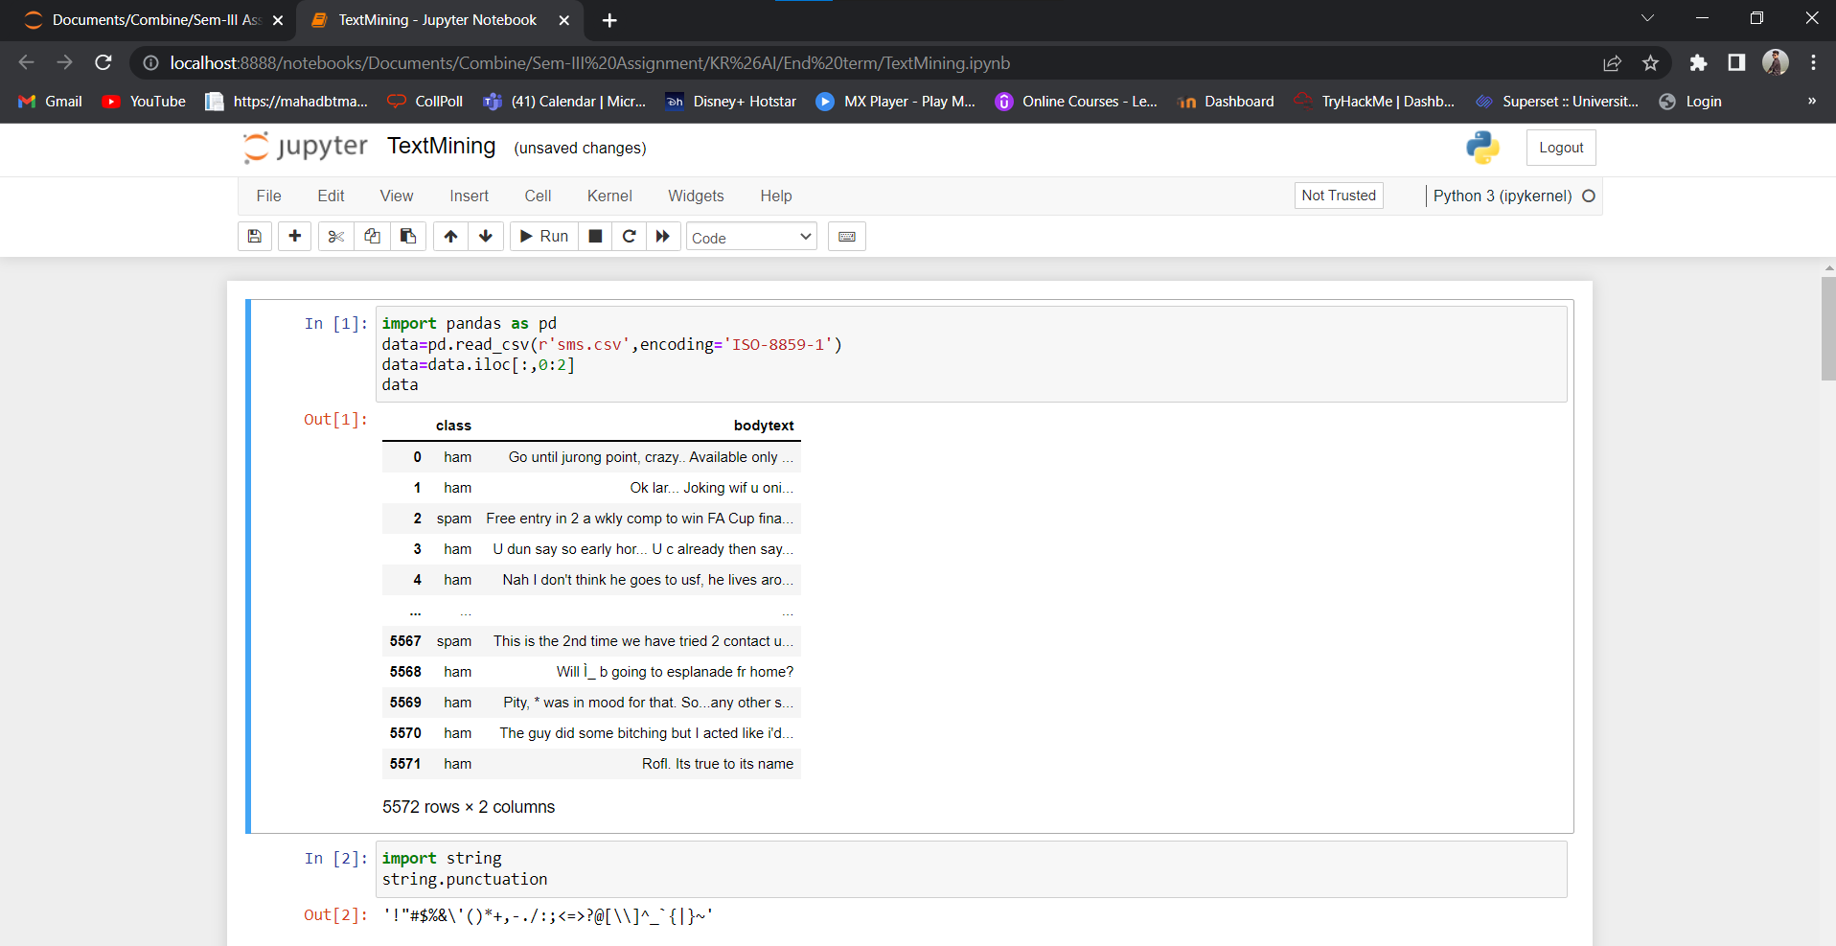

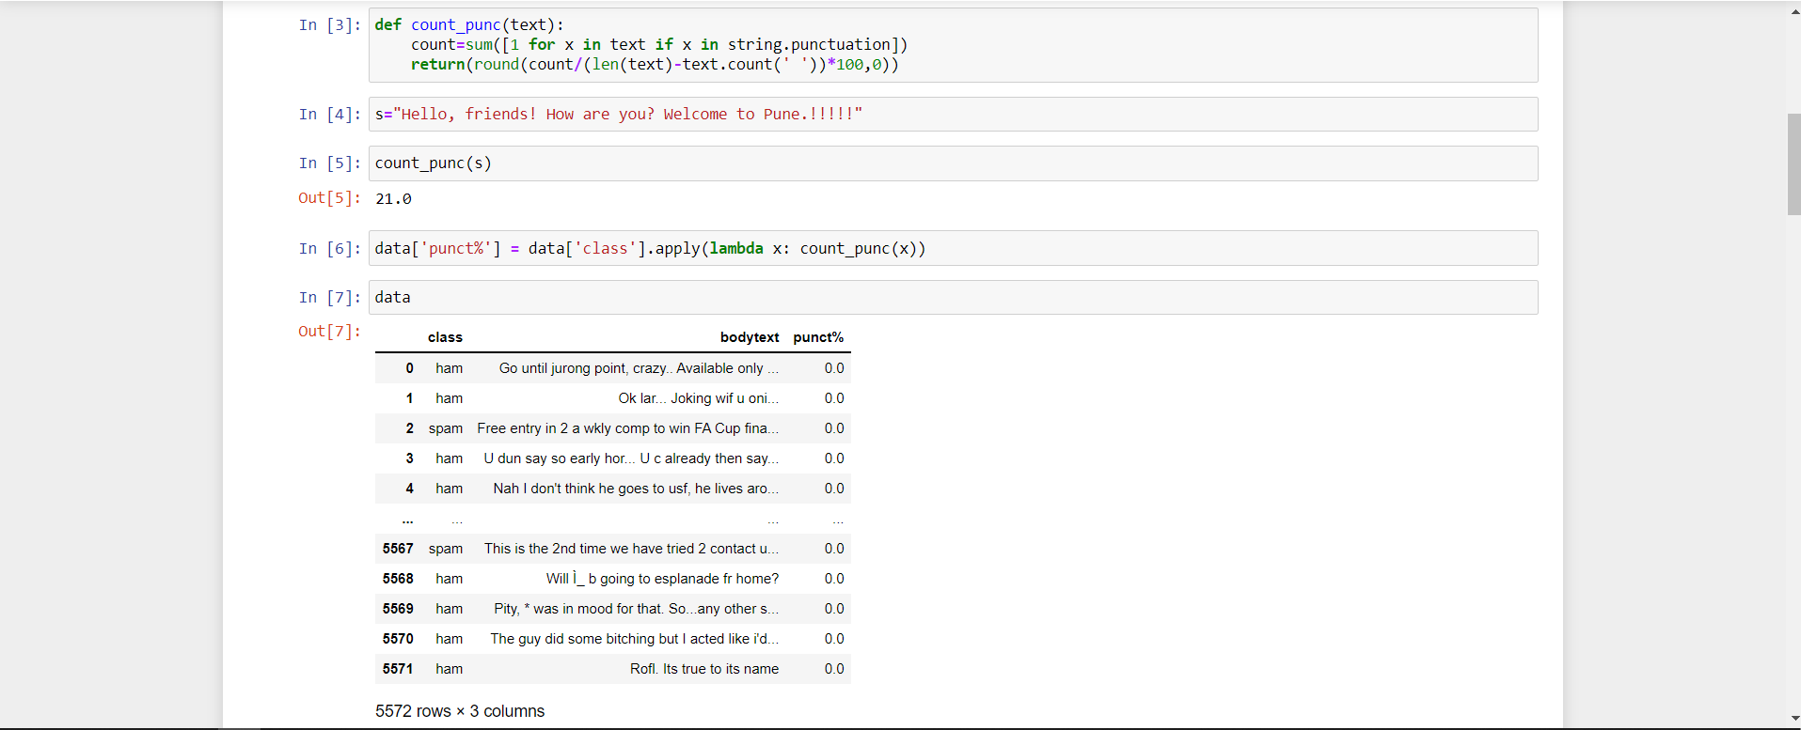 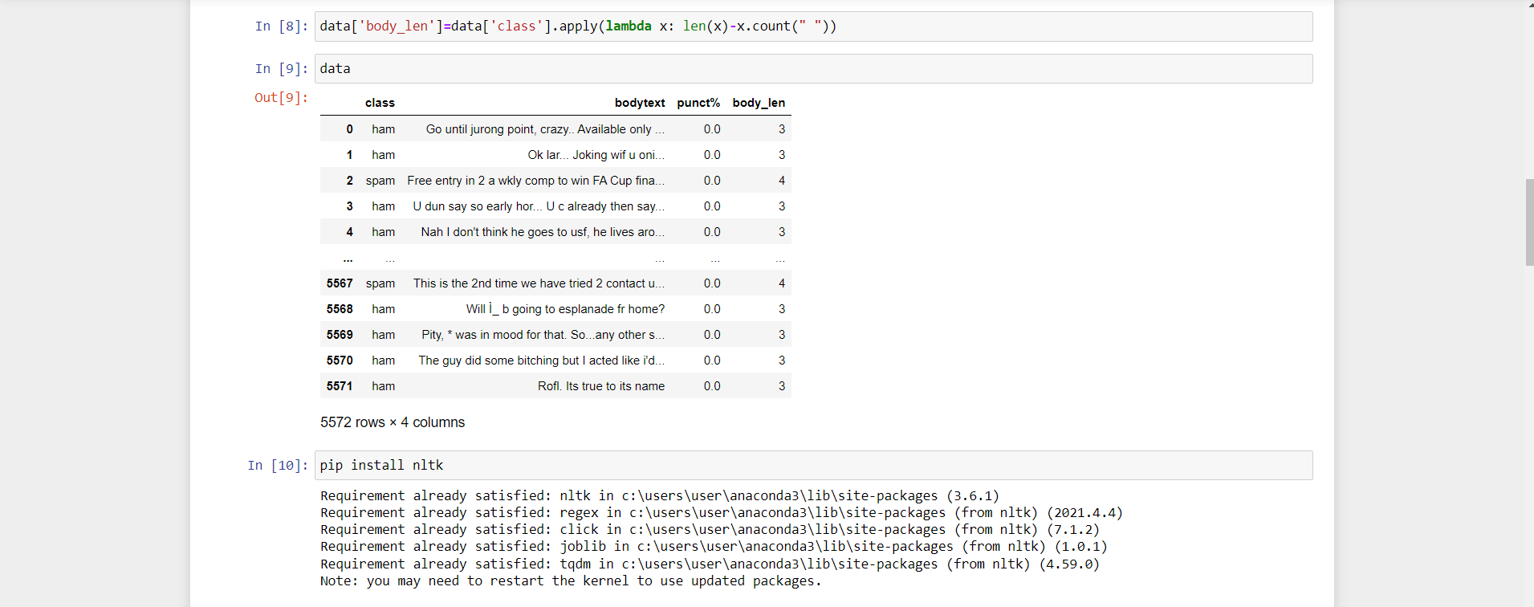 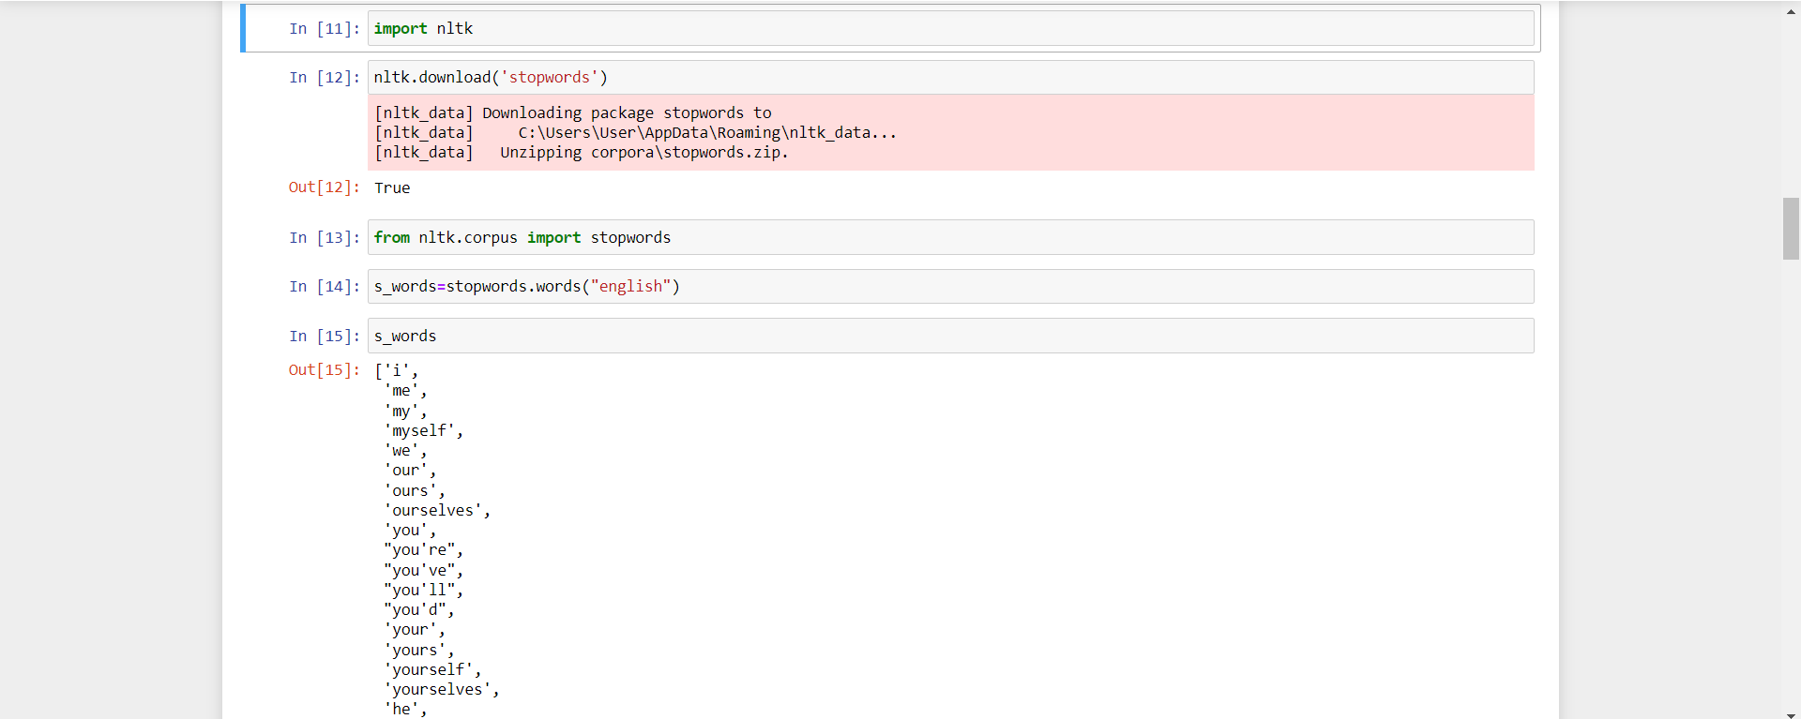

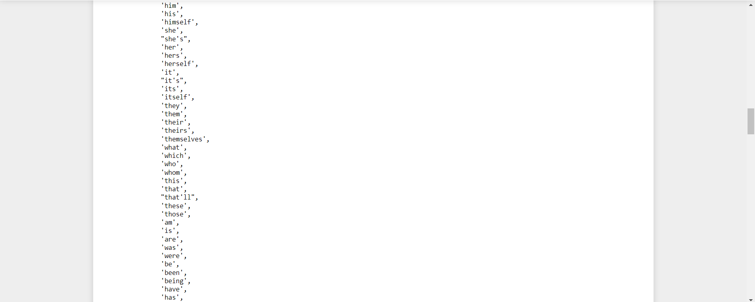 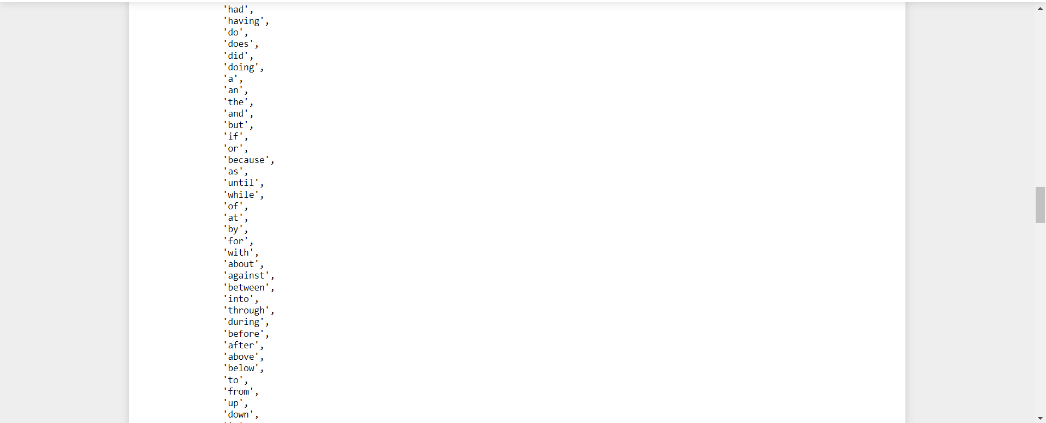 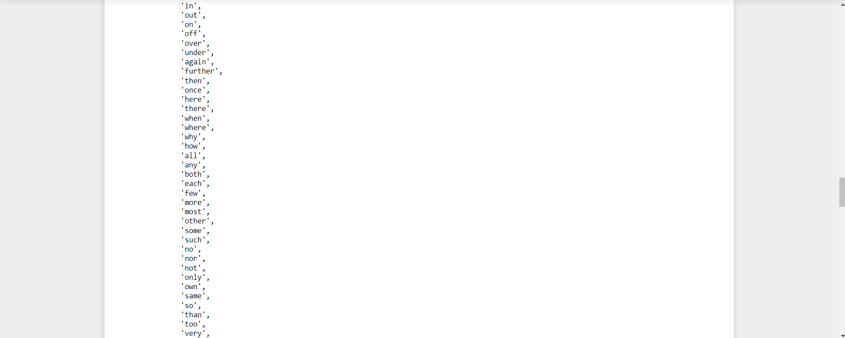

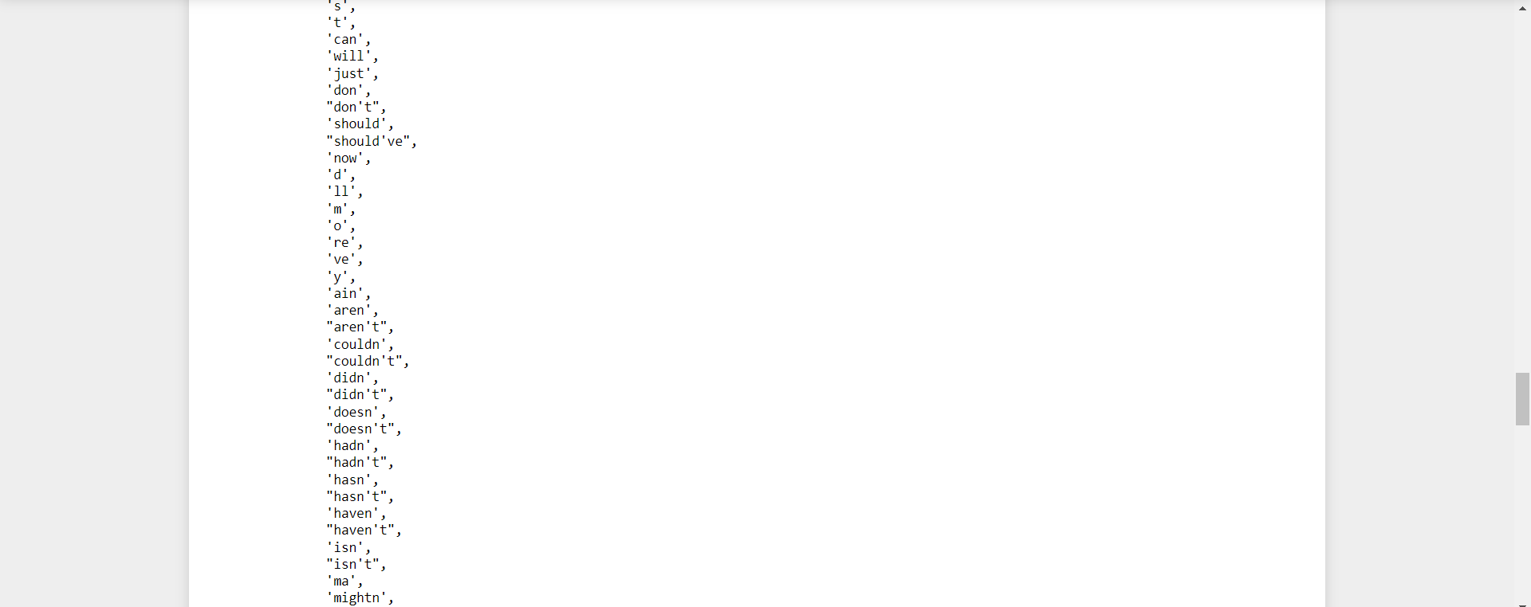 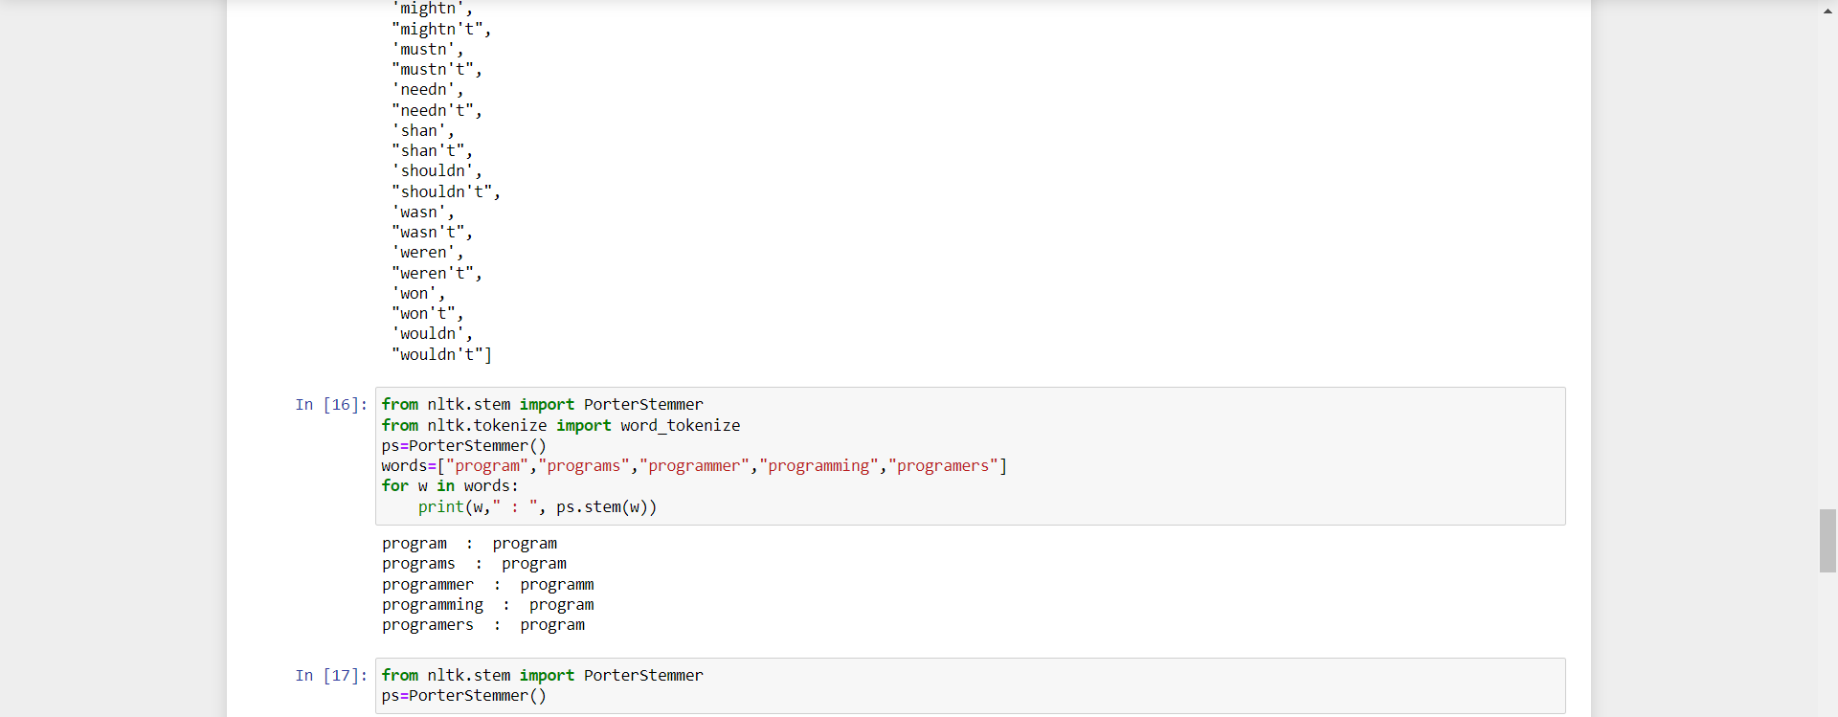 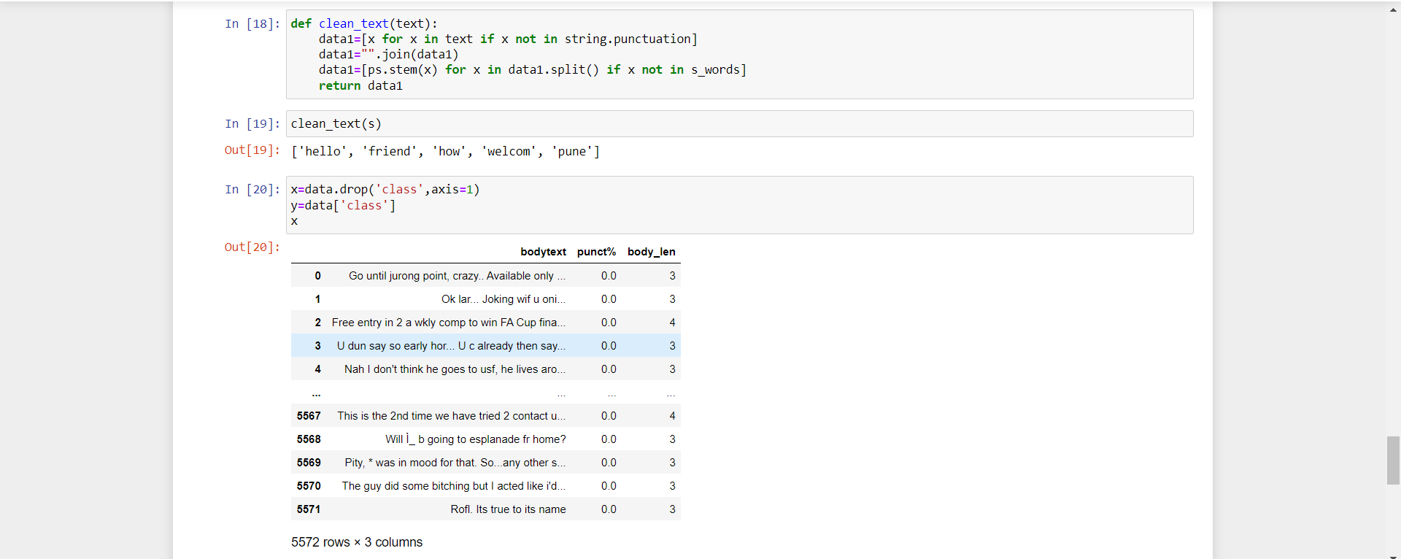

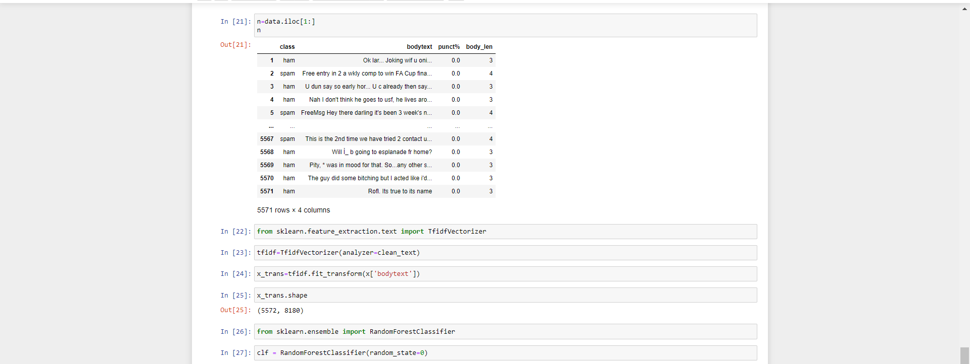

**Q.15 Plot the cluster data using python visualizations.**

**Output:**

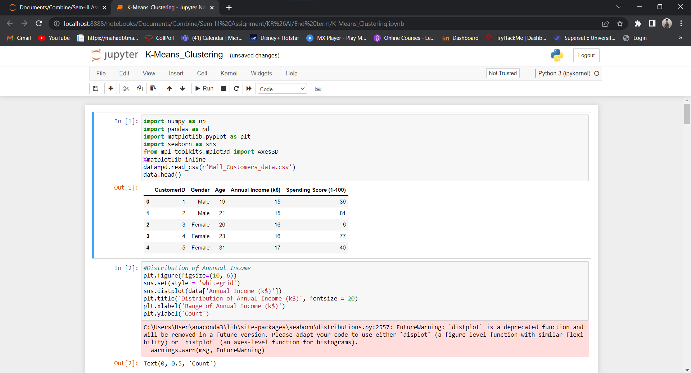 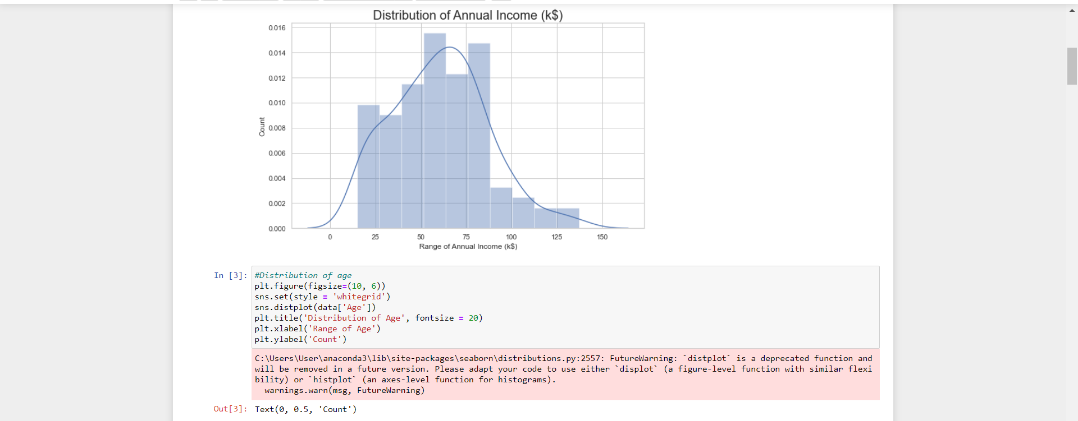

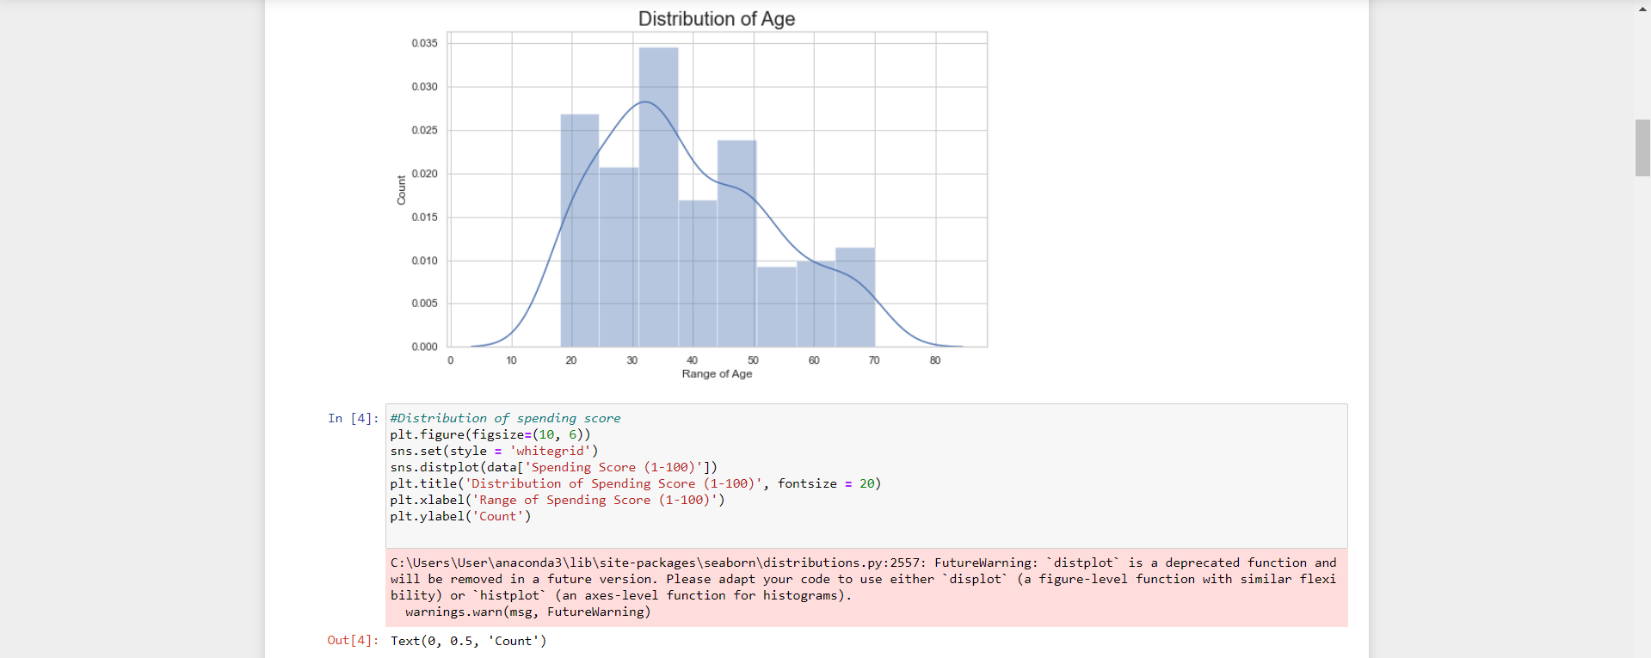 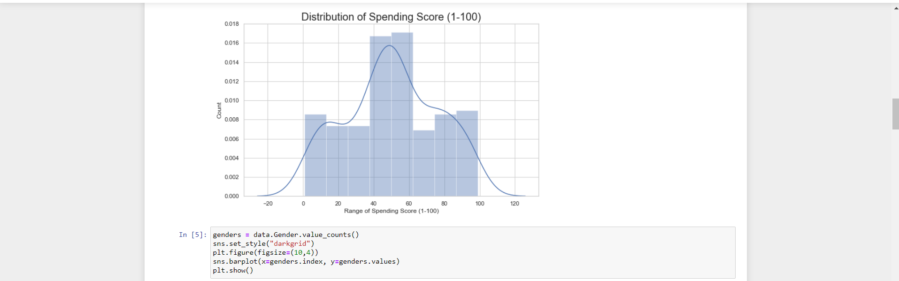 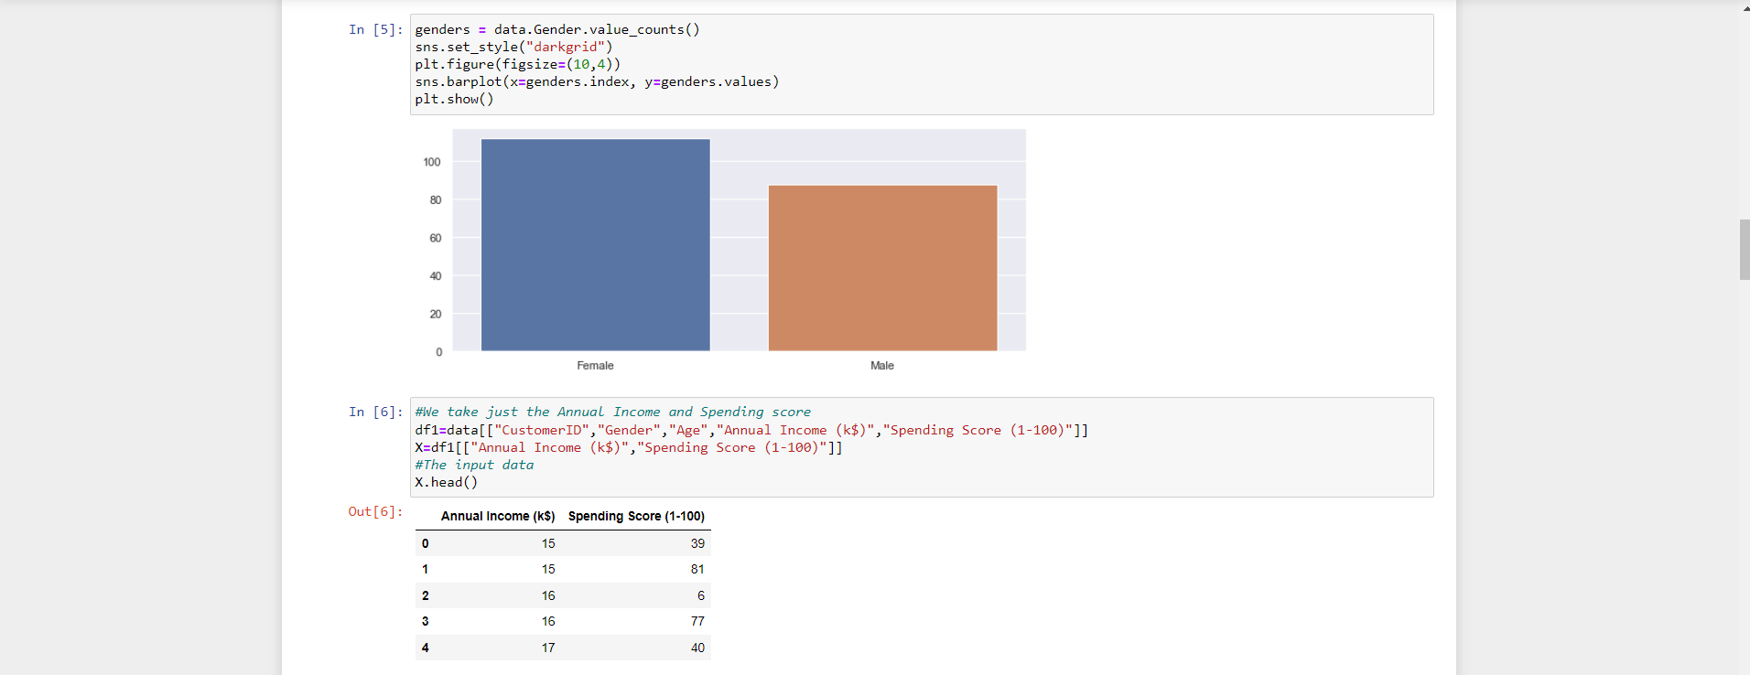

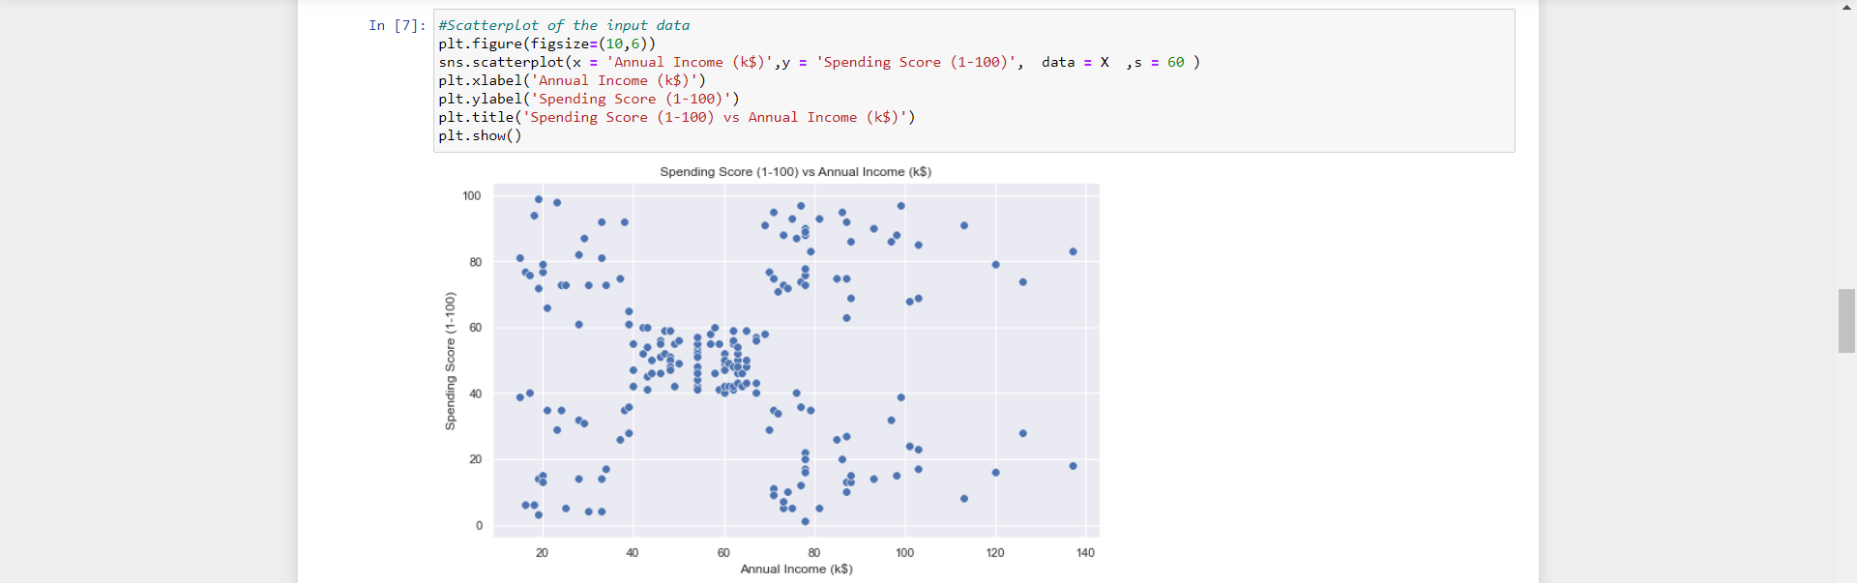 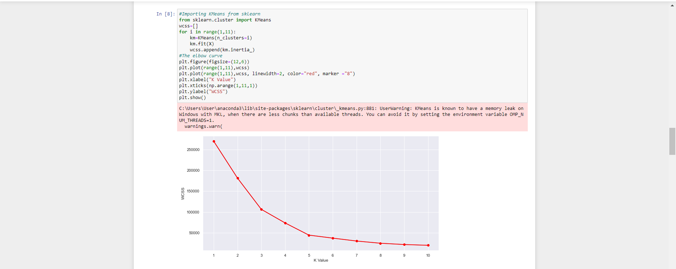 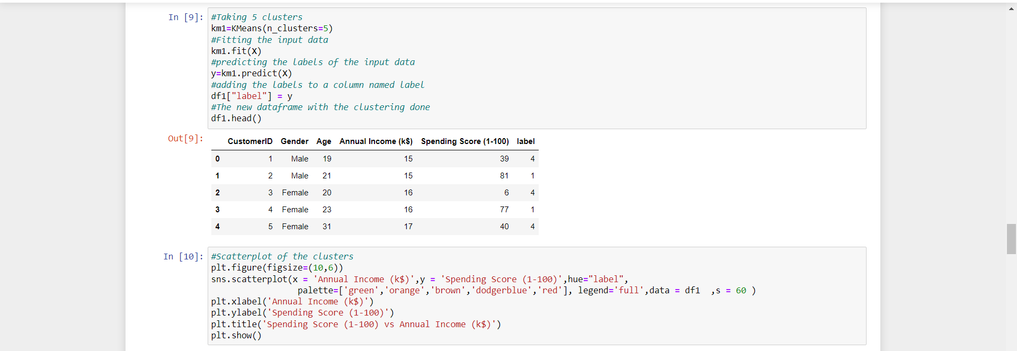

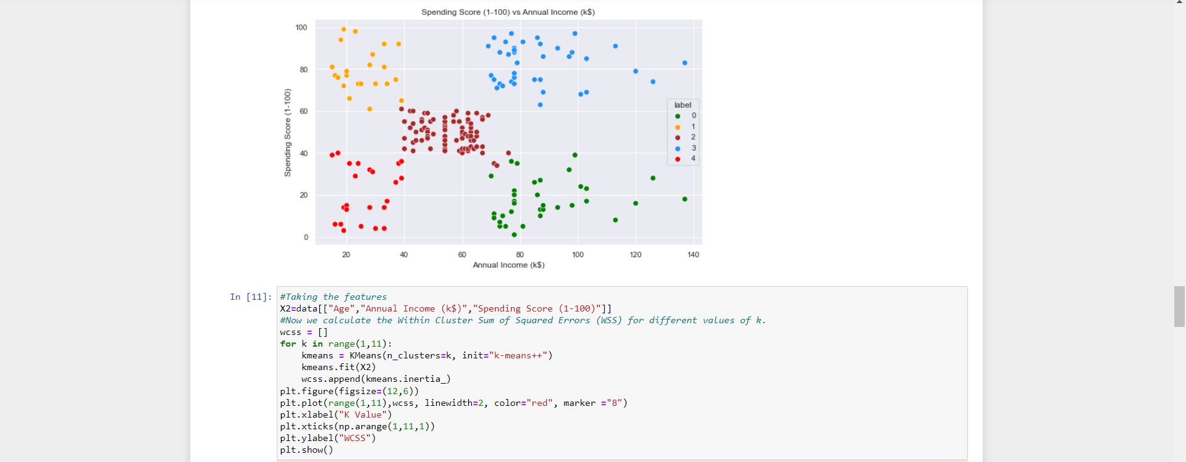 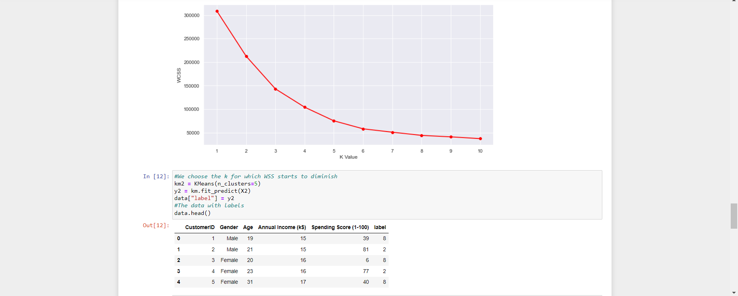 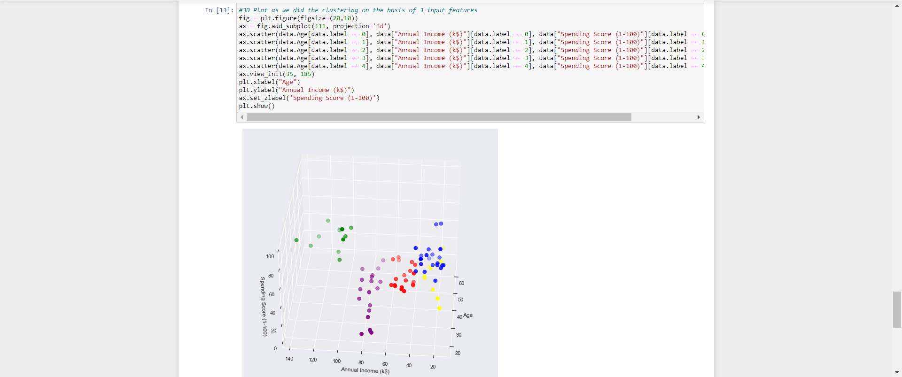

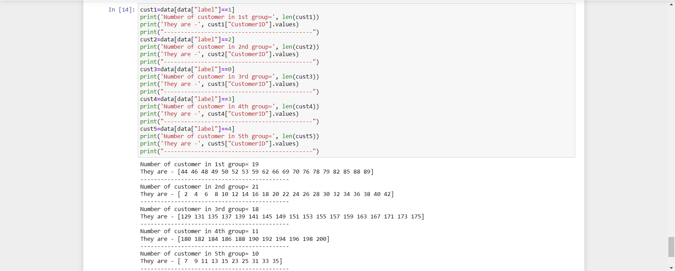

**Q.16 Creating & Visualizing Neural Network for the given data.**

**Output:**

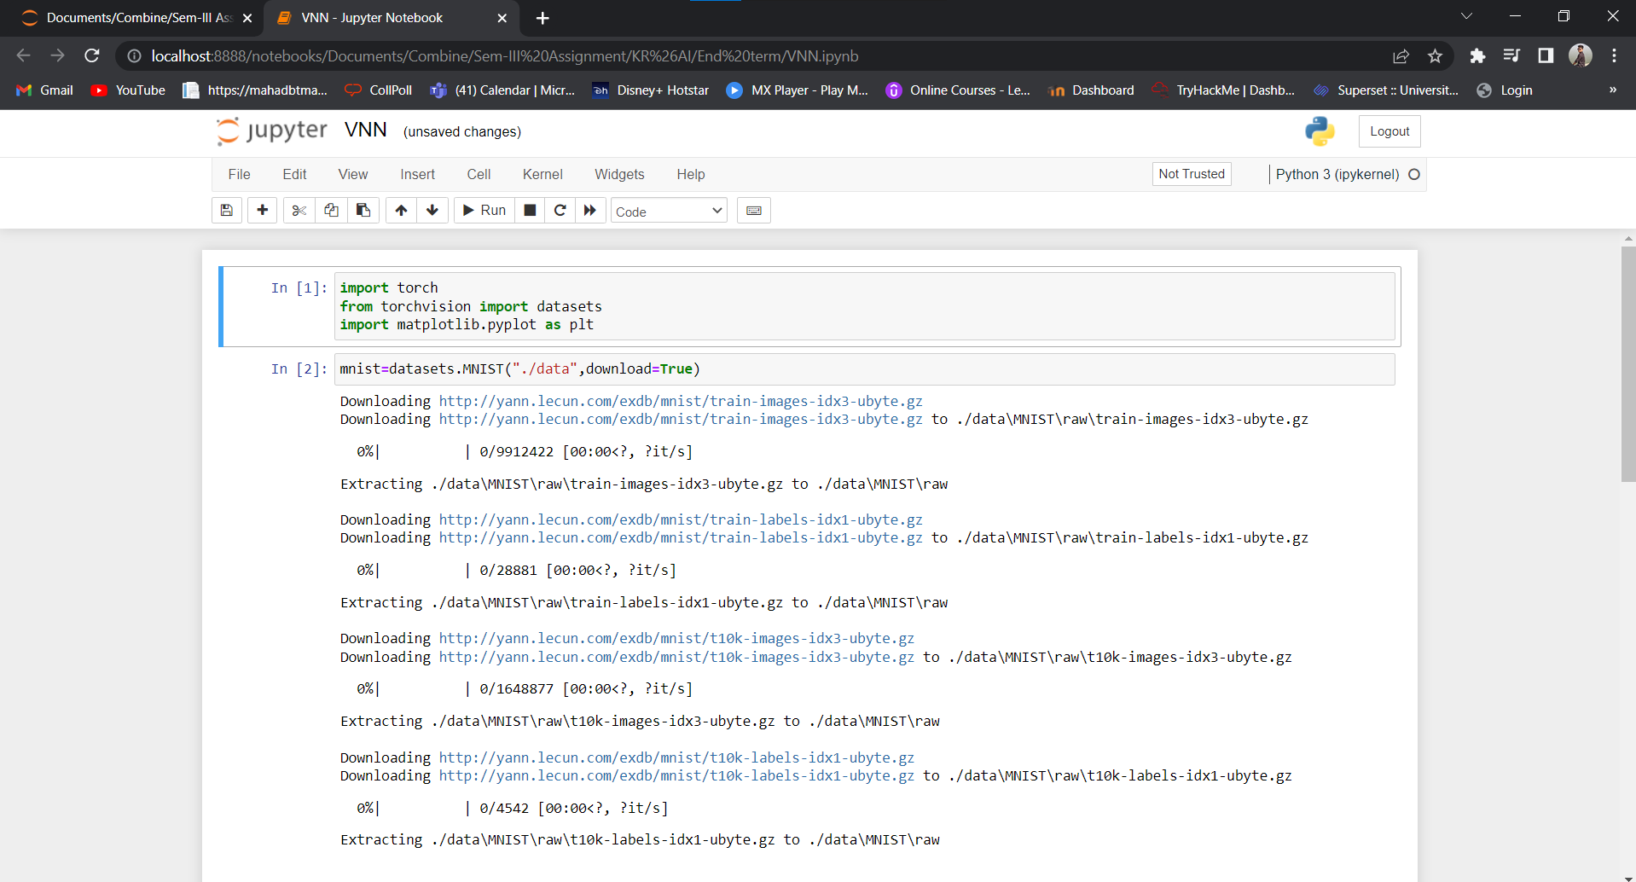 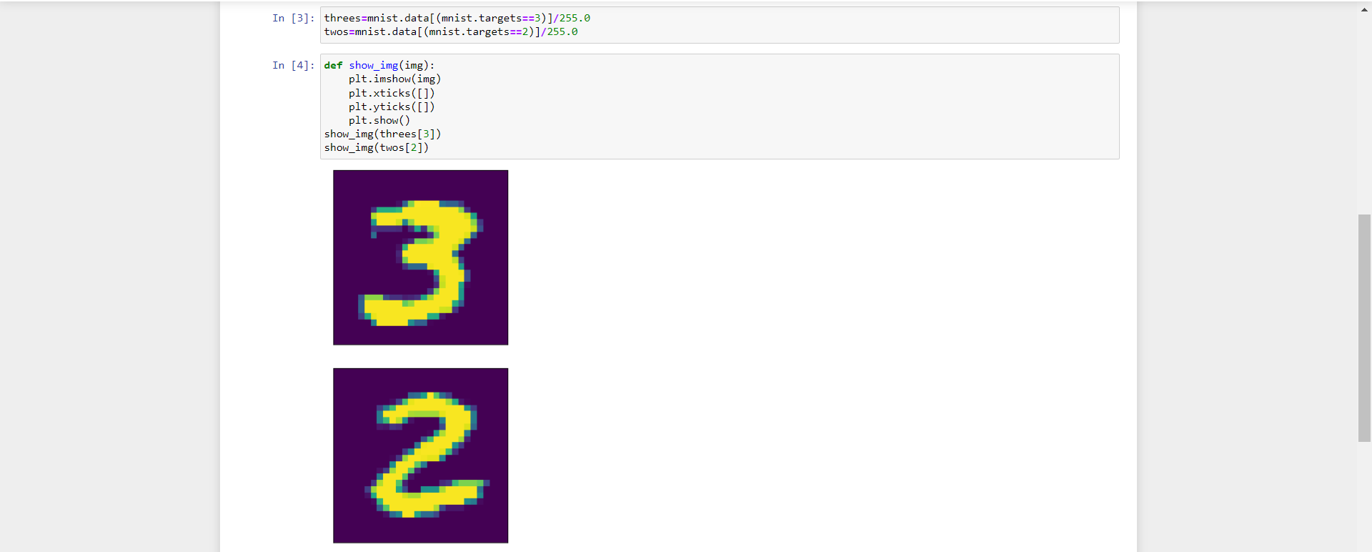 

**Q.17 Recognize optical character using Artificial Neural Network (ANN).**

**Output:**

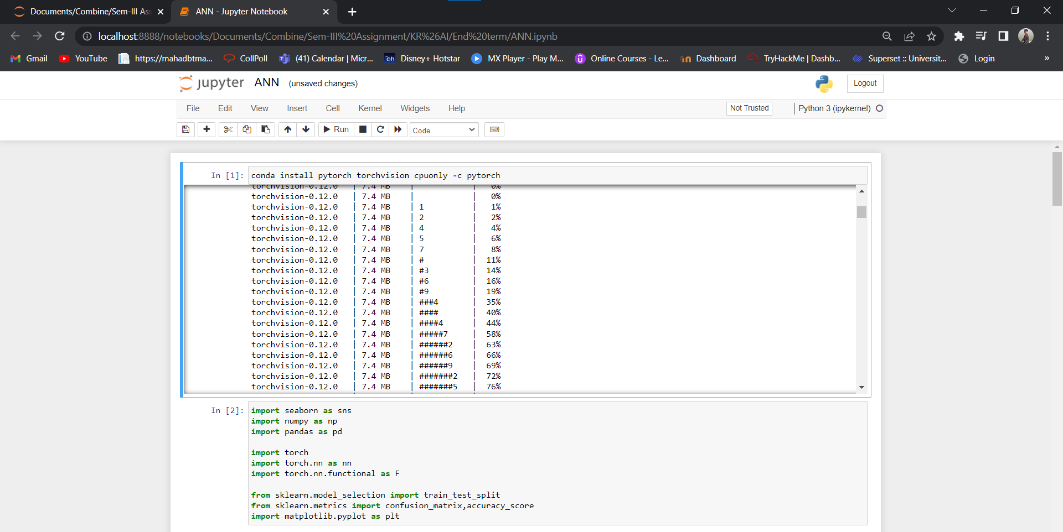 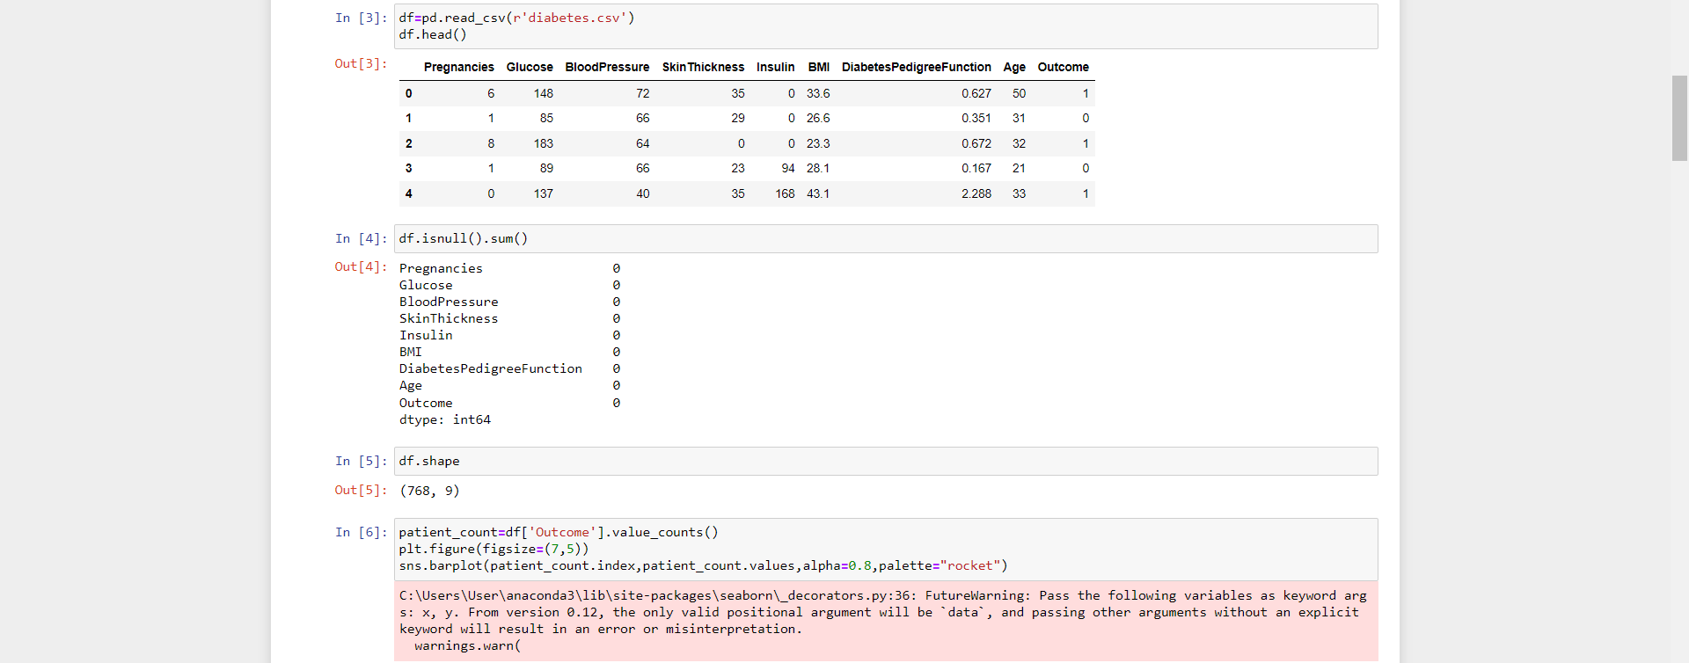 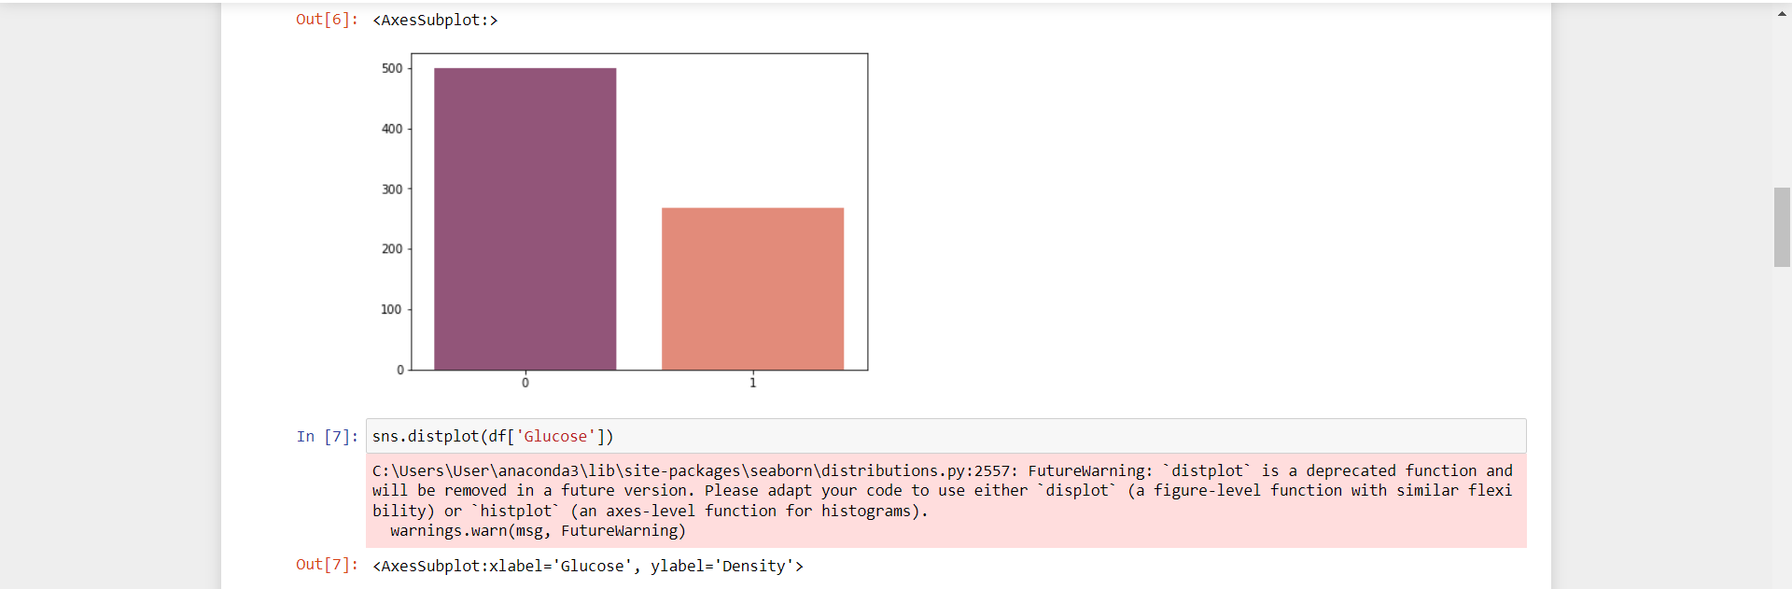

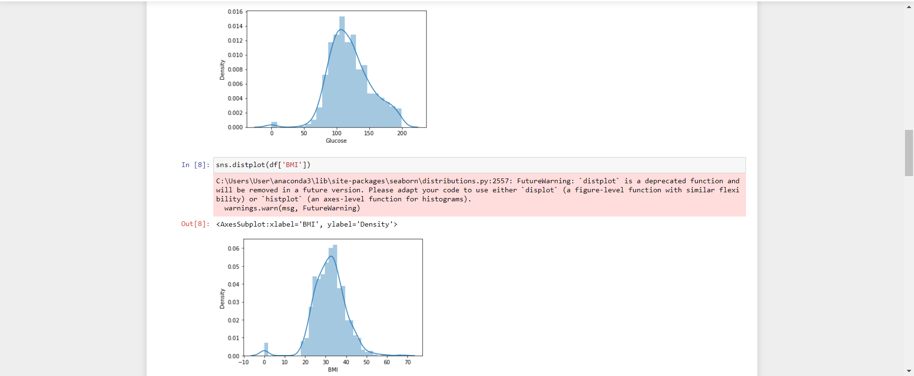 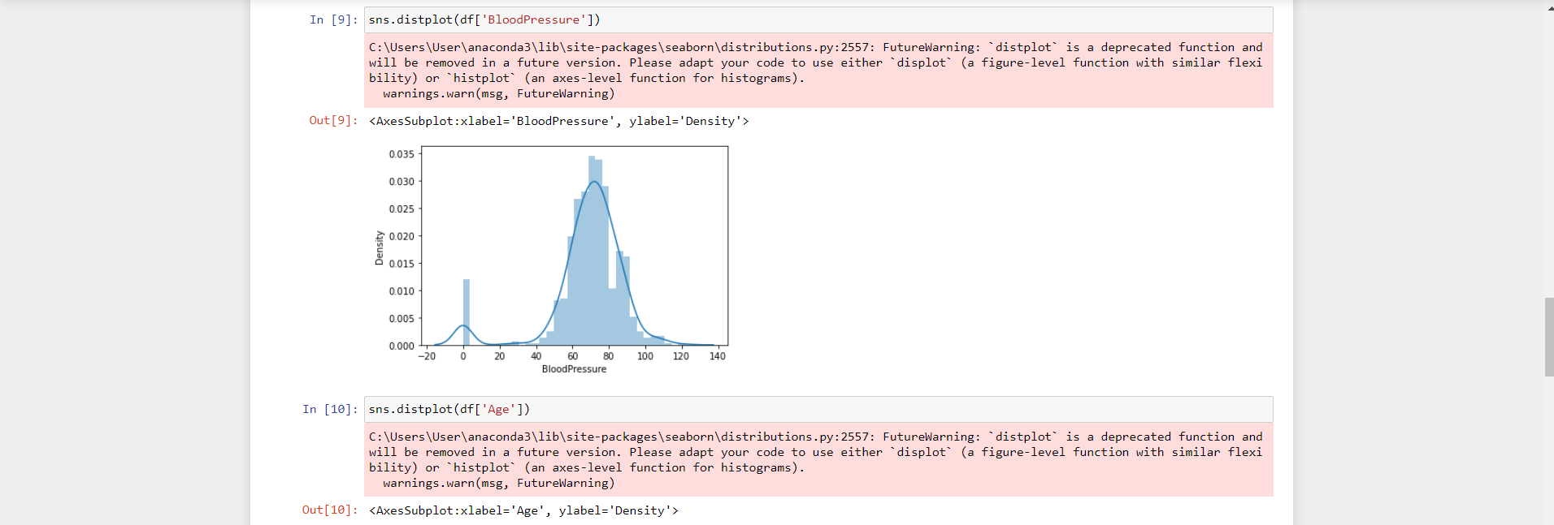 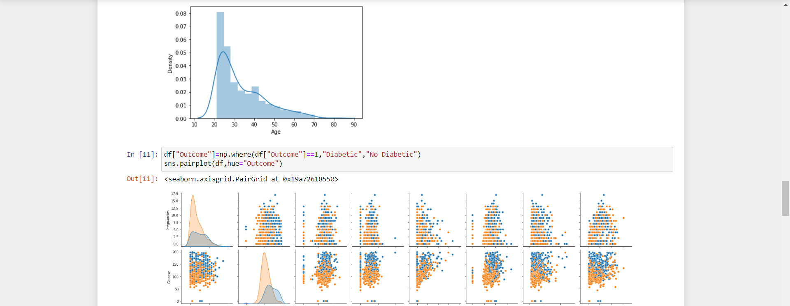

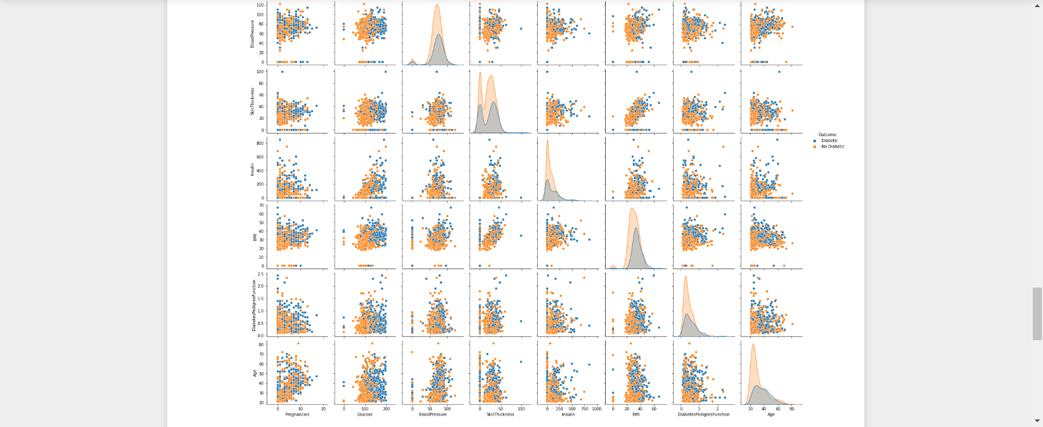 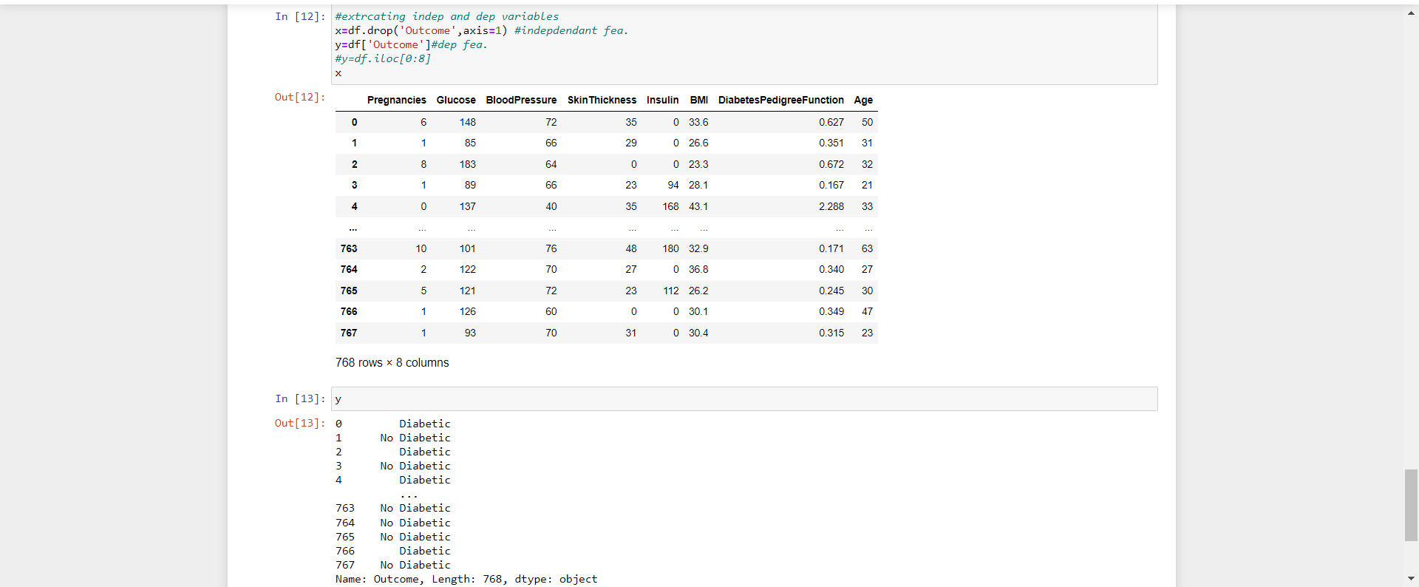 

**Q.18 Write a program to implement Convolutional Neural Network (CNN).**

**Output:**

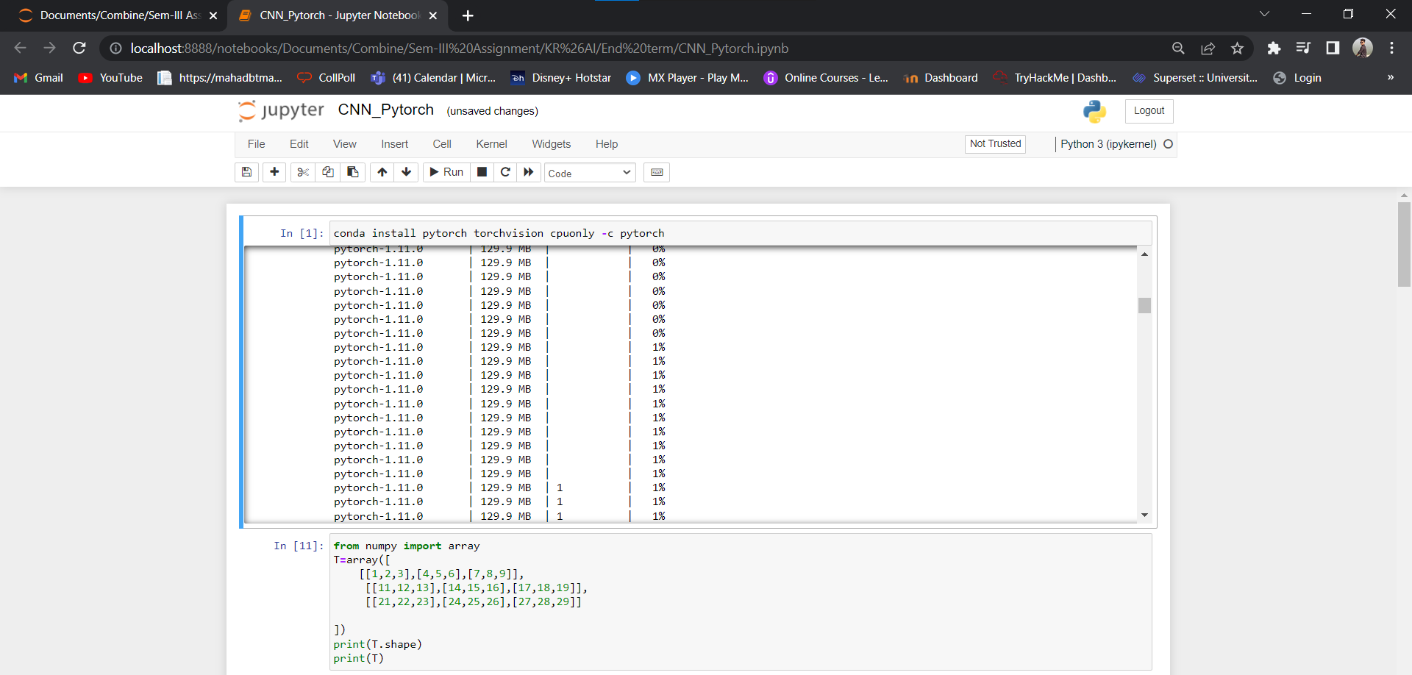 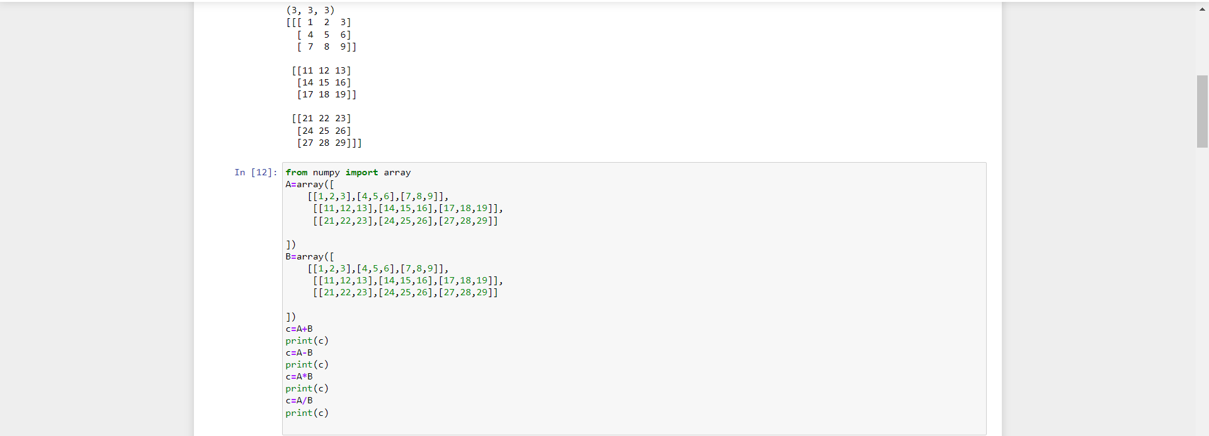

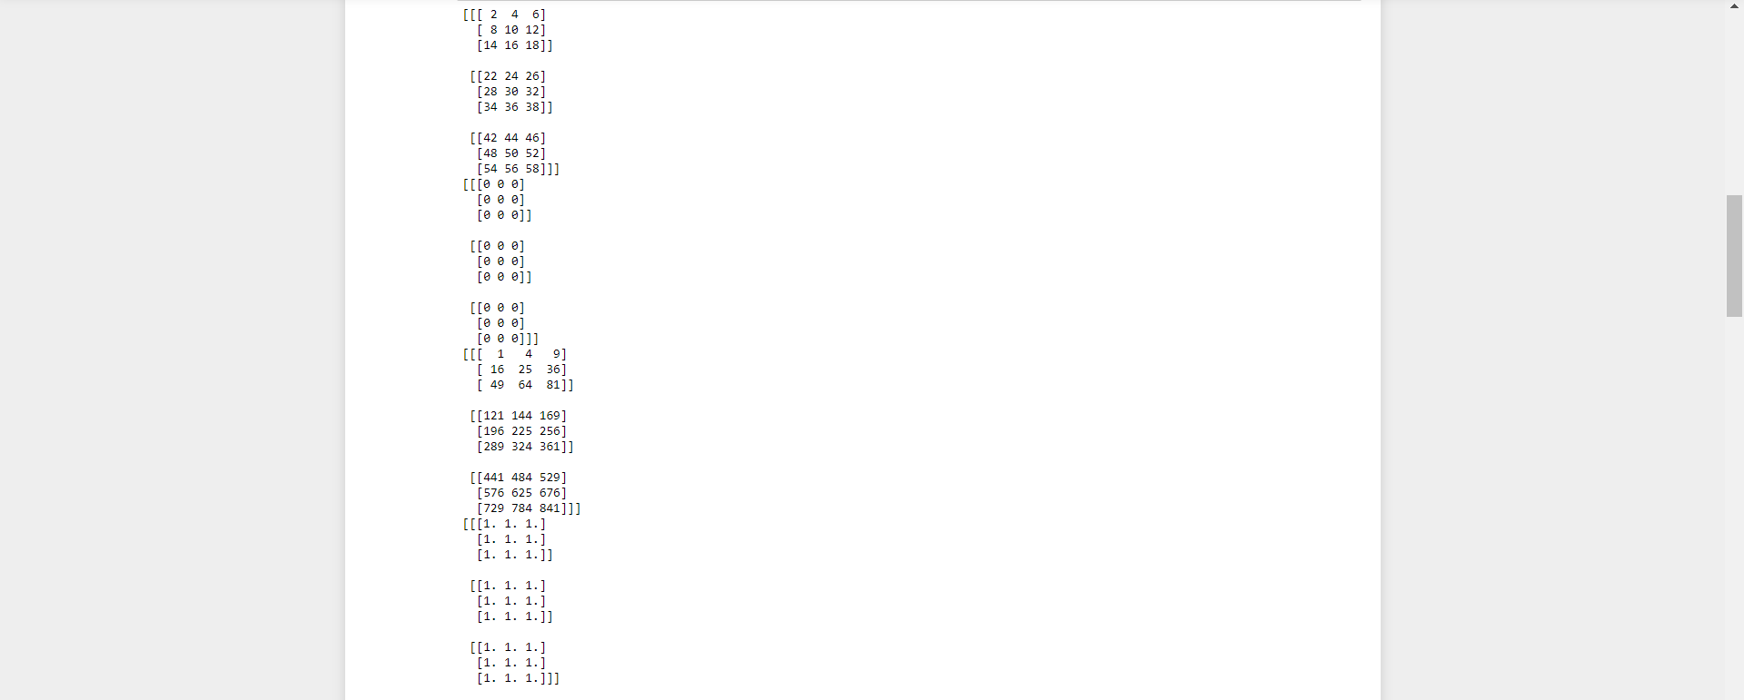 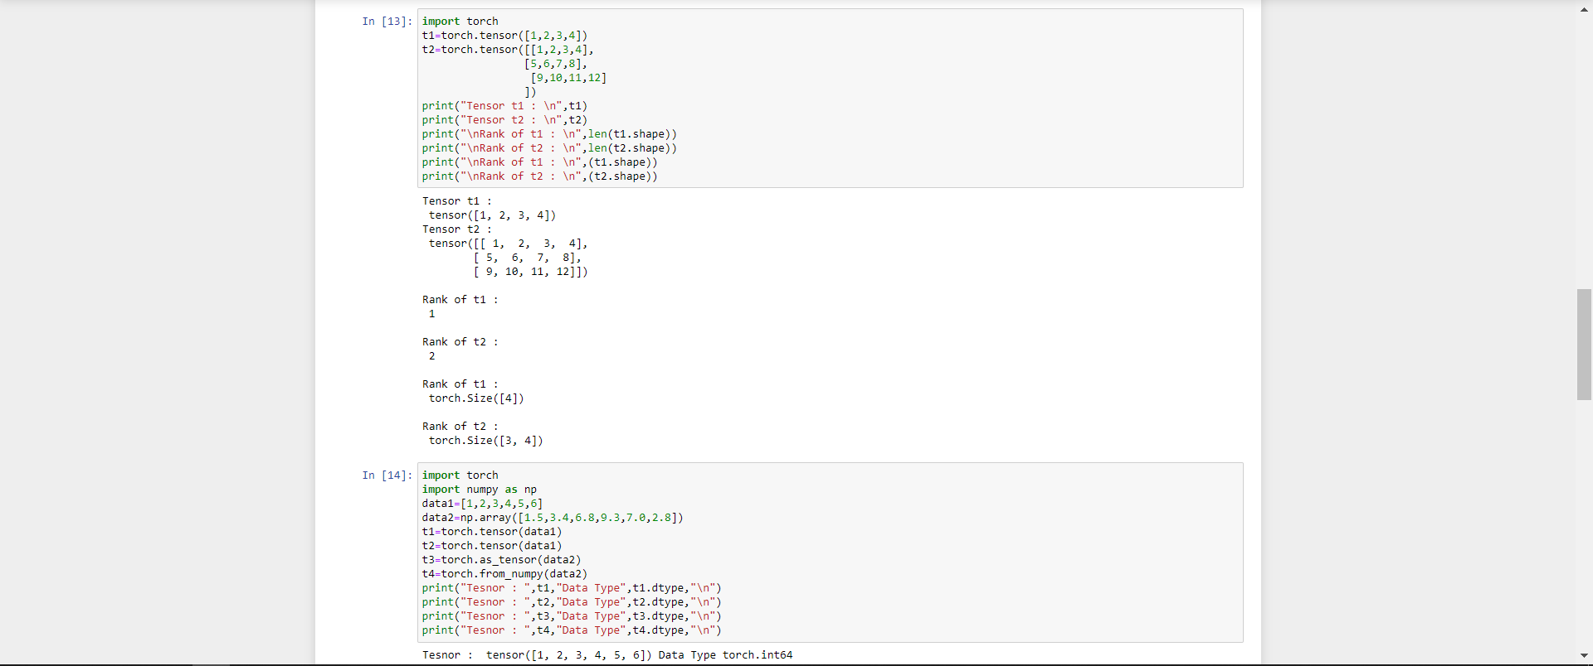 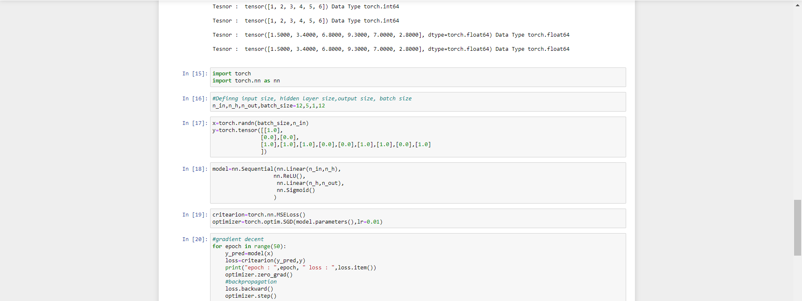

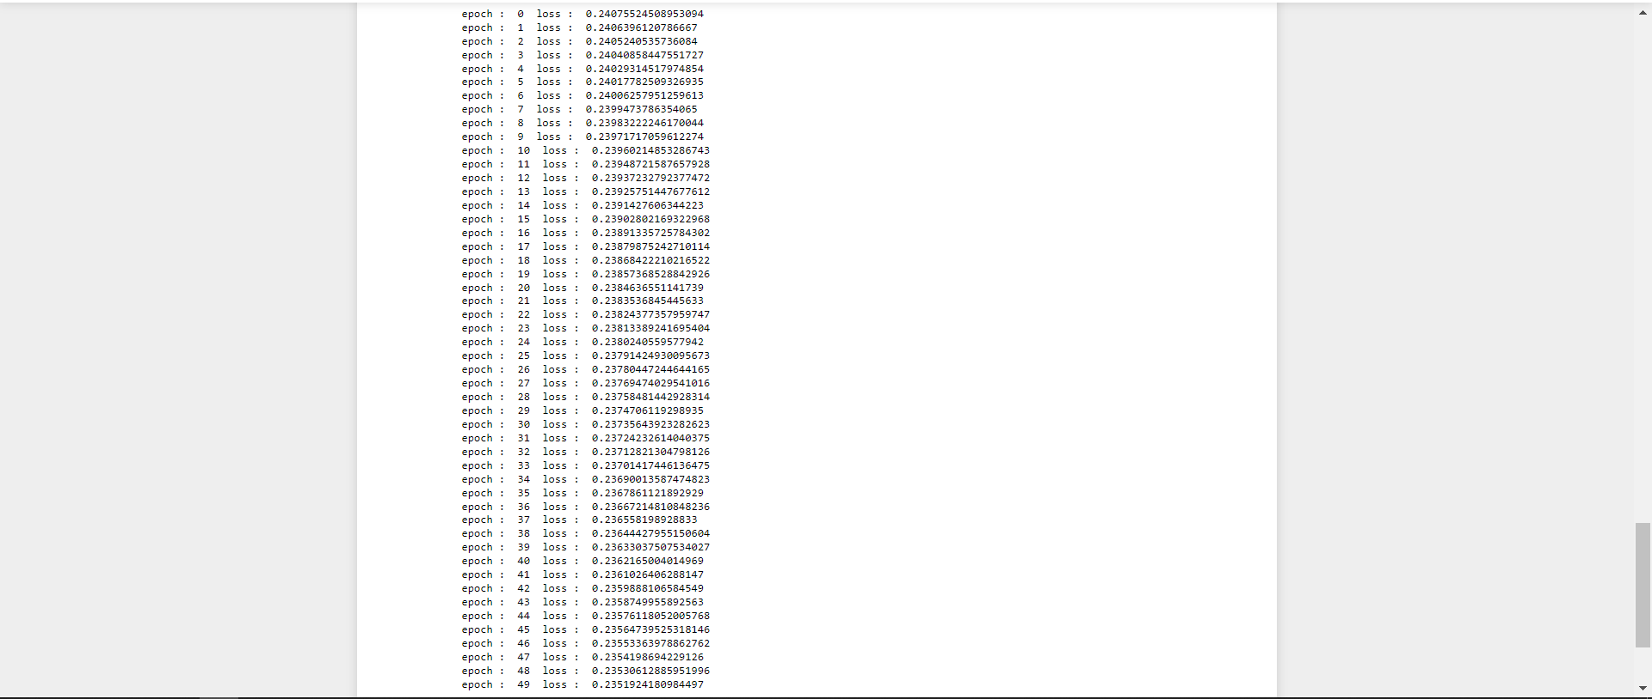

**Q.19 Write a program to implement Recurrent Neural Network (RNN).**

**Output:**

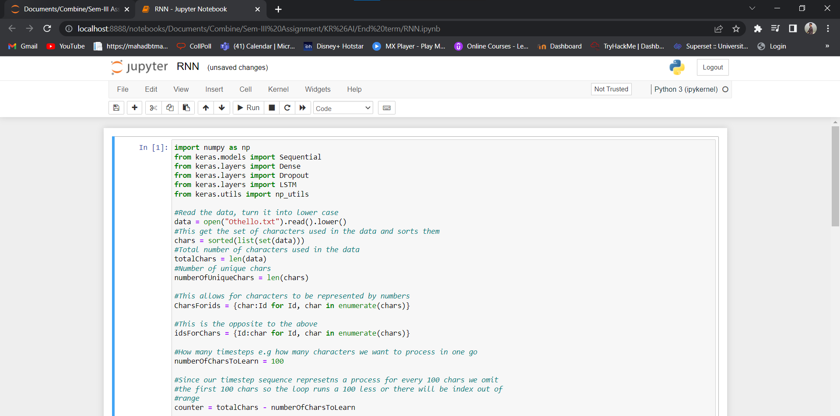 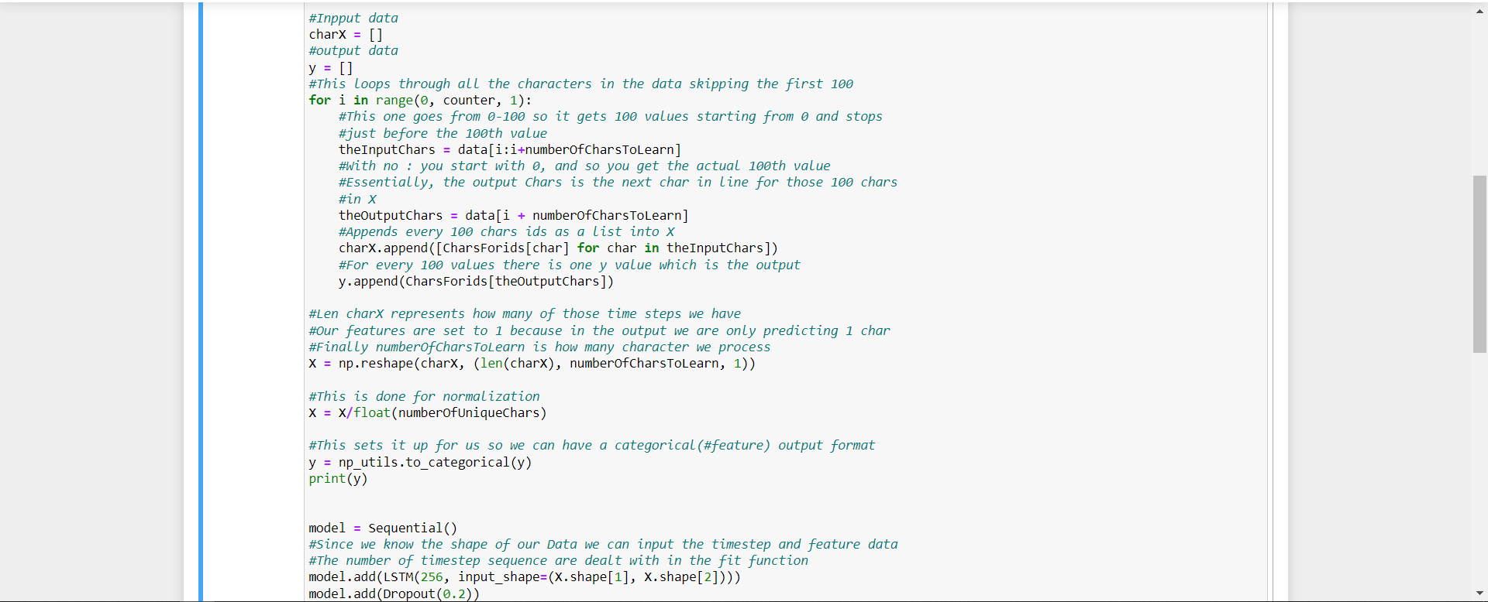

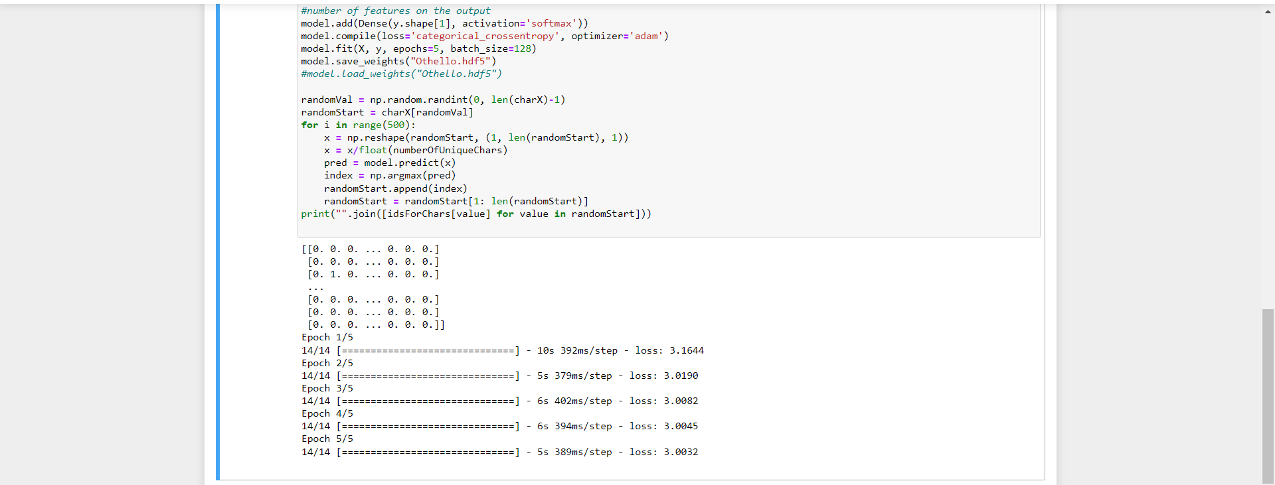

**Q.20 Write a program to implement Generative Adversarial network (GAN)**

**Output:**

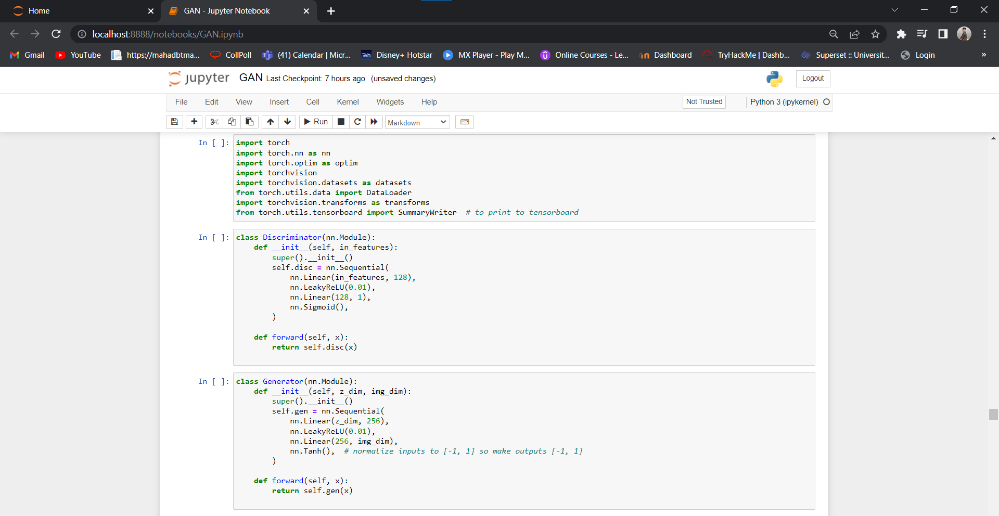 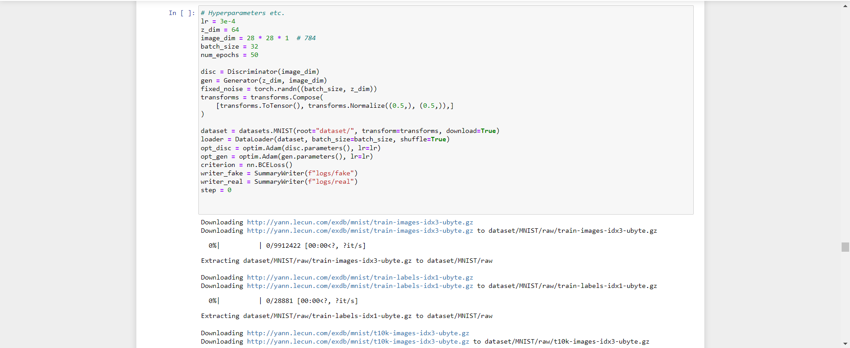

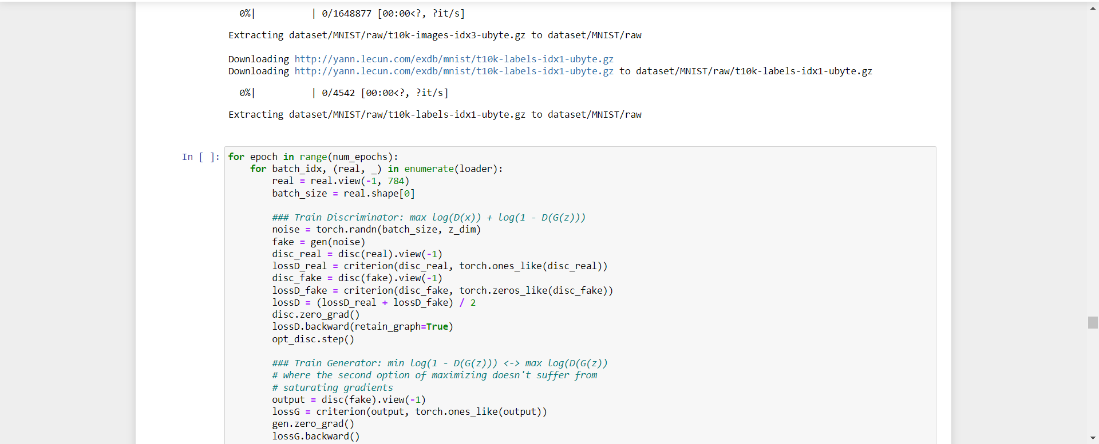 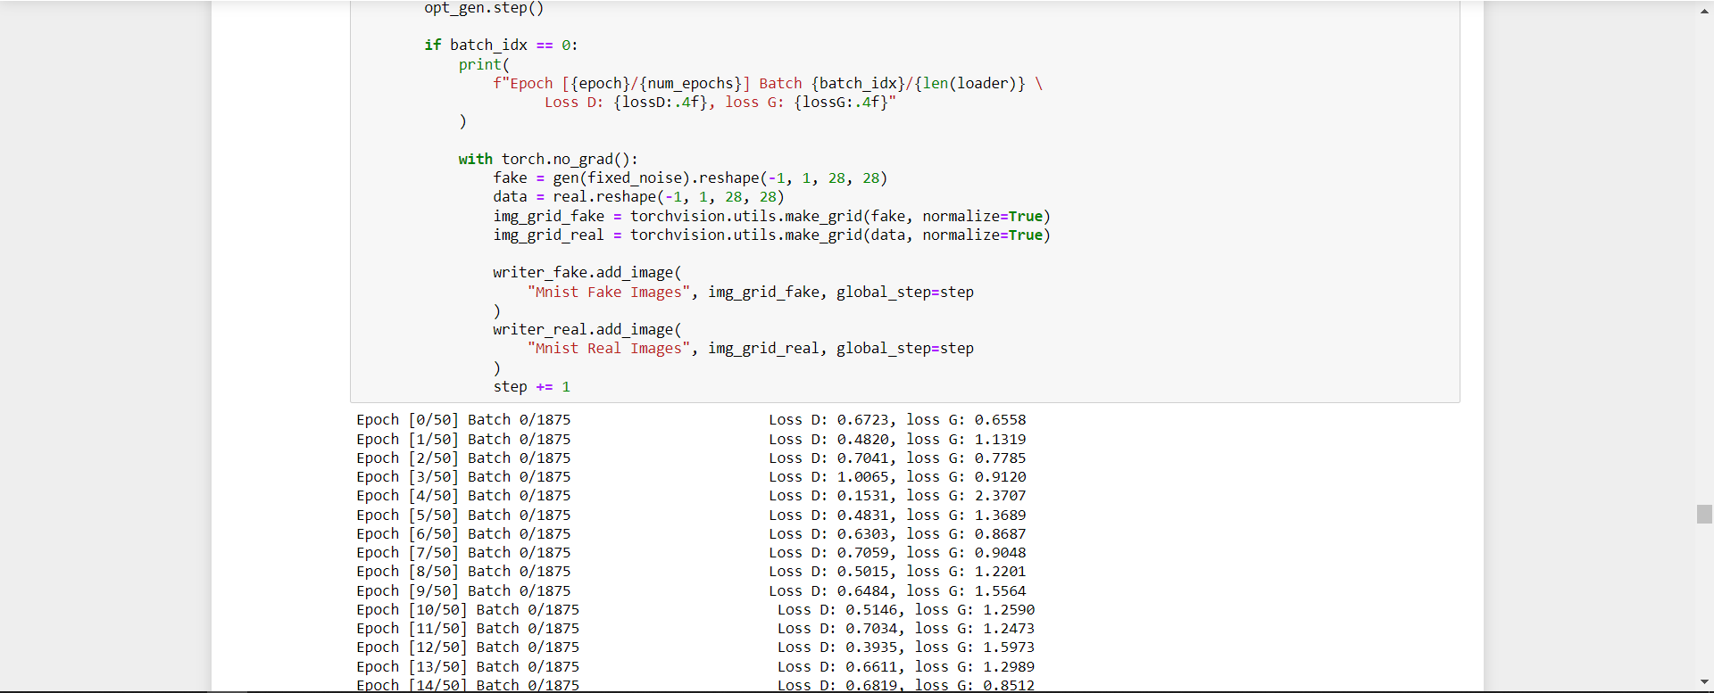 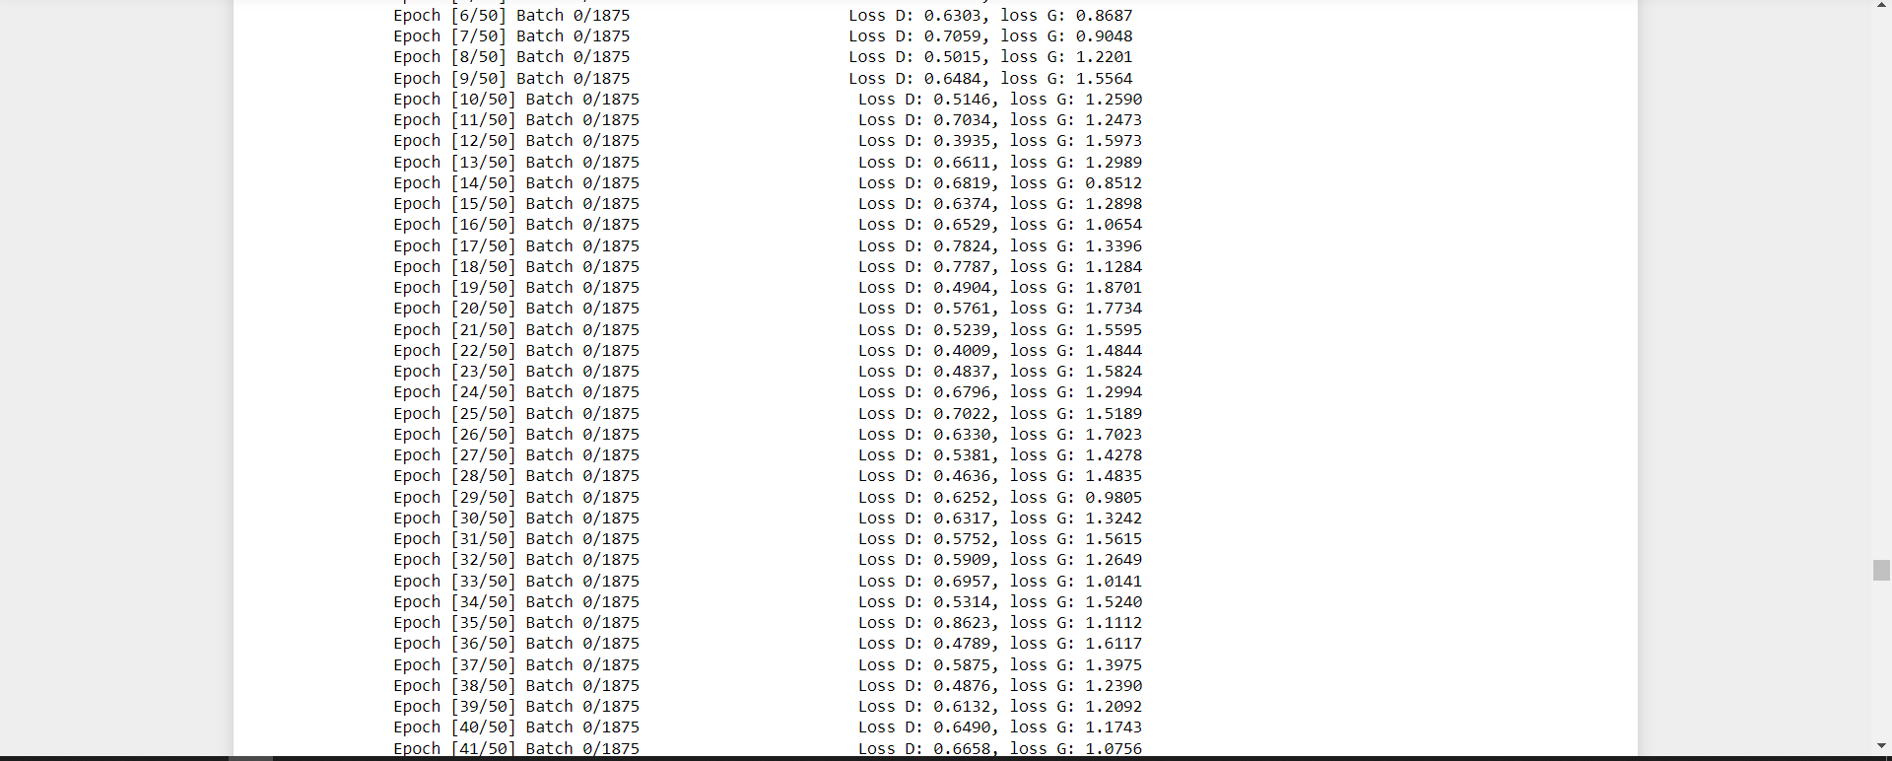

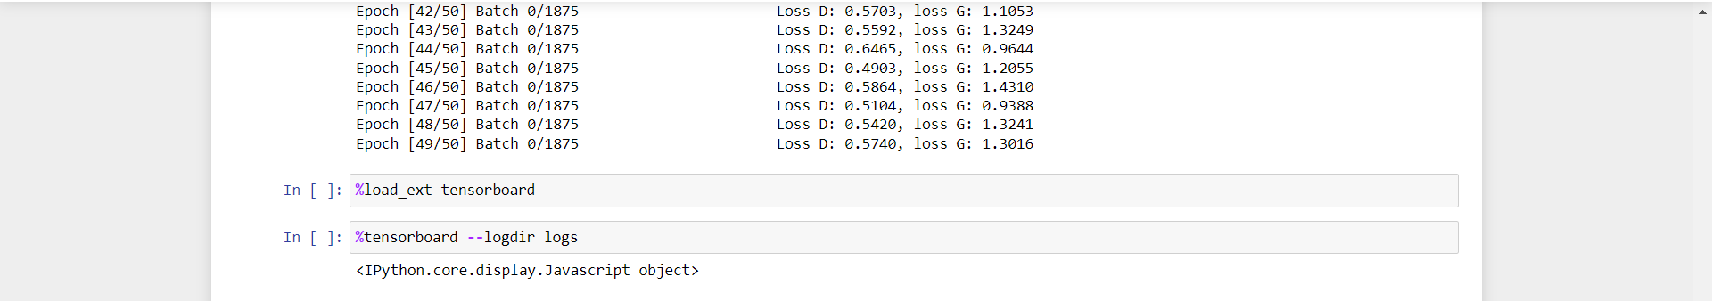

**Q.21 Web scraping experiments (by using tools)**

**Web Scraping Using Tool: ParseHub**

**Output:**

**Website** <https://www.amazon.in/s?k=fiction+books&i=stripbooks&crid=12X98CI0OQIXR&sprefix=fic%2Cstripbooks%2C854&ref=nb_sb_ss_c_3_3_ts-doa-p>

